MetLoop
Daily Weather Newsletter
Southeast Edition
May 3, 2016

Good Morning from Houston,
The Southeast experienced more severe weather yesterday, but this time, Kentucky, Tennessee, Virginia and the Carolinas were the target. No tornadoes were reported, but there was plenty of hail; some as large as 2 inches in diameter. There were also lots of reports of wind damage, with a reported maximum over 70 miles per hour.
The storms will remain along the East Coast and Gulf Coast today, going from Virginia to Alabama with the strongest threat over the Carolinas.
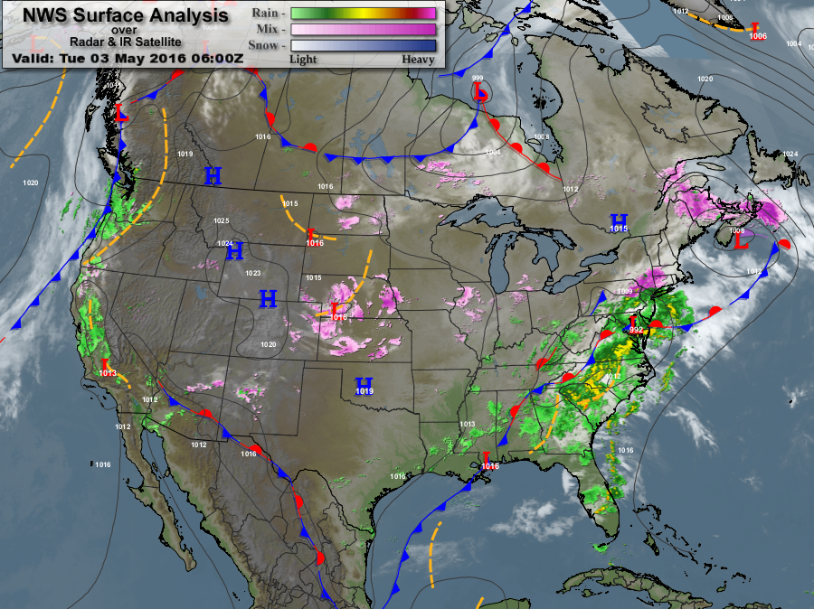
Surface Chart
We still see the lengthy stationary front from New Jersey to Mexico, and back to California. As we have witnessed over the past week, the rain and thunderstorms stay aligned with the frontal boundary.
The key feature on the Surface Chart is the cold front in Canada. This cold front intends to sweep southward very quickly, and will be through the Southeast by late Thursday. This fast-moving front will bring drier air to the Southeast, resulting in warm days and cool nights. Remember, dry air heats and cools faster than moist air.
Speaking of temperatures, the world will be upside down for the next few days. Because of how the jet stream is oriented, temperatures in Northwest Canada will be in the upper 70s today, while Kentucky, Tennessee and Northern Mississippi will be about 15 to 20 degrees cooler.
Tomorrow, the disparity in temperatures grows larger with values in the 80s in Canada, while Atlanta will hit only 68 degrees. Temperatures on Thursday seem even crazier, when temperatures in Northern Canada will be as high as 87 degrees, while the Gulf Coast will see values in the low 70s. Crazy weather.
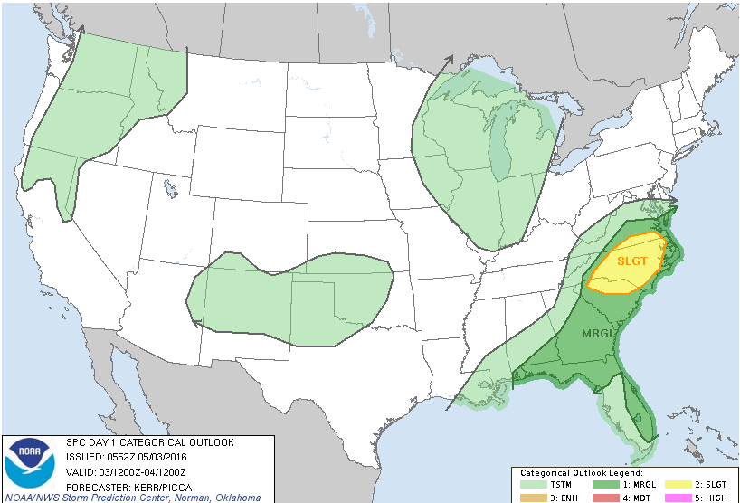
SPC Outlook for today
Tomorrow, the stationary front will slowly move offshore along the East Coast, while the Canadian front comes barreling down into the Midwest. The Canadian front will generate clouds and rain for parts of the Midwest tomorrow and on Thursday, more clouds and rain for Virginia, Kentucky, Tennessee and the Carolinas.
For most of the Southeast, it’s going to be a great weekend of weather; lots of sunny skies, warm days and no precipitation, as a large High pressure system moves over the Southeast.
For locations around the edges of the High pressure center (Virginia, the Carolinas, Kentucky, Texas), it going to be wavering between partly to mostly cloudy, sporadic rain and an increasing probability of severe weather over Texas and Oklahoma.
It appears that we have about 2 or 3 more weeks of severe weather for the Southeast, before it all transitions northward.
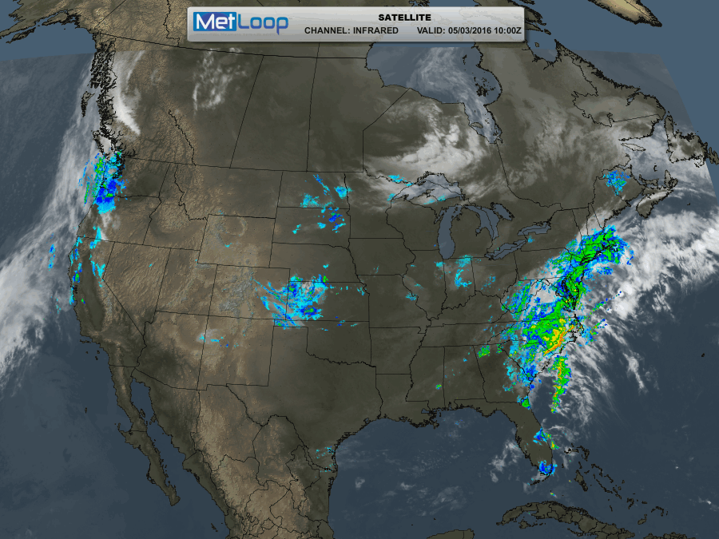
National Satellite and Radar image as of 5:00AM CDT

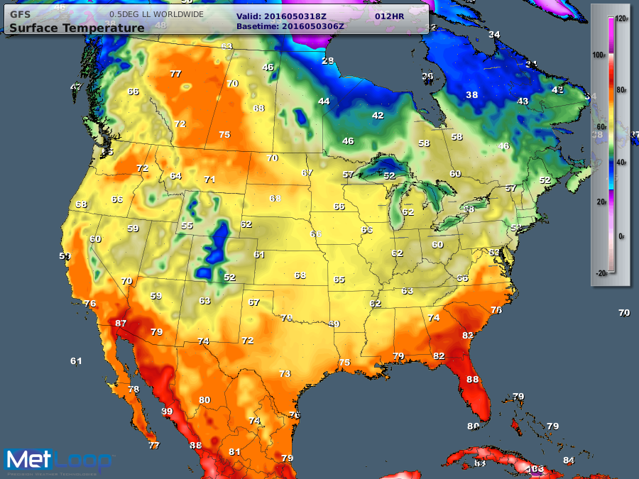
Maximum Temperatures for today
As you look at the maximum temperatures over the next 3 days, you will see what I’m talking about, with values in Canada much higher than parts of the Southeast.
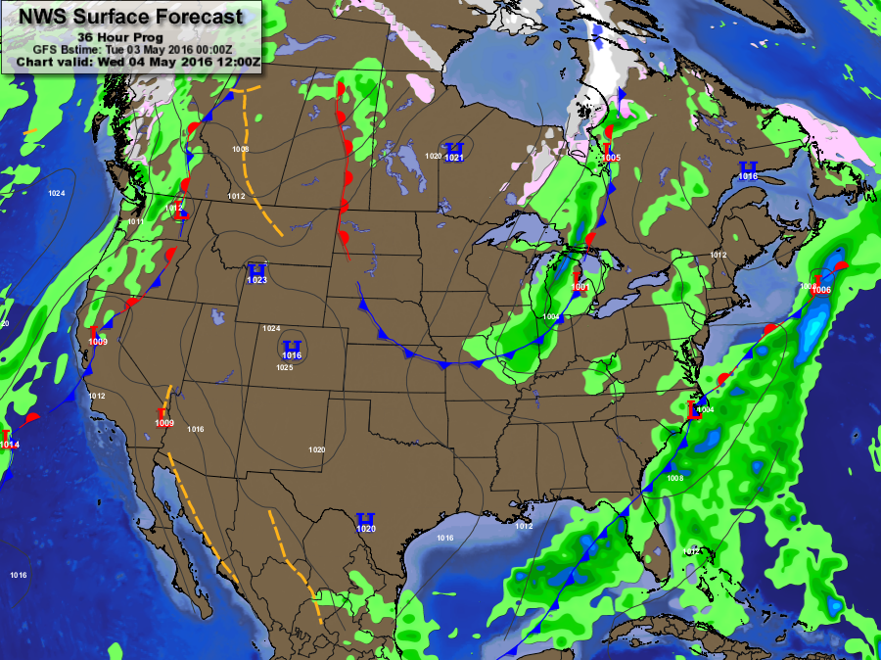
Forecast Map – Wednesday, May 4, 2016

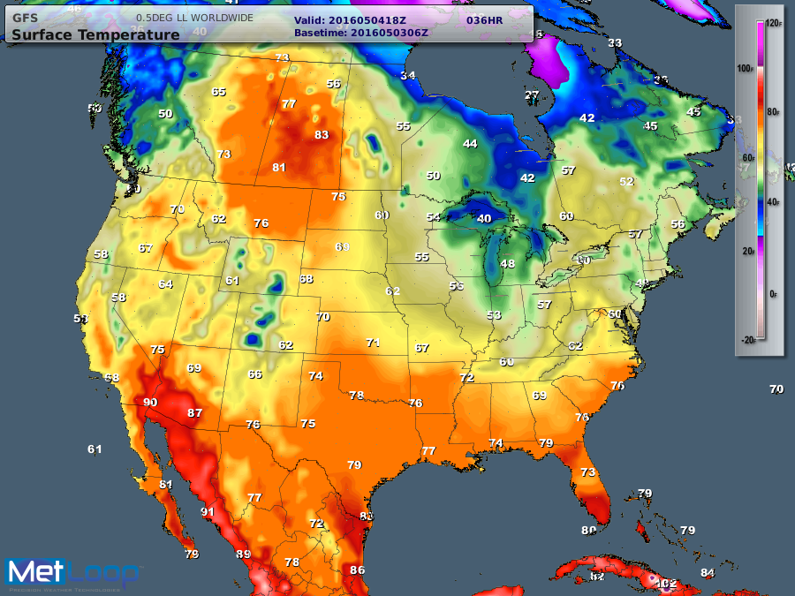
Maximum Temperatures – Wednesday, May 4, 2016

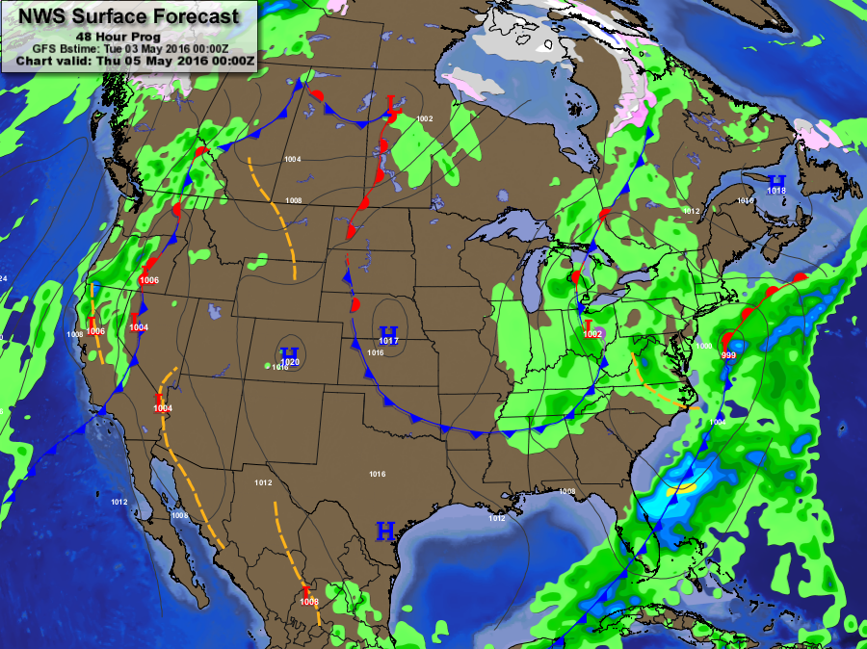
Forecast Map – Thursday, May 5, 2016

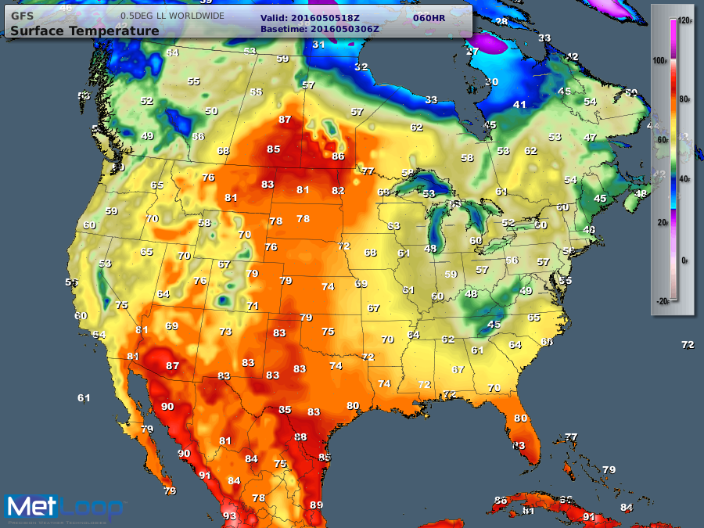
Maximum Temperatures – Thursday, May 5, 2016

We are coming to an end of almost 2 weeks of severe weather smacking the Southeast. We have experienced tornadoes, hail as large as 4 inches, wind speeds close to 80 miles per hour and so much rain that some people started to build personal arks.
Yes, we have a few more weeks of severe weather, but I believe that the severity of weather will slightly diminish, as warmer weather continues to take hold across the Southeast.
As for me, I’m in Houston for business and will be here until Thursday.
Until tomorrow,
Rocco
Chief Meteorologist
MetLoop

