MetLoop
Daily Weather Newsletter
Southeast Edition
May 11, 2016

Good Morning,

Up to now, 2016 has been a year marked by a lot of severe weather, and I don’t see an end in sight for at least 3 more weeks. Yesterday, there were 23 reported tornadoes, hail reaching 3 inches in diameter and wind gusts to 85 miles per hour. There is a high probability that these numbers were much higher, but most severe weather events go un-reported.

Today will be another round of severe weather covering much of the eastern United States, with the greatest threat over North Texas and Oklahoma.

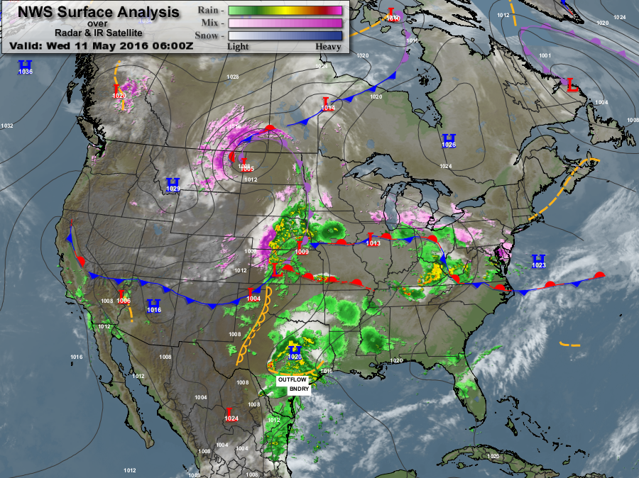
Surface Chart

We continue to see a frontal boundary that stretches from the East Coast to the West Coast. To the south of the frontal zone, we have hot, humid air, and to the north of the boundary, the airmass is cool and drier.

We will see the formation of another “dry line” over West Texas today, and it will all come together along the Texas – Oklahoma border area. I expect to see more tornadoes, very large hail and wind gusts above 70 miles per hour today.

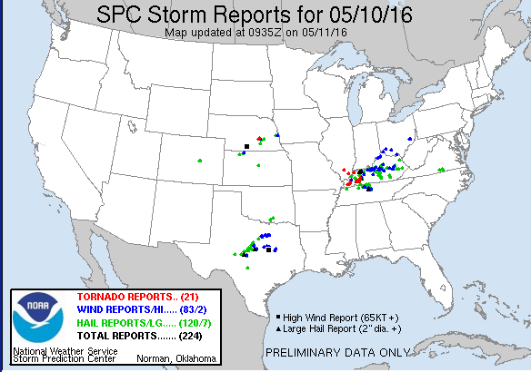
SPC Severe Weather Summary for yesterday

The summary from the Storm Prediction Center (SPC) from yesterday, tornadoes are Red dots, hail is Green, and winds reports above 58 miles per hour are Blue. The Black squares represent hailstones of 2 inches and larger.

As I said, this is only what was actually reported; most people when they witness severe weather usually do 1 of 2 things: they hide trying to survive, or they record a video and upload it to YouTube. The result is an under-reporting of severe weather.

Today will generate the highest threat of severe weather, for tomorrow and Friday, the probability will diminish. Please note that I said “diminish”, not disappear; there is a big difference.

The lengthy frontal zone will get a push of cold air from Canada, and we will see a strong cold front move through most of the Southeast over the weekend. Temperatures will be dropping by 15 to 20 degrees and more in some areas.

For example, the daytime high temperature in Memphis today will be 83 degrees, but on Sunday it will only reach 60 degrees. Temperatures along the Gulf Coast will remain quite warm throughout the weekend.

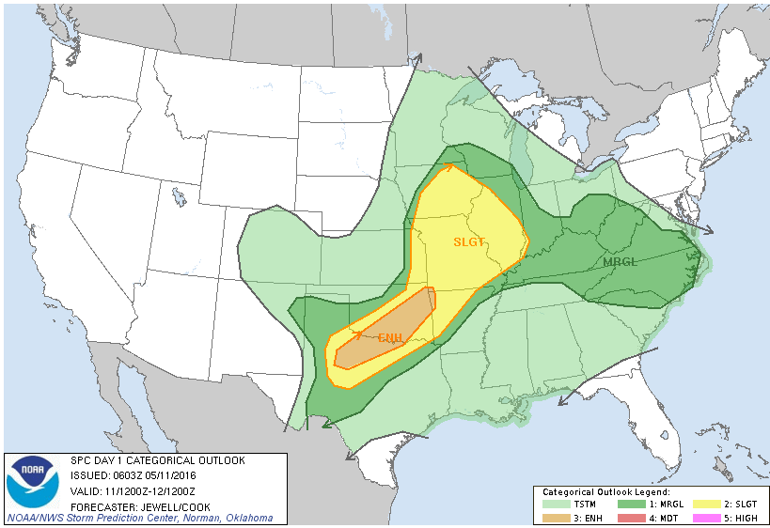
SPC Outlook for today

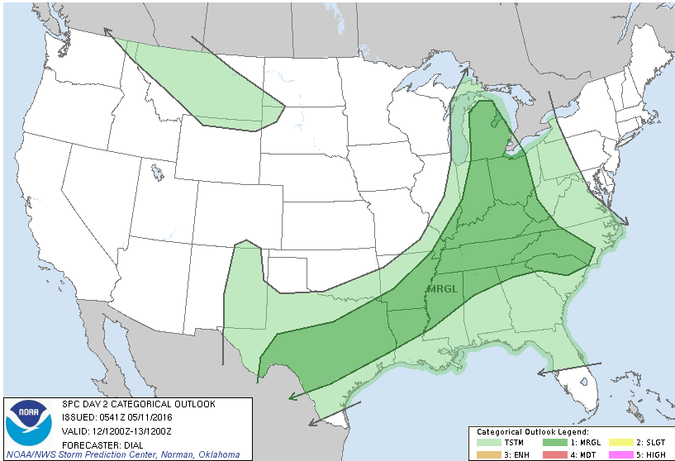
SPC Outlook – Thursday, May 12, 2016

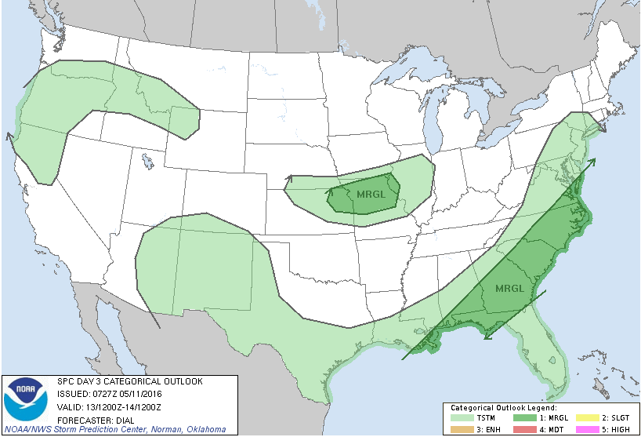
SPC Outlook – Friday, May 13, 2016

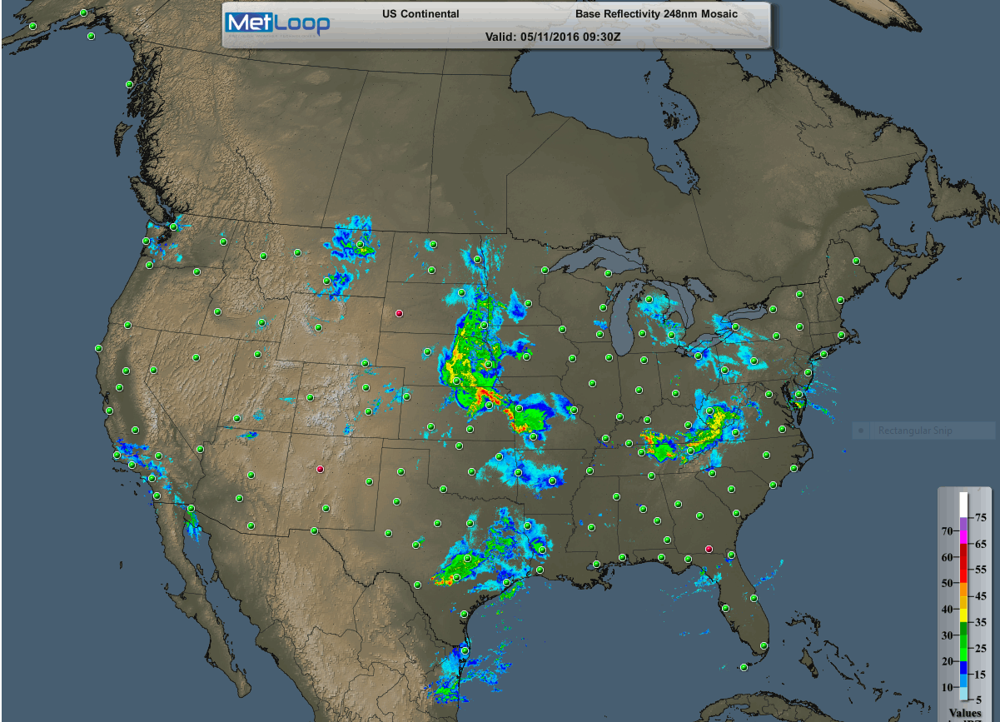
National Radar Summary as of 4:30AM CDT

I’m displaying the national radar summary this morning to show that we already have severe thunderstorms popping up in Nebraska, Kansas, Missouri, Texas and Tennessee. The situation will worsen throughout the day, as the sun comes up and begins to heat the surface. This will cause a greater disparity in atmospheric conditions and more severe weather will be the result.

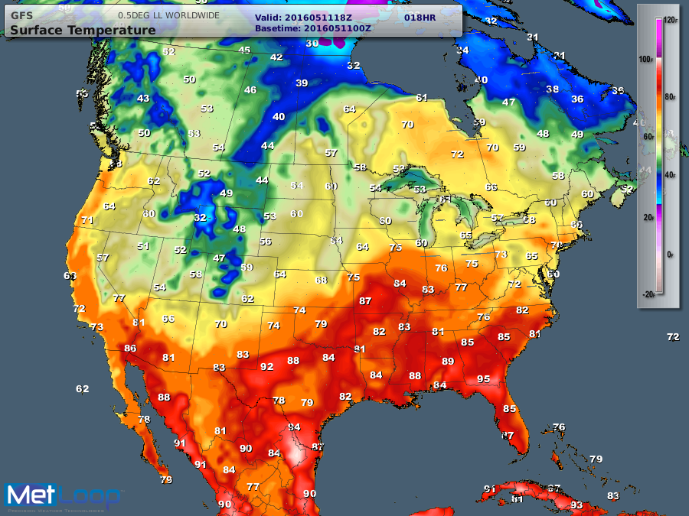
Maximum Temperatures for today

The weekend won’t be too bad for most of the Southeast, as the cold front moves through, we will see cloudy skies, rain and thunderstorms. Once the cold front passes, skies will clear, temperatures will drop and the rains will cease.

Along the Gulf Coast, we will have the clouds, rain and thunderstorms, but our temperatures will remain quite warm. For Sunday, Bagdad Kentucky will be lucky to hit 60 degrees, while Pascagoula Mississippi will be close to 87 degrees.

The entire severe weather mechanism cranks up again over West Texas on Sunday and spreads eastward next Monday, May 16, 2016. Next week is going to bring a lot of heavy rain to the Southeast; mostly over Tennessee, Arkansas, Northern Mississippi and of course, Texas.

On or about May 19, 2016, Houston and the surrounding area, will be under the gun for heavy rains with accumulations above 4 inches. Get ready.

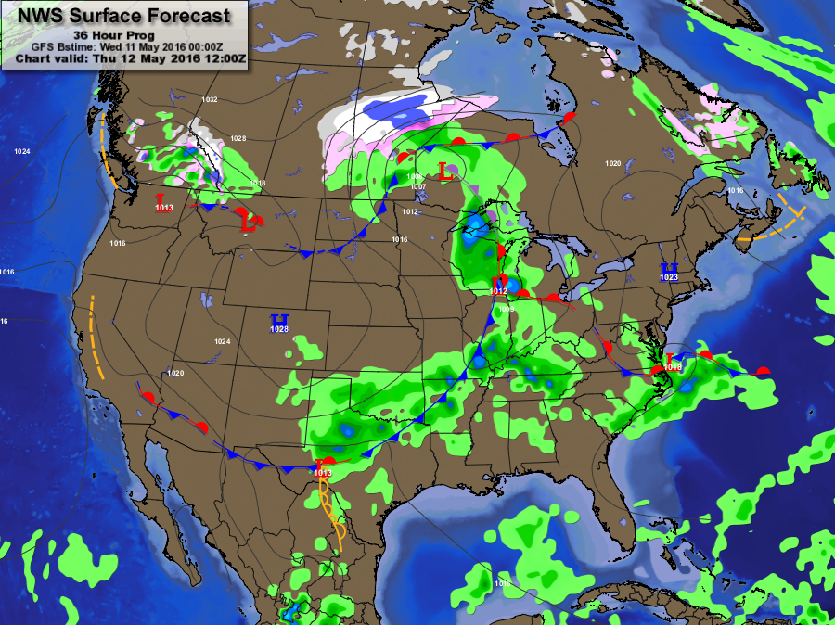
Forecast Map – Thursday, May 12, 2016

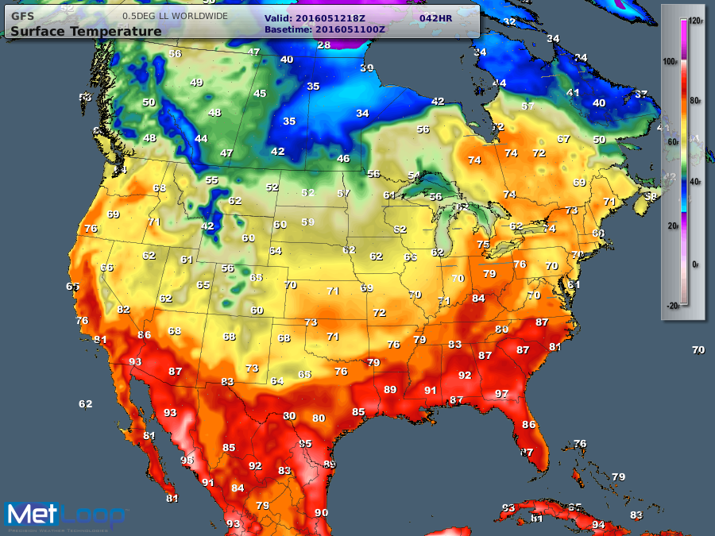
Maximum Temperatures – Thursday, May 12, 2016

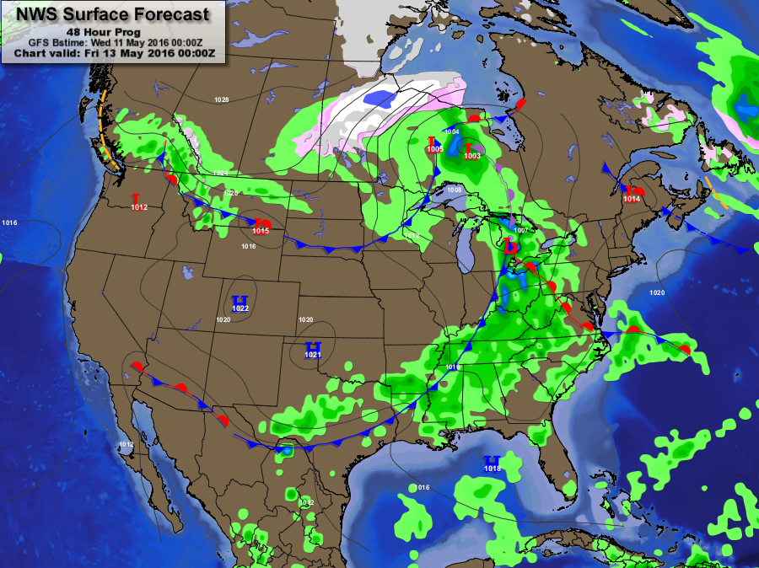
Forecast Map – Friday, May 13, 2016

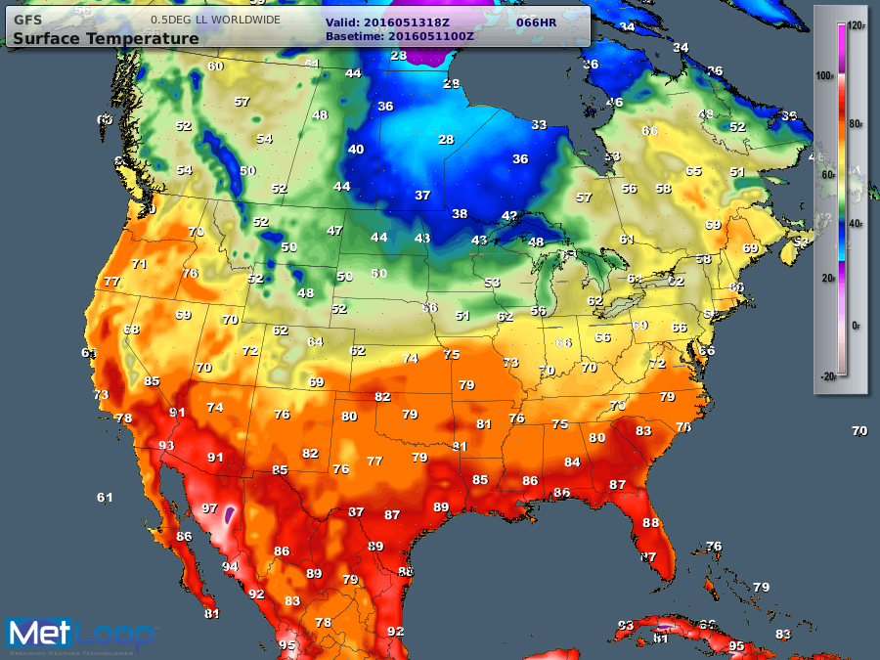
Maximum Temperatures – Friday, May 13, 2016

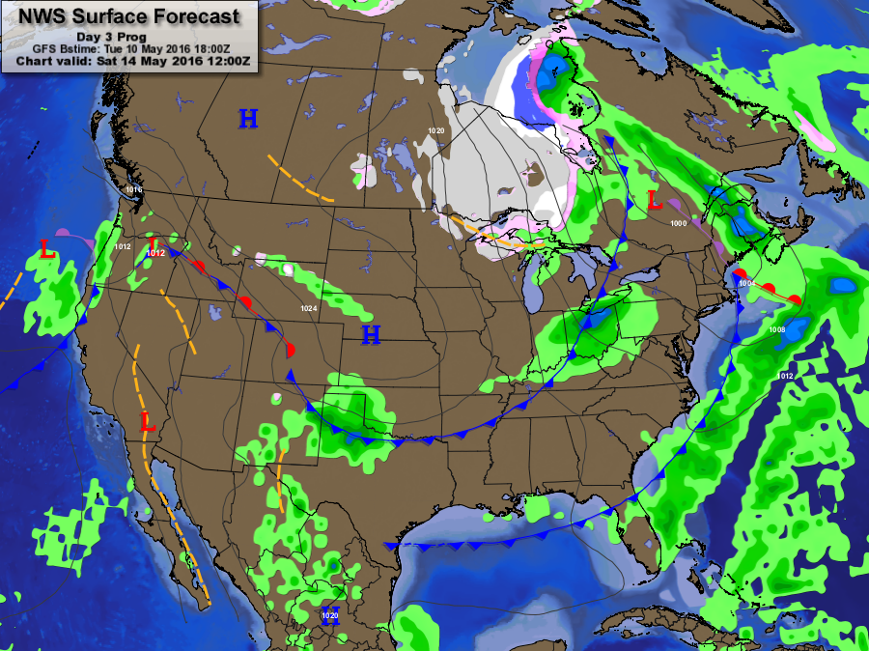
Forecast Map – Saturday, May 14, 2016

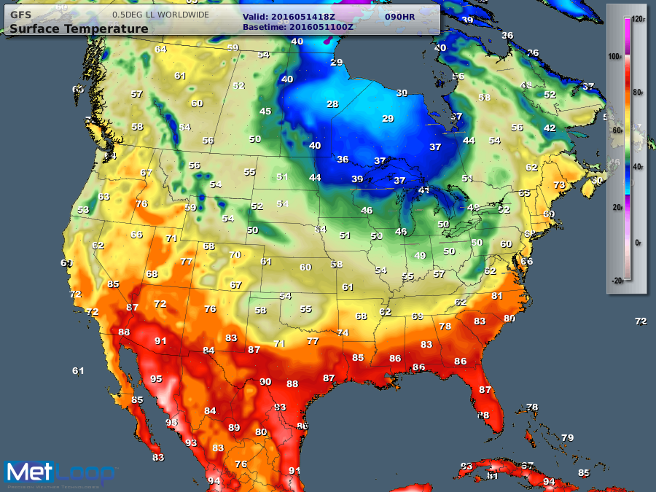
Maximum Temperatures – Saturday, May 14, 2016

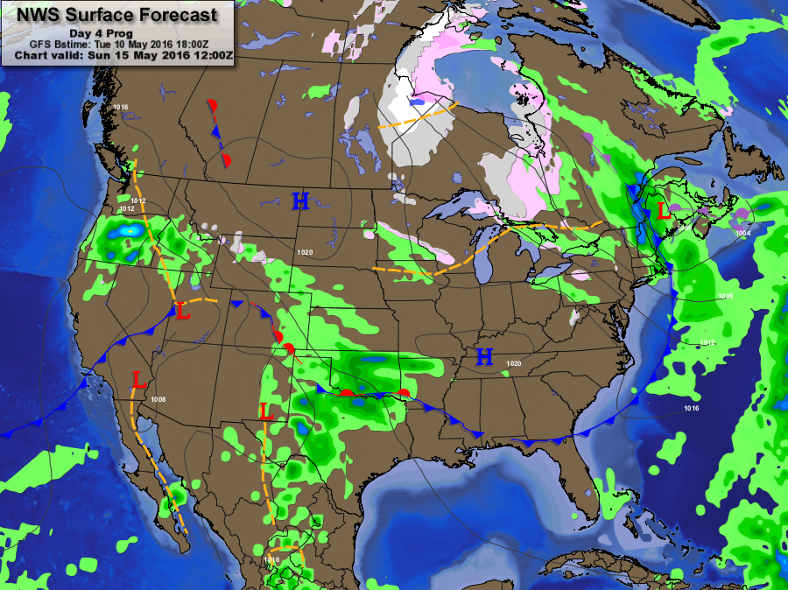
Forecast Map – Sunday, May 15, 2016

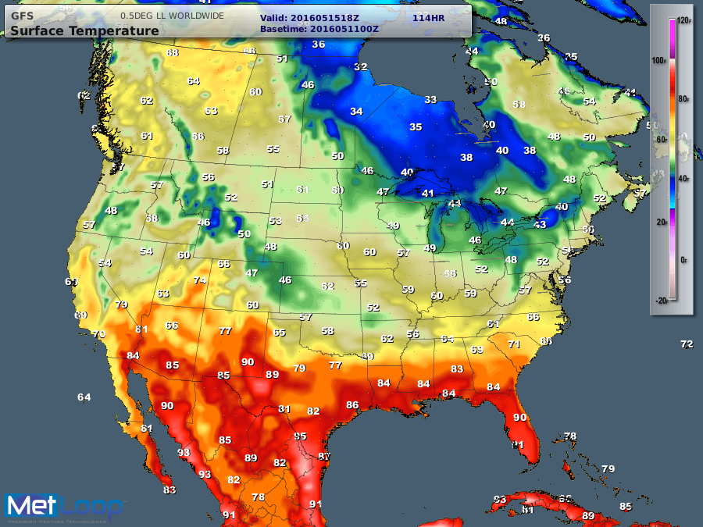
Maximum Temperatures – Sunday, May 15, 2016

It’s more of the same, when it concerns severe weather for the Southeast, specifically Texas. To my family and friends in Texas, make sure you are prepared for more severe weather; the rest of the month looks like it’s going to be a wild ride.

Until tomorrow,

Rocco
Chief meteorologist
MetLoop

