Sports Lighting

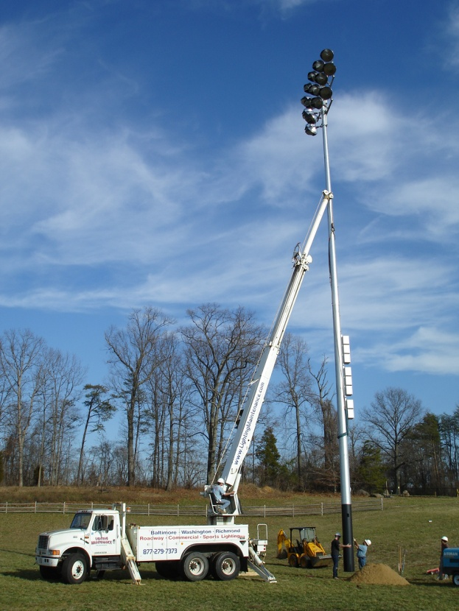
LMI has 3-bucket trucks capable of reaching 100 feet and several employees certified to climb sports lighting poles. We design and install all major manufacturers of sports lighting systems. Sports lighting systems include Tennis, Soccer, Football, Baseball, Softball, Lacrosse, and Multipurpose. 24/7 LMI will respond to any lighting emergency within 2 hours, most often within 60 minutes. Please note that emergency rates apply to all emergency calls regardless of time of call.
