Logo Design Brief: Iconic Jewellery

Hello!
We are looking for an elegant new logo for our luxury jewellery brand, 'Iconic Jewellery’.
Please see the details below and the attached brief for important requirements and examples.
We are looking for a logo that contains both Typography and a Symbol. The combination of typography and symbol can be used separately but would mostly be used together, with the symbol placed to the left of the typography.
Typography example: Cartier
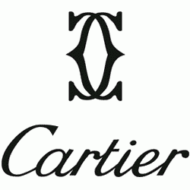
Symbol example: Also Cartier
The logo should work in all the following 3 configurations:
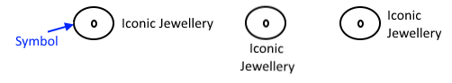
Notes:
- The logo should be balanced on both sides and if possible symmetrical.
- We are looking for a feminine logo and not a masculine logo.
- Style: Softness, chic, curves more than sharp edges. The logo needs to be elegant, minimal and high-end
- The symbol height should be aligned to the text height.
- Note that the logo must work well when shrunk very small. We would like to use our brand colours in the logo (see our website www.iconicjewellery.com) but it must also work well in black and white.
Please enter ORIGINAL ideas, not direct copies of the examples given. Feel free to drop us a message if you have any questions. Thank you!
Ideas and References:
- Background
Iconic Jewellery is a jewellery manufacturer and retailer focused on diamond jewellery and engagement rings.
Target market: Women aged 25-45, located in mainly western but also some Asian countries.
The jewellery we sell is manufactured in Thailand.
- Requirements
Use:
- Both online (website header, as favicon, social media, etc.) and offline (on our packaging, etc.)
- Where logo will displayed on our website:
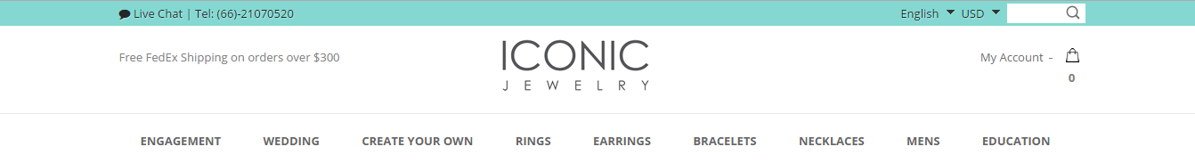
Color Suggestions:
- Solid black (no gradient) and our theme color:
Elements:
- Typography that includes full brand name ‘Iconic Jewellery’
- Abstract symbol
Examples:
Cartier’s 2 logos
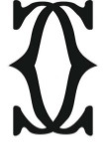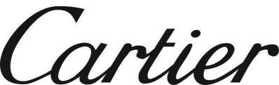
Tacori’s 2 logos
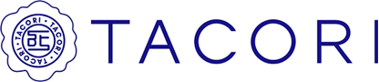
File format and Quality:
- Vector file (.Ai or a like)
- The JPEG files you will send must be high resolution retina image (suitable for retina display)
- Work well if shrunk very small

- The Design
Typography Style:
ELEGANT, MINIMAL, HIGH-END

Below are some references to other jewellery companies and some ideas we like. Please use this as a reference for your creative ideas. Please do not copy from anyone.
Typography Examples
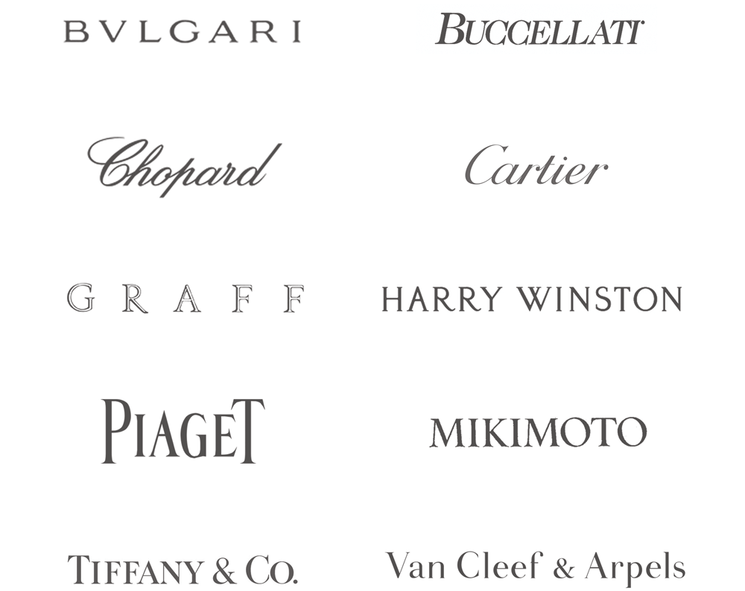
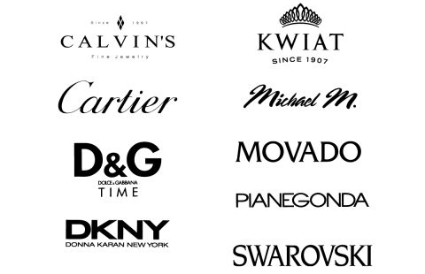
Symbols and logos - Our ideas and examples
Idea 1: Letters from the name ‘Iconic Jewellery’ stylized and flipped to create a design. Can include letter combinations such as: I / I C O C I / I J
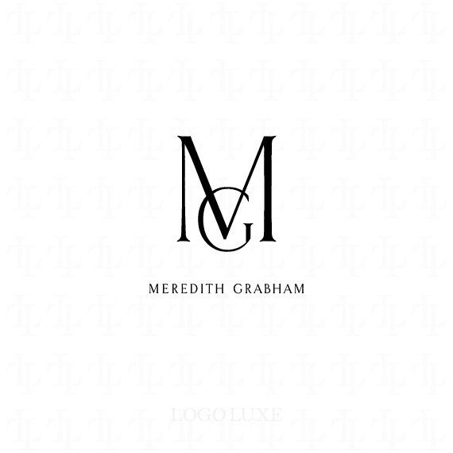
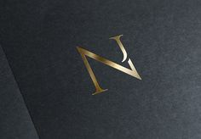

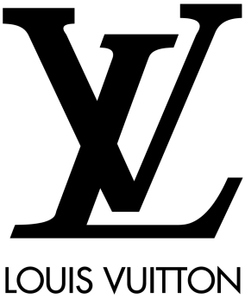
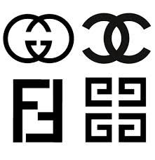
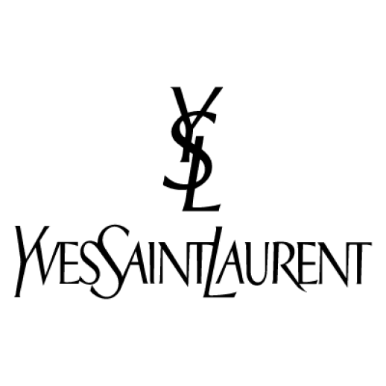

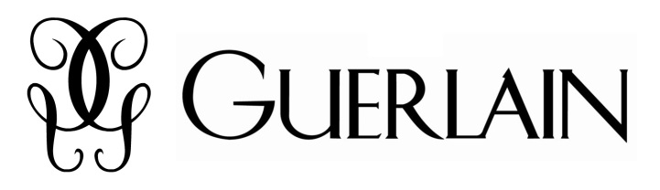

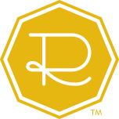
Idea 2: Letter ‘I’ inside a diamond table shape, similar to Ritani logo below (symbol logo on left).
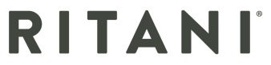

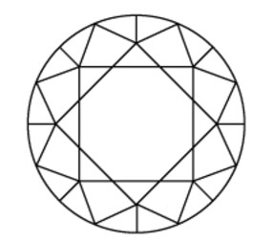
Octagon represents a top view of a round cut diamond:

Idea 3: Use space between letters to create a negative space logo. Suitable shapes to suggest would be:
- Crown
- Heart
- Other feminine shapes
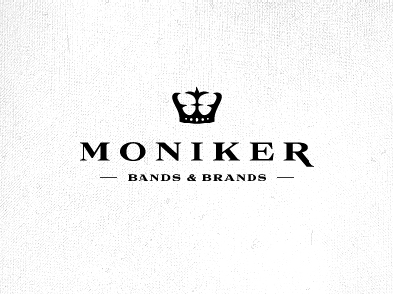
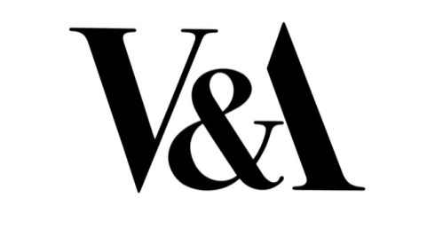
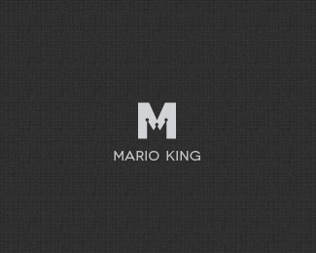
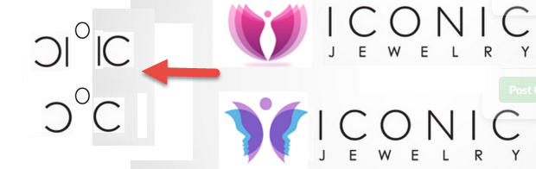

Idea 4: This is our least favorite- using elements of jewellery in the symbol. To us these typical jewellery company logos show poor taste and quality. However, if you have a good idea, we are open to it!
- Ring
- Diamond/s
- Gold
- Shiny metal
- Other ornate things

