Debra Williams
debw@cecnow.com

COMPANY LOGO
COMPANY NAME: Concentric Cognitive Solutions

1) What do you want your new logo to accomplish? Transmit a clear statement about our cognitive solution – that it is about acquiring understanding through thought, experience and the senses.

2) Do you have a tag line? If so, would you like it stated along side your logo? “Unleash the Better You" but it doesn’t necessarily need to be incorporated into the logo. Would be interesting to see some with and some without the tagline.

3) Do you have any specific imagery in mind for your logo? Not really… something abstract like a concentric form ( the IBM Watson logo below is one example of a very simple abstraction) 

4) Do you have any color preferences, or existing brand colors? BLUE and maybe we can incorporate green, bright yellow or bright orange ?

5) Do you have any colors that you do not wish to use? purple, red, pink, brown, beige, rust

6) What feeling or message do you want your logo to convey to those who view it? Deep science, easy use/actionable, and something that comes from the inside out like when you drop a pebble in the water and the ripples get bigger the further out you go. Positive impact that originates from the inside out.

7) How do you prefer your logo to be worded or written out? Not sure about the difference? Is this about using a WORD as the logo itself, like “Coke” does? If so, we would be curious about how to use the words concentric cognitive solutions in the logo design.
One thing to note: there are a few businesses out on the web that use Concentric as part of their name, so if we used the word as part of the logo we wouldn’t want to do it as they have:
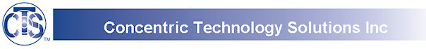

FYI: these are examples of logos that we don’t like - ugly and boring.

Perhaps something more like this:

or something with transparent layers that overlap:

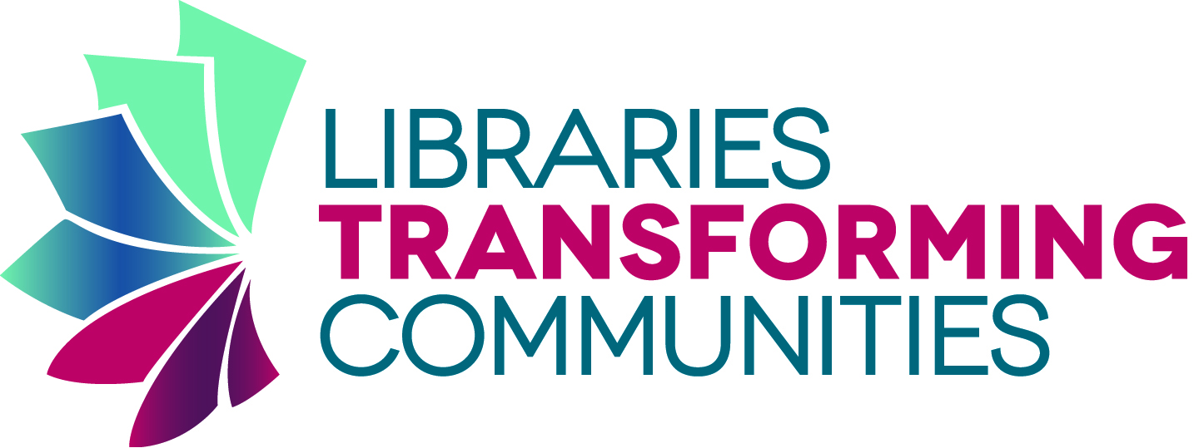

or layers of water color?

8) How would you like the typography to appear?
Example: script, bold, light, hand drawn, custom lettering - let’s see options

9) What’s your preferred deadline, time frame or exact date of completion? ASAP

