Front
**images of product**
Kleppo
Cloth Diaper Sprayer
SLOGAN - STAY GREEN KEEP CLEAN ™

- Includes Brass Sprayer head, metal hose, T-adapter and holder
- Fits standard North American style toilets
- EASY installation – NO plumber or tools needed
- The easy way to clean cloth diapers
- Perfect for personal and feminine hygiene

Side 1
***SIDE 1 CAN LOOK LIKE THIS EXAMPLE 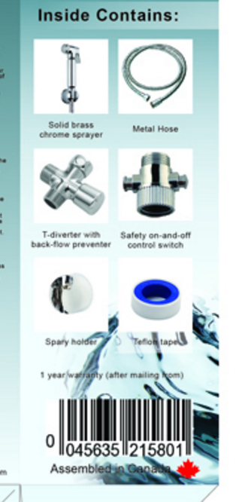

Inside Contains:
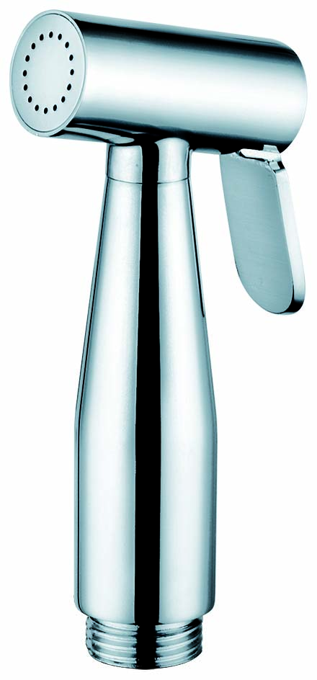 | 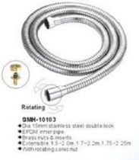
Brass Sprayer Head | 1.5m Stainless Steel Hose
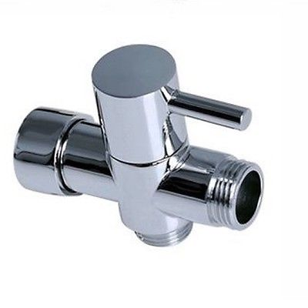 | 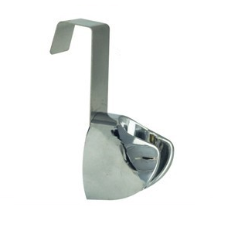
3 Way T-adapter with rubber washer  (Size: 7/8” + 7/8” + ½”) | Sprayer Holder



(this is the actual barcode for the product)
Side 2
LOGO

Back
Installation Instructions:
___________________________________________________________________________
IMPORTANT! Your toilet must have a flexible supply line to install a Kleppo Cloth Diaper Sprayer (Flexible hose not included).

Step 1: Shut off water supply to the toilet by turning the water valve all the way to the right (should be a tap on the wall), flush the toilet and hold down the handle to drain the tank.
Step 2: Disconnect the flexible water supply line from under the toilet tank.
Step 3: Ensure the rubber washer is placed properly inside the top of the 3-way T-adapter before connecting it to the toilet tank. Afterwards, reconnect the flexible water supply line to the bottom end of the 3-way T-adapter (do not overtighten).
Step 4: Ensure that the rubber washers are placed properly on EACH end of the metal hose; attach one end of the hose to the open end of the 3-way T-adapter and the other end to the sprayer head.
Step 5: Lift the toilet water tank lid and hang the sprayer holder over the edge of the tank. Close the toilet tank lid.
Step 6: Turn the water supply line valve back on (the one that was turned off in step 1). Inspect for leaks upon completing installation and again after 10 minutes. Use plumbers tape on any leaking joints.
After following these steps, you are now ready to use your cloth diaper sprayer. The whole installation should take no longer than 10 minutes and should require no tools.
It has never been easier to install a cloth diaper sprayer in your own bathroom.

How to use:
Step 1: Open the T-adapter to allow water to flow.
Step 2: Press the lever to release the water from the sprayer head.
Step 3: Adjust to your desired water pressure by gently turning the handle of the T-adapter whilst holding down the lever on the sprayer.

WARNING! When the sprayer is not in use, please switch the T-adapter off. Failure to do so may weaken the hose or sprayer head. Kleppo is not responsible for damages that may be caused by the failure to follow this warning.

