Logo Brief: Cadence Wealth

What is it? Cadence Wealth delivers cradle to grave financial and lifestyle management for sportsmen and high net worth individuals. They bring everything under one roof: hand holding through critical career decisions; delivering a financial legacy built around maintaining their lifestyle beyond their sporting retirement.

Customers: Sportsmen, and high net worth individuals. Specifically Premiership or Championship footballers, either playing now and looking for sound financial advice or retired and looking for guidance to further their career in a new direction (e.g. Broadcasting). Used to a luxury lifestyle.

The brand: At its core are an independence, integrity and affability that place the client first, all the time, every time.

Symbolism: ‘Cadence’ is a regular beat or rhythm, and in sport it’s the pace and effort put in by the athlete (think steps, revolutions or strokes per minute). Symbolically, we want Cadence Wealth to reflect the constant effort to do the best for the client, whether financially or in their career path.

The logo/identity brief: We need to reflect a professional and trustworthy solidity. We’re not boring. It’s got to feel inspirational, clever and innovative to match up to the knowledge and solutions being delivered. We need a symbol/icon that can be used where the whole mark isn’t appropriate (e.g. social media). Keep it simple. Make it premium to reflect the target market.

Things to avoid:

- Cheap, gimmicky, overly-complicated
- Colour red

Things we like and want to try:

- Colours: blue and grey
- Fonts: lower case, clean and modern. The Dyson brand font is preferable.
- Symbolism: try the infinity icon to reflect the constant effort/work done, stars could play to the clients’ egos and the quality of service. We were also thinking of a sphere instead to symbolize the connection to footballers.
- Can the infinity symbol be moulded into the ‘cadence’ wordmark (at the start using the ‘c’ and ‘a’) – this would negate the need for an accompanying icon, if not this is not an issue at all.

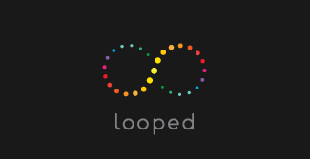
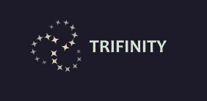

Considerations: Can we get jpeg, png and original ai files in colour and mono. It will need to work on social media as well as larger formats, so if appropriate we may need stacked and landscape versions. We will need the icon files too.
Appendix
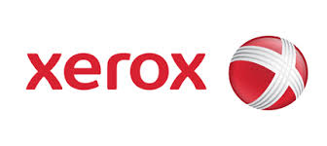
Logos we like…

Xerox ‘x’ icon – simple, clean

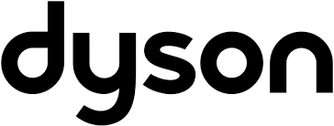

Dyson – modern, bold font

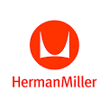

Herman Miller – simple., clean icon with modern font

