Notes on Design 10800291 – 6th May

Panel 1
In the ‘ABOUT OUR SCHOOL’ section, could you please remove the hyphenations in the text in line number 1 and 4. ie. pro-vides and stu-dent

Could you please change the wording in the bullet-points to read:
- is personal and professional;
- trains students to be accountable in their learning; and
- encourages students to be respectful towards others in both their attitude and behaviour.

In the final paragraph could you replace that paragraph with the following:

We encourage you to find out what Nambucca Valley Christian Community School has to offer your family. Please contact the school office so we can organise a tour of the school so that you can see us in action.

Panel 2
no changes needed

Panel 3
Could you change the wording from ‘NEED OF FUNDING SUPPORT’ to ‘We need your financial support’.

Panel 4
In the ‘SUPPORT NEEDED’ section could you please change the wording in the last line from ‘Class Rooms’ to ‘Classrooms’.

Just above the ‘SUPPORT NEEDED’ heading, could you ad the following: ABN 26 139756893

Could you also please replace the photo at the bottom of the three students and the teacher, with this one please.


Panel 5
In the ‘WHO CAN DONATE’ section, could you please remove the hyphenation in the word ‘grandpar-ents’ please.

The work you did on the photo at the bottom of this panel was great, however I’ve just found out that we can’t use that photo. Could you use this photo instead please.


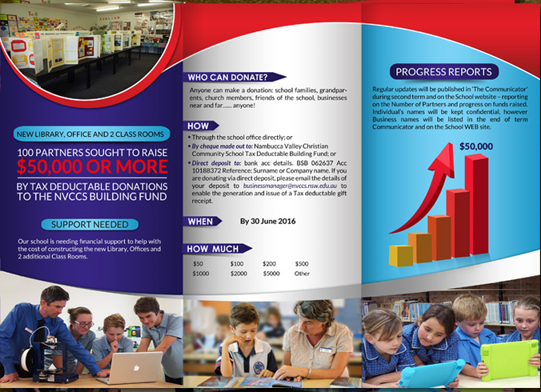




Panel 6
In the ‘PROGRESS REPORTS’ section – could you please change the wording in the last line, from ‘WEB site’ to ‘website’.

