Nambucca Valley Christian Community School
– New Library, Office and 2 Class Rooms
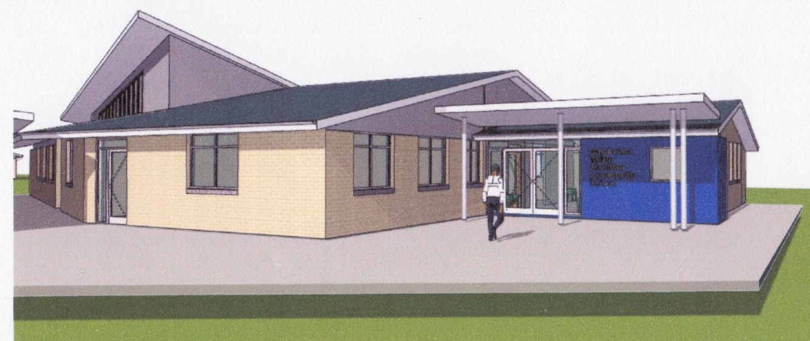
100 Partners sought
To raise
$50,000 or more
By Tax deductable donations to the NVCCS building fund
Towards the cost of the constructing the new Library, Offices and providing 2 additional Class Rooms. The total cost is $1.45m.
WHO School families Grandparents Church members Christian Community Nambucca Valley Businesses Others
WHEN By 30 June 2016
HOW MUCH $100 $200 $500
$1000 $2000 $5000 Other
WHERE Donate:
through the School office directly
or…. By cheque to; NVCCS, PO Box 172, Nambucca Heads, NSW, 2448 by
or…. direct deposit A/C--------------
(name required for Tax deduction)
PROGRESS REPORTS
Number of Partners and progress on money raised will be included in ‘The Communicator’ each week during second term. Individual names will be kept confidential.
Business Names will be listed in the end of term Communicator and on the School WEB site.

