Panel 1
Panel 2
Panel 3
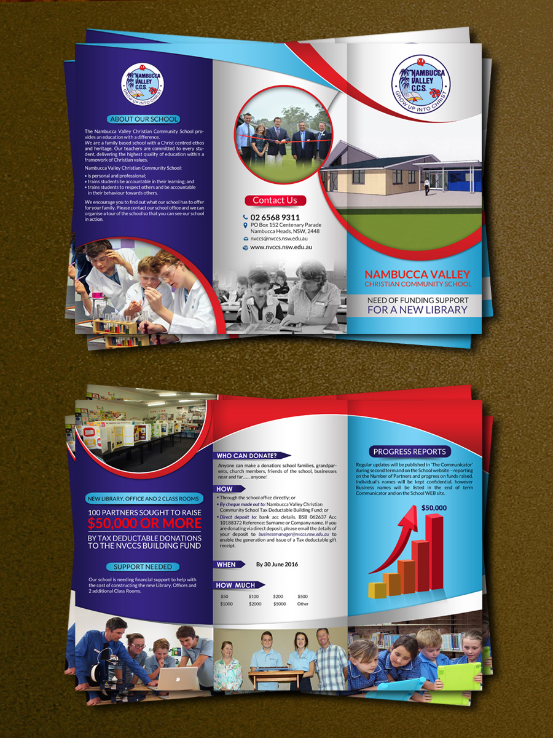

Panel 6
Panel 5
Panel 4

Notes:

Panel 1 – perfect.
Panel 2 – bottom picture needs to revert to the picture of the two girls in black & white
Panel 3 – the picture of the new building needs to move a bit to the right so that not so much of it is on panel 2.
Panel 3 – please remove the line ‘FOR A NEW LIBRARY’
Panel 4 – perfect.
Panel 5 – the picture of the two adults and two students needs to be removed and replaced with the picture of the teacher and student that currently is on the bottom of panel 2 (though it can be in colour in its proper location – and if you’re able to blur the background a little and focus more on the teacher and student that would be great)
Panel 6 – perfect.

