“Jodi Goldman” Website Design Requirement +Mockups

Elements on each page

1) “Jodi Goldman” logo on menu bar in a ‘handwritten’ style font:

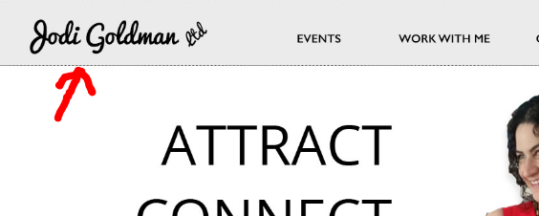

2) Menu bar and menu headings...We are undecided on the colour of the bar:

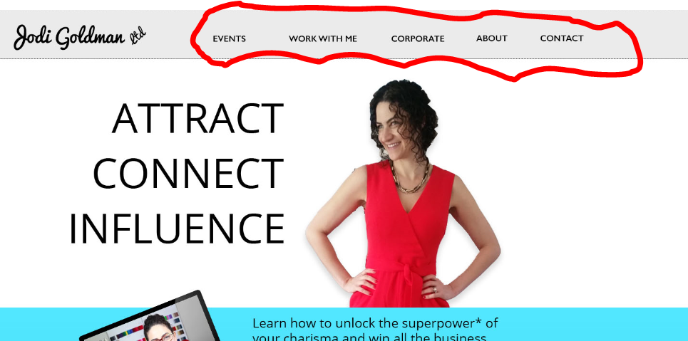

3) Banner (NB page width = 1920)

There will be slightly different banners on each of the main site pages. The banners will be fashion-shoot style photographs of Jodi, taken against an all white background in a photographic studio. In each one she will be wearing a red outfit (like in the mockup) and may be interacting with the words in the banner in some way. We are looking for the style of the text that will go over these banners: there will be lots of white space to put the text over.

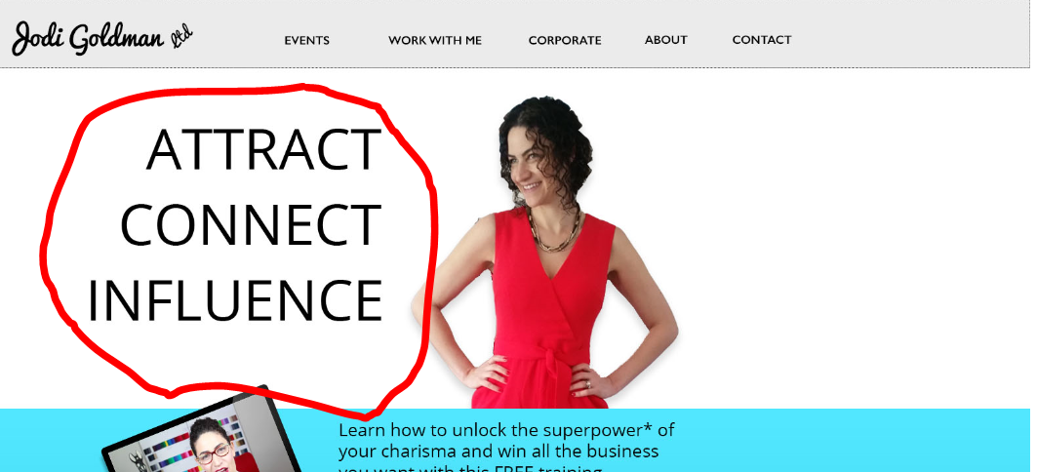

4) Sign up strap

Underneath the banner there will be a sign-up strap. Text: ”Learn how to unlock the superpower* of your charisma and win all the business you want with this free training.” Then somewhere on the strap there is a “*” and next to it, small text “Promise to only use your powers for good.” The image will probably be a laptop with a still from Jodi’s free training video on it.

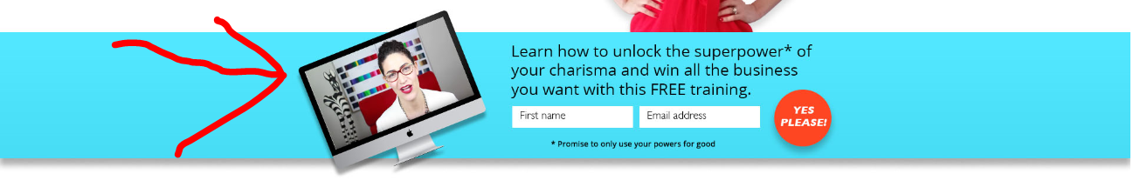

5) Footer

A footer with some text, a newsletter sign-up and social media buttons. Text: “Hey! Don’t go without signing up because you’ll miss out on exclusive offers, awesome tips, and weekly motivation in my fab newsletter*.” Then somewhere on the strap there is a “*” and next to it, small text “And that’ll make me sad :-(”

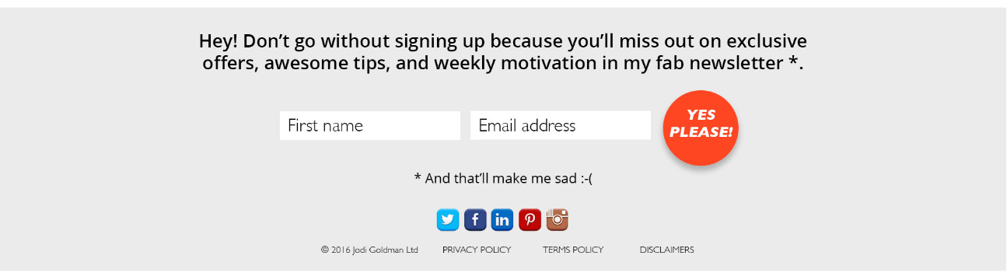

Different page content (there are 4 different page types)
1) Blog Pages (Home page and individual blog pages)

a) The area where Jodi’s blog will go. We want to use a content area on the left and a sidebar on the right. Something like below:
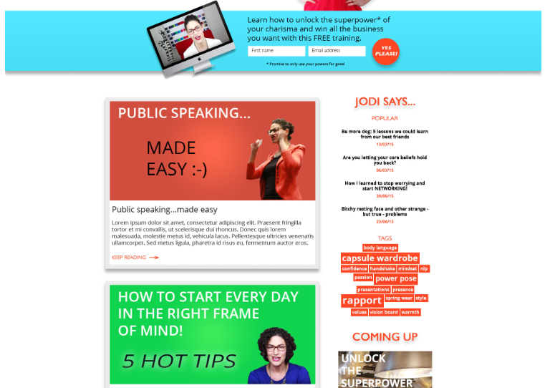
We are looking for the width of the content / blog area (compared to the sidebar width) to be designed and defined. We would also like a little gap between each blog. And obviously the font(s) for use in the content, header styles etc…and any background colouring or styling behind the content (i.e. if the blog sits on a light grey or coloured panel of some kind) etc. It’s up to you. Would prefer webfonts of some kind.

b) The sidebar will contain a simple graphic plus text widget for promoting things on other pages of the site:
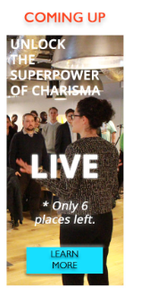
What we need is the text and styling that we could use…so that we could just put pictures underneath and edit the text. We really like this kind of thing:
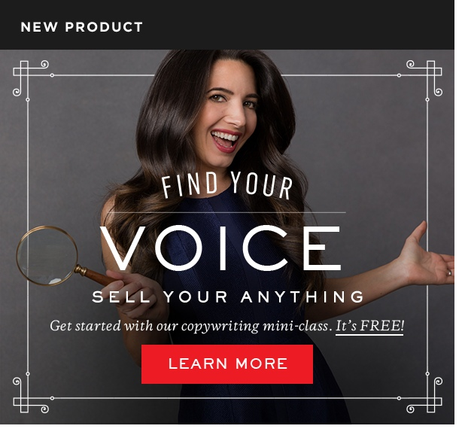
2) Product Pages (“Events”, “Work with me”, “Corporate” page)

a) Product pages feature a promotion for an event / course like below:

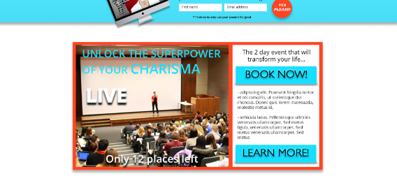
We are basically looking for a much better design than the mock-up above!

b) They also have a testimonial area

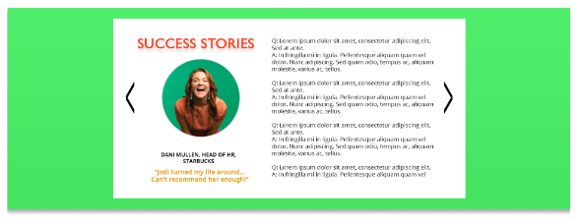
We are basically looking for a much better design than the mock-up above!

c) And they also have a bottom bar as opposed to a sidebar

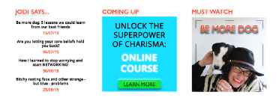

What we need is a plain version of the promotional widget (like the middle widget above) maybe just using one or two strong colours and text in a plain but forceful way.
3) About Page

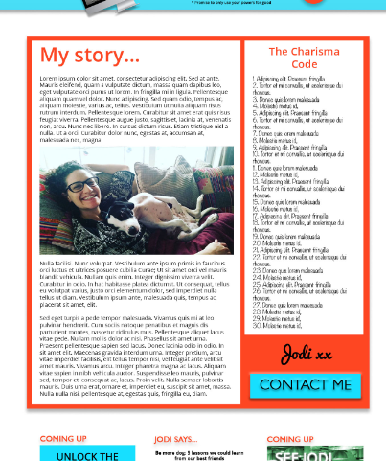

We are basically looking for a much better design than the mock-up above!

4) Contact page

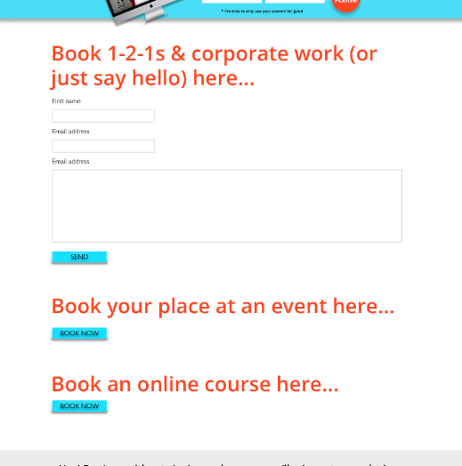

We are basically looking for a much better design than the mock-up above!

ROUGH MOCKUPS on following pages:

