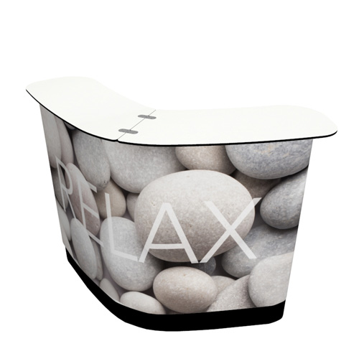


Solid or gradient background?

See http://www.displayit.com/accessories/replacement-graphics/counter-graphics/large-convertible-case-to-counter-replacement-graphic.aspx for more details.

Engineering  - Instrumentation  - Process Control  - Utility Connections (Gas, Water, Power, Wastewater)  - Technology Infrastructure  Integration  - Instrumentation  - Control Systems  - Process Optimization  - Human-Machine Interfaces | Connected Services  - Remote Monitoring  - Real-time Visibility  - Alarm & Event Tracking  - Automated Reporting  - System Performance  Operations Support  - On-call Troubleshooting  - Root Cause Analysis  - System Reconfiguration  - Management of Change

