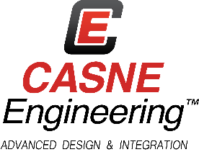

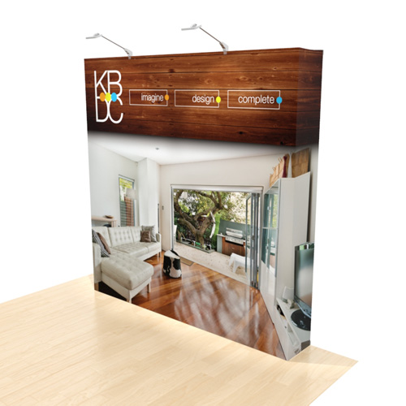
Tagline Example (please wordsmith this):
“Making Good Beer Better with Clarity Connected Services”
All art should be 100 dpi built in CMYK. See http://www.displayit.com/8-10-wide-displays/graffiti-wall-system/8-foot-flat-graffiti-wall.aspx#templates for more details
Stainless steel background?
Improve Situational Awareness  Bridge across multiple information silos and achieve seamless visualization of the operation  Real-time Visibility  Facility wide line visibility across multiple equipment types and production areas  Improve Productivity  Arm operators and brewers with the tools they need to solve problems  Enjoy Cost Savings  Reduce hold time by tracking product specifications and eliminate needless discarded product | Maximize People Power  Reduce time spent on manual tasks and free up people for higher value activities  Improve Quality and Consistency  Eliminate costly errors and improve repeatability and consistency.  Conform to Standards & Regulations  Track product history and improve specification limits for DO, CO2, and Turbidity.  Track Your Success  Implement meaningful key performance indicators and create and track performance targets.

