IN THE FRONT:

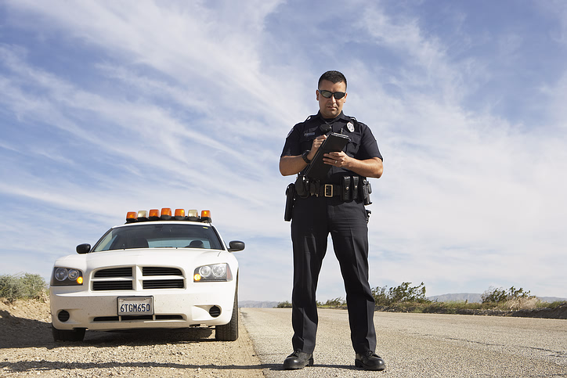

Please switch out the bottom left picture for this picture instead.
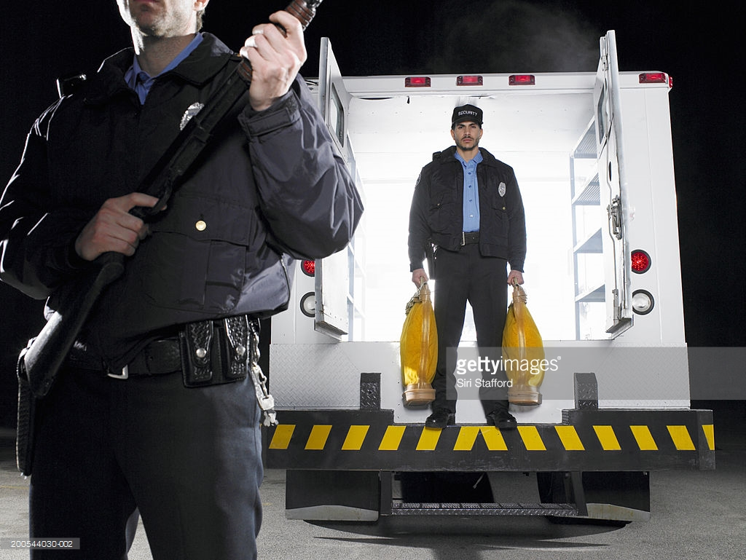

Please switch out the top right picture for this picture instead. Please hide the gettyimages logo.
Then, swap the new top right picture and the bottom right picture (pic of 2 officers facing glowing lights) so that the new picture (the one above) is now in the bottom and the other (pic of 2 officers facing glowing lights) is on top.

IN THE BACK:
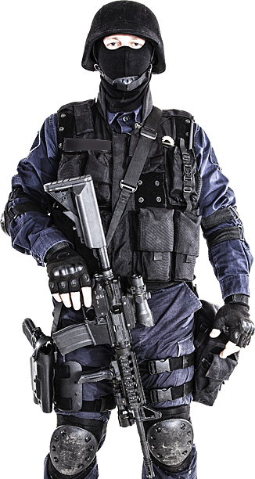

Please place this picture in the background of the package information, centered, instead of the package logos provided

