

“We give you savings or we give you $500”

Free home loan health check with a GBHL lending adviser!

Terms and conditions
- Our Give Back policy is where the savings start
All calculations of savings include GBHL Give Back policy of 0.15% on the running balance of your loan.

- At least $300,000 loan
Your current loan size needs to be a minimum of $300,000.

- Must be local and in person.
Your appointment must be within 35km of Melbourne CBD and face-to-face with a GBHL adviser.

- The client must currently reside there.
Your current loan must be for the home you currently reside in.

- Must be with Big 4 home loans only ANZ, CBA, NAB or WBC branded home loans
Must be a big four loan easily accessible by the public.

- Must be an owner occupied loan with a Variable Rate and principal interest repayments
All three of the above criteria must be met (GBHL specifically exclude investment loans, fixed interest and interest only loans.

- The loan must be at least 30 months old.
Must be at least 30 months since day of settlement.

- The dot point design should look like this down the bottom
And our licensee details in tiny print down the bottom

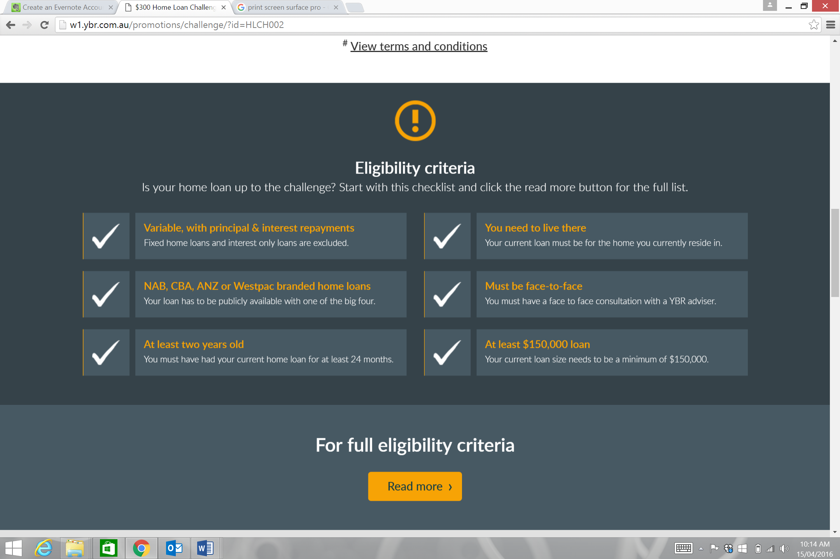

A Life Well Planned Lending Pty Ltd Trading As Give Back Home Loans ABN 22 163 508 905, Authorised Representative of Australian Finance Group ABN 11 066 385 822, Australian Credit License 389 087.

- The dot point design should look like this down the bottom
