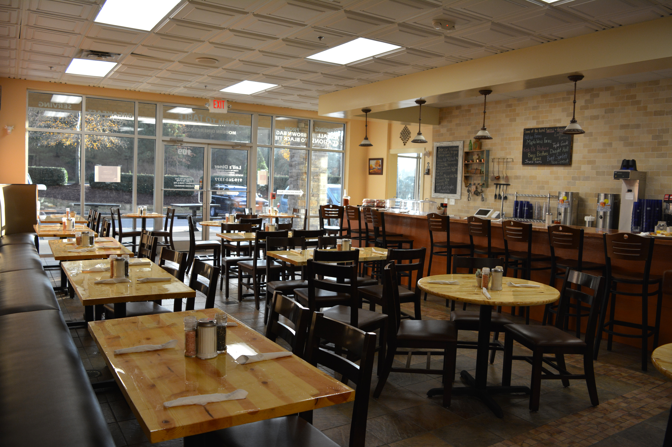


Food Provided By

Leli’s Diner

Farm to Table Modern Diner

The Spring Sale
  - Lorem Ipsum Dolor Sit Amet
www.lelisdiner.com
919-263-1377
3325 Rogers Road Wake Forest NC 27587

