Qualitas Insurance Group Website Rough Draft

Home Page
Qualitas Insurance Group has joined with regional & national insurance companies to provide quality products and superior service. We take the time to discuss options and coverages, not to just sell insurance products. We strive to educate you in the decision making process to become an informed consumer.
We specialize in commercial business & personal insurance. We are committed to providing personal attention to all your insurance needs.
At Qualitas Insurance Group, we are independent insurance agents. As independent agents, we do not work for any one insurance company; we sell coverage from several different companies. This allows us to focus on providing you with the right amount of insurance and the right type of coverage for your unique needs.

About Us
Established in 2015, Qualitas Insurance Group is a full service independent insurance agency. Our licensed agents have the experience to custom tailor a program to meet your specific needs & our professional support staff will provide you with top notch customer service to help ease the burden of managing your insurance program.
We have established relationships with carriers in order to offer you the most competitive products and services available in the marketplace today.
We look forward to working with you!

Agents
Insert > Picture of Nick
Insert > Nick’s Bio to include education and insurance experience with info regarding any professional memberships etc.

Qualitas Insurance Group Mission Statement
????
Qualitas Insurance Group is committed to providing the best risk management solutions to fit each client’s unique needs. This includes providing creative solutions as if we were seeking insurance for our own family.

Contact Us
We are located in the Marina Lake Business Park in Miami, Florida
4960 SW 72nd Avenue, Suite 211
Miami, FL 33155

Phone: (305) -
Fax: (786) 513-2823

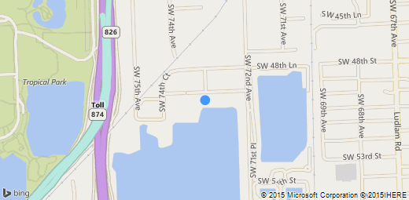
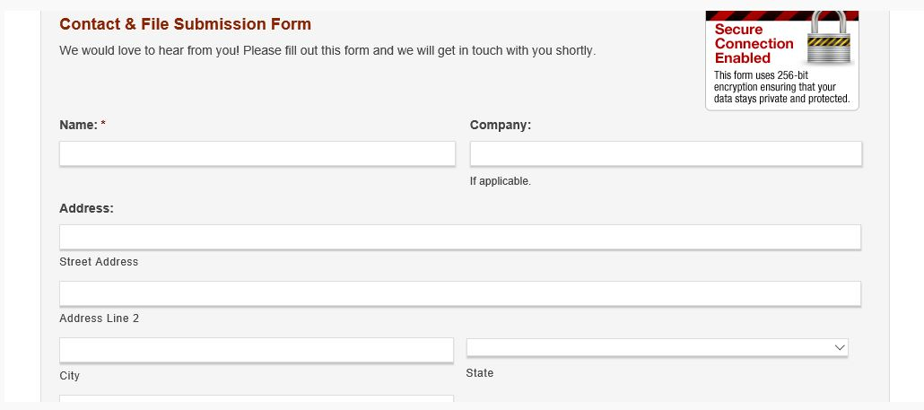
Please prepare a contact us box where a prospective client can input their information and click submit which will email us their information.
See Example to the left.
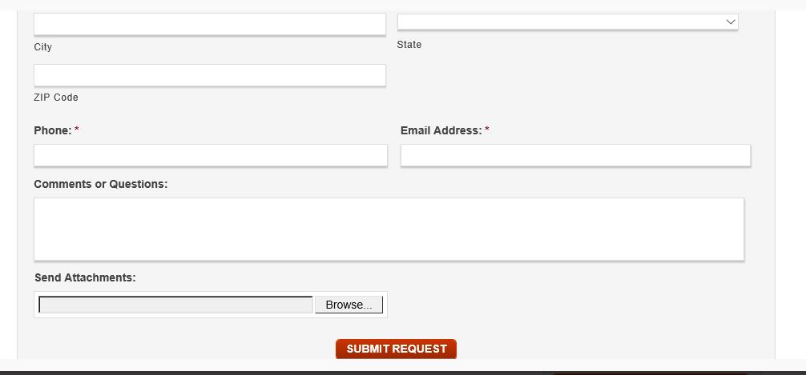

Products and Services Page
Qualitas Insurance Group is a one stop shop for all of your personal and business insurance needs. With our established relationships and market knowledge, we will tailor an insurance program specifically designed to meet your needs.
As an independent insurance agency, we are able to provide you with a wide variety of plans and carriers.
Qualitas Insurance Group represents top insurance carriers in the marketplace.
Click a link below to learn more about the different types of insurance we offer.
Business Insurance (Link to Business Insurance Page with links to a definition page for each type)
Personal Insurance (Link to Personal Insurance Page with links to a definition page for each type)
> Input logos of companies we will be representing here <

See example below of page the above Personal Insurance and Business Insurance link should take you to. Once you click the hyperlink for each coverage, it will take you to another page which will explain that particular insurance type. We will need a page like the below for both Personal and Business Insurance. See below definitions for each link needed for each category.
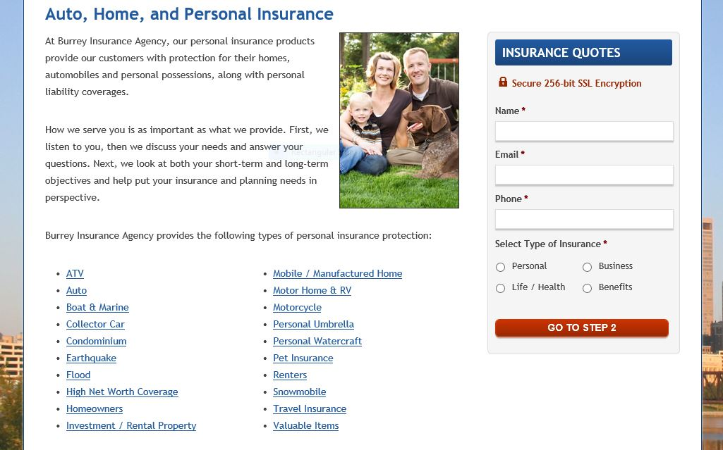

Business Insurance Page

Protecting Your Business is Our Priority.
Qualitas Insurance Group can help you take steps to protect your business and your family from the financial consequences of events that could disrupt operations, reduce profits, or even cause the business to go bankrupt.
We know what questions to ask, what risks need to be identified, and most importantly, we understand how to best insure them.
Business insurance is a risk management tool that enables businesses to transfer the risk of a loss to an insurance company. Business Insurance protects your business against the possibility of sustaining a much larger financial loss. All businesses need to insure against risks—such as fire, theft, natural disaster, legal liability, automobile accidents, and the death or disability of key employees—but it is especially important for small business owners. Your life savings may be tied up in the company.
Qualitas Insurance Group provides the following types of business insurance coverage:
Click a link below to learn more about the different types of business policies that are available
Bond
Builders Risk
Business Owners Policy (BOP)
Commercial Auto
Crime
Crop / Hail
Difference in Conditions
Directors and Officers (D&O)
Employment Practices Liability
Errors & Omissions (E&O)
Equipment Breakdown
Garage
General Liability
Inland Marine
Liquor Liability
Medical Malpractice
Owners and Contractors Protective Liability (OCP)
Professional Liability
Property
Truckers
Umbrella
Workers Compensation / Employer Liability

Personal Insurance Page
One size rarely fits all. Neither do standard personal insurance products. At Qualitas Insurance Group, we strive to understand your needs and provide tailored solutions. We present all viable options and equip you with the information you need to make informed decisions.

Your Personal and Family Assets are Our Priority

Our Personal Insurance Department provides tailored coverage for your home, autos, boats, and personal and liability protection.
Qualitas Insurance Group provides the following types of personal insurance coverage:
Click a link below to learn more about the different types of personal policies that are available
Auto
Boat & Marine
Collector Car
Condo
Flood
High Net Worth
Homeowners
Rental and Investment Property
Mobile Home
Motor Home
Motorcycle
Personal Umbrella
Recreational Vehicles
Renters
Travel
Valuable Items

Business Insurance Links below

Commercial Property (link)
Property insurance is an insurance policy for businesses and other organizations that insures against damage to their buildings and contents due to a covered cause of loss, such as a fire. The policy may also cover loss of income or increase in expenses that results from the property damage (PD).

Windstorm / Hurricane Coverage
Florida law requires property insurance policies to include coverage for damage caused by wind during a storm that the National Hurricane Center declares to be a hurricane. Policyholders are eligible for premium discounts for installing certain wind resistant features on their homes. Policies may include a separate deductible applicable specifically to damage caused by a hurricane.
The Florida legislature created a state run insurance safety net, Citizens Property Insurance Corporation, to provide insurance to homeowners who cannot find insurance in the private market. The legislature also created a state administered reinsurance program (a reinsurer insures insurance companies) called the Florida Hurricane Catastrophe Fund to provide a stable and ongoing source of reimbursement to insurers for a portion of their catastrophic hurricane losses.
“Hurricane coverage” is coverage for loss or damage caused by windstorm during a hurricane. It includes ensuing damage to the interior of a building, or to property inside a building, caused by rain, snow, sleet, hail, sand, or dust if the direct force of the windstorm first damages the building, causing an opening through which rain, snow, sleet, hail, sand, or dust enters and causes damage.
“Windstorm” means wind, wind gusts, hail, rain, tornadoes, or cyclones caused by or resulting from a hurricane that results in direct physical loss or damage to property. “Hurricane” means a storm system that has been declared to be a hurricane by the National Weather Service's National Hurricane Center. A hurricane includes the time period (1) beginning when the National Hurricane Center issues a hurricane watch or warning for any part of Florida, (2) continuing for the time period during which the hurricane conditions exist

Business Income
Commercial property insurance covering loss of income (AKA Business Income or BI) suffered by a business when damage to its premises by a covered cause of loss causes a slowdown or suspension of its operations. Coverage applies to loss suffered during the time required to repair or replace the damaged property. It may also be extended to apply to loss suffered after completion of repairs for a specified number of days. There are two business income coverage forms: the business income and extra expense coverage form and the business income coverage form without extra expense. Business income coverage is also referred to as business interruption coverage.
Extra Expense: Commercial property insurance that pays for additional costs in excess of normal operating expenses that an organization incurs to continue operations while its property is being repaired or replaced after having been damaged by a covered cause of loss. Extra expense coverage can be purchased in addition to or instead of business income coverage, depending on the needs of the organization.

Formula for determining business income payment:
(Did / Should) X Loss = Ultimate BI Payment
– Did: The amount of business income insurance actually purchased by the insured;
– Should: The estimated 12-month business income exposure (taken from “J.1.”) MULTIPLIED BY the Coinsurance Percentage Chosen (either the “maximum coinsurance percentage” or something lower); and
– Loss: Compensable business income (which is not the same as “insurable income”) lost during the particular “period of restoration.”
7 Steps for Determining Business Income
- Add together the money brought in from sales or services. Only include revenue that the business has earned and received, not income that is expected or accounts receivable. The result is the company’s gross revenue.
- Calculate the money that the company does not expect to collect, returns and allowances. This could be from accounts unsuccessfully recovered through collection, returns or refunds.
- Sum up the various kinds of inventory and operating expenses. This includes the cost of goods sold, salaries and overhead. Do not include the cost of inventory that has yet to be sold.
- Calculate asset depreciation. If the business has assets such as machinery, tools and furniture that will be used for a long period of time, it can spread its costs over the life of the asset. There are several methods for calculating depreciation, such as straight-line and expedited. Discuss with an accountant the best method to use for your business’ specific circumstances.
- Add up the company’s expenses with the additional expenses. The result of these two numbers is the company’s total expenses.
- Total the amounts computed for Steps 2, 3, 4 and 5 to come up with the total expenses.
- Subtract the company’s total expenses from the gross revenue. This final number is the company’s net income, or business income.

Difference-in-conditions (DIC) insurance (link)
A Difference in Conditions policy is designed to broaden coverage by providing additional limits of coverage for specific perils when standard markets won't provide adequate limits of coverage, providing coverage for perils that are excluded on standard coverage forms, or supplementing international policies that are written by admitted insurers in the applicable foreign countries.
An all risks property insurance policy that is purchased in addition to a commercial property policy to obtain coverage for perils not insured against in the commercial property policy (usually flood and earthquake).
An endorsement to a contractor's blanket builders risk insurance policy that fills the gaps between a policy provided by the project owner and the contractor's policy so that the contractor has insurance comparable to what it would have had if coverage had been arranged under the contractor's builders risk program. When a project owner elects to provide the builders risk coverage for all parties with an insurable interest, the project is normally removed from coverage under the contractor's policy. A DIC endorsement typically states that, to the extent a loss is not covered under the owner-provided policy but would be covered under the contractor's policy, coverage will apply on an excess basis.
An insurance policy that is designed to fill the gaps between the coverage provided by a multinational organization's master insurance policies (property or liability) and coverage provided by policies purchased locally in accordance with each country's insurance requirements so that the organization has uniformity of coverage regardless of location. This policy is referred to as a foreign DIC policy.

Business Owners Policy (AKA BOP) (link)
A Business Owners Policy is a package policy that provides both property and liability coverage for eligible small businesses. BOPs are written on special coverage forms that are generally very similar to their monoline property and liability form counterparts, but they typically have some unique features that make them especially advantageous for businesses that qualify.

Commercial Auto (link)
The entire portfolio of coverage forms that furnish auto coverage for any type of commercial entity. It includes the business auto, business auto physical damage, garage, motor carrier, and truckers’ coverage forms.

Umbrella Liability Policy (link)
An Umbrella policy is designed to provide protection against catastrophic losses. It generally is written over various primary liability policies, such as the business auto policy (BAP), commercial general liability (CGL) policy, watercraft and aircraft liability policies, and employers’ liability coverage. The umbrella policy serves three purposes: it provides excess limits when the limits of underlying liability policies are exhausted by the payment of claims; it drops down and picks up where the underlying policy leaves off when the aggregate limit of the underlying policy in question is exhausted by the payment of claims; and it provides protection against some claims not covered by the underlying policies, subject to the assumption by the named insured of a self-insured retention (SIR).

Workers Compensation and Employer Liability Policy (link)
The system by which no-fault statutory benefits prescribed in state law are provided by an employer to an employee (or the employee's family) due to a job-related injury (including death) resulting from an accident or occupational disease.
This policy provides coverage for an employer's two key exposures arising out of injuries sustained by employees. Part One of the policy covers the employer's statutory liabilities under workers compensation laws, and Part Two of the policy covers liability arising out of employees' work-related injuries that do not fall under the workers compensation statute.

Coverage Requirements For Florida Employers
- Construction Industry: An employer in the construction industry who employs one or more part or full-time employees must obtain workers' compensation coverage. Sole proprietors, partners, members of a limited liability company (LLC) who owns at least 10% of the business, and corporate officers are considered employees. Corporate officers, and members of an LLC who own at least 10% of the business, may elect to exempt themselves from the coverage requirements of Chapter 440, F.S.
A construction industry contractor, who sub-contracts all or part of their work, must obtain proof of workers' compensation coverage or a Certificate of Election to be Exempt from all sub-contractors, prior to work being done. If the sub-contractor is not covered or exempt, for purposes of workers' compensation coverage, the sub-contractor's employees shall become the employees of the contractor. The contractor will be responsible to pay any workers' compensation benefits to the sub-contractor and its employees.
- Non-Construction Industry: An employer in the non-construction industry, who employs four or more part or full-time employees, must obtain workers' compensation coverage. Corporate officers and members of an LLC who own at least 10% of the business are considered employees, unless they elect to exempt themselves from the coverage requirements of Chapter 440, F.S. Sole proprietors and partners in the non-construction industry are not considered to be employees unless they elect to be employees. The Notice of Election of Coverage, form DWC 251, must be submitted to the Division. Once approved the individual is considered an employee until a Revocation of Election of Coverage, form DWC 251-R is filed with, and accepted by the Division.
- Agricultural Industry: Agricultural employers with six or more regular employees and/or 12 or more seasonal employees, who work for more than 30 days, must obtain workers' compensation coverage for those employees.
- Out-of-State Employers: Any construction industry employer having one or more part- or full-time employees performing work in Florida is required to obtain a Florida policy through a Florida-licensed insurance company. The company must use the Florida job classification codes, approved manual insurance premium rates, rules, and manuals prior to beginning work in Florida. If the construction industry employer has an out-of-state policy, the insurance company must be licensed in Florida, and Florida must be listed in Section 3A of the policy. A Non-construction industry employer is required to obtain a Florida policy through a Florida-licensed insurance company once it has 4 or more employees working in Florida.
- Extraterritorial Reciprocity: Out-of-state employers whose home jurisdiction has in its statute an "extraterritorial reciprocity" clause allowing temporary employees from another jurisdiction (including Florida) to work under the "home state's" workers' compensation policy is permitted to work in Florida using the workers' compensation policy from their "home state", as long as the work is temporary in nature. Temporary is defined as no more than 10 consecutive days with a maximum of 25 total days in a calendar year. For a current list of the jurisdiction who have an extraterritorial reciprocity statute you may visit www.cbs.state.or.us/external/wcd/compliance/ecu/etsummary.html.

Use the below link to apply for a workers compensation exemption if you meet the critieria.
https://apps.fldfs.com/bocexempt/#b

Commercial General Liability (link)
General Liability is a standard insurance policy issued to business organizations to protect them against liability claims for bodily injury (BI) and property damage (PD) arising out of premises, operations, products, and completed operations; and advertising and personal injury (PI) liability.

Professional Liability (link)
Professional Liability is a type of liability coverage designed to protect traditional professionals (e.g., accountants, attorneys) and quasi-professionals (e.g., real estate brokers, consultants) against liability incurred as a result of errors and omissions in performing their professional services. Although there are a few exceptions (e.g., physicians, architects, and engineers), most professional liability policies only cover economic or financial losses suffered by third parties, as opposed to bodily injury (BI) and property damage (PD) claims. This is because the latter two types of loss are typically covered under commercial general liability (CGL) policies. The vast majority of professional liability policies are written with claims-made coverage triggers. In addition, professional liability policies contain what are known as "shrinking limits," meaning that unlike CGL policies (where defense costs are paid in addition to policy limits), the insurer's payment of defense costs reduces available policy limits. Accordingly, when attempting to determine appropriate policy limits, insureds must consider the fact that because defense costs are often a high proportion of any claim settlement or judgment, they must usually purchase additional limits. The most common exclusions in professional liability policy forms are for BI, PD, and intentional/dishonest acts.

Errors and Omissions Insurance (AKA E&O) (link)
Errors and Omissions insurance protects the insured against liability for committing an error or omission in performance of professional duties. Generally, such policies are designed to cover financial losses rather than liability for bodily injury (BI) and property damage (PD).

Medical malpractice insurance (link)
Medical malpractice insurance provides coverage for the acts, errors, and omissions of physicians and surgeons, encompassing physicians professional liability insurance, hospital professional liability (HPL) insurance, and allied healthcare (e.g., nurses) professional liability insurance. Although the majority of policies are written with a claims-made coverage trigger, such coverage is sometimes available on an occurrence basis. Typical exclusions are for: intentional/criminal acts, punitive damages, sexual misconduct, and specialized procedures (e.g., radial keratotomy) for which coverage may be "bought back" in return for additional premium. In addition to commercial insurers, medical malpractice coverage is also available in most states through physician-owned insurance companies known as "bedpan mutuals."

Bond (link)
A Bond is a three-party contract under which the insurer agrees to pay losses caused by criminal acts (e.g., fidelity bonds) or the failure to perform a specific act (e.g., performance or surety bonds). The principal (i.e., the party paying the bond premium) is also called the obligor (i.e., the party with the obligation to perform). If there is a default, the surety (i.e., the insurer) pays the loss of the third party (the obligee). The obligor must then reimburse the surety for the amount of loss paid.

Builders Risk Policy (link)
A Builders Risk Policy is a property insurance policy that is designed to cover property in the course of construction. There is no single standard builders risk form; most builders risk policies are written on inland marine (rather than commercial property) forms. Coverage is usually written on an all risks basis and typically applies not only to property at the construction site, but also to property at off-site storage locations and in transit. Builders risk insurance can be written on either a completed value or a reporting form basis; in either case, the estimated completed value of the project is used as the limit of insurance.

Crime policy
A crime insurance policy that is designed to meet the needs of organizations other than financial institutions (such as banks). A commercial crime policy typically provides several different types of crime coverage, such as: employee dishonesty coverage; forgery or alteration coverage; computer fraud coverage; funds transfer fraud coverage; kidnap, ransom, or extortion coverage; money and securities coverage; and money orders and counterfeit money coverage.

Crop-hail insurance (link)
Crop and/or Hail insurance is a policy that covers hail damage to insured crops. Farmers often purchase this coverage in areas of the country susceptible to hail, particularly for high-yielding crops. Unlike federal crop insurance, the federal government does not subsidize crop-hail insurance. Licensed insurance agents sell it and the premiums depend, for a large part, on past loss experience. The coverage is township or county rated; in other words, the rate is determined by the historical hail loss experience of that particular township or county. The perils of fire and wind can be added to this coverage; although the availability of these extensions varies by state and by type of crop.

Directors and officers (D&O) liability insurance (link)
Directors and Officers Insurance is a type of liability insurance covering directors and officers for claims made against them while serving on a board of directors and/or as an officer. D&O liability insurance can be written to cover the directors and officers of for-profit businesses, privately held firms, not-for-profit organizations, and educational institutions. In effect, the policies function as "management errors and omissions liability insurance," covering claims resulting from managerial decisions that have adverse financial consequences. The policies contain "shrinking limits" provisions, meaning that defense costs—which are often a substantial part of a claim—reduce the policy's limits. This approach contrasts with commercial general liability (CGL) policies, in which defense is covered in addition to policy limits. Other distinctive features of D&O policies are that they: (1) are written on a claims-made basis, (2) usually contain no explicit duty to defend the insureds (when covering for-profit businesses), and (3) cover monetary damages but exclude bodily injury (BI) and property damage (PD).

Employment practices liability insurance (EPLI) (link)
Employment practices liability insurance is a type of liability insurance covering wrongful acts arising from the employment process. The most frequent types of claims covered under such policies include: wrongful termination, discrimination, sexual harassment, and retaliation. In addition, the policies cover claims from a variety of other types of inappropriate workplace conduct, including (but not limited to) employment-related: defamation, invasion of privacy, failure to promote, deprivation of a career opportunity, and negligent evaluation. The policies cover directors and officers, management personnel, and employees as insureds. The most common exclusions are for bodily injury (BI), property damage (PD), and intentional/dishonest acts. EPLI policies are written on a claims-made basis. The forms contain "shrinking limits" provisions, meaning that insurer payment of defense costs—which are often a substantial part of a claim—reduce the policy's limits. This approach contrasts with commercial general liability (CGL) policies, in which defense is covered in addition to policy limits. Although EPLI is available as a stand-alone coverage, it is also frequently sold as part of a management liability package policy. In addition to providing directors and officers (D&O) and fiduciary liability insurance, management liability package policies afford the option to cover employment practices liability (EPL).

Equipment breakdown insurance
Equipment breakdown insurance provides coverage for loss due to mechanical or electrical breakdown of nearly any type of equipment, including photocopiers and computers. Coverage applies to the cost to repair or replace the equipment and any other property damaged by the equipment breakdown. Resulting business income and extra expense loss is often covered as well. Equipment breakdown insurance is increasingly replacing traditional boiler and machinery (BM) insurance, in part simply because the title is more descriptive of the coverage provided. Also, today's equipment breakdown policies typically provide slightly broader coverage than traditional BM policies, and they usually do not use the specialized terminology found in traditional BM policies.

Garage liability insurance (link)
Garage Liability is insurance covering the legal liability of franchised and non-franchised automobile, truck, truck-tractor, motorcycle, recreational vehicle, and trailer dealers for claims of bodily injury (BI) and property damage (PD) arising out of business operations. It includes two separate insuring agreements, "who is an insured" provisions, and "limit of insurance" provisions—one dealing with garage operations involving the ownership, maintenance, or use of autos and the other dealing with all other garage operations.

Inland Marine insurance (link)
Inland Marine insurance is a form of property insurance for property in transit over land, certain types of moveable property, instrumentalities of transportation (such as bridges, roads, and piers, instrumentalities of communication (such as television and radio towers), and legal liability exposures of bailees. Many inland marine coverage forms provide coverage without regard to the location of the covered property; these are sometimes called "floater" policies.

Liquor Liability Insurance (link)
Liquor Liability is a common law liability imposed on those selling alcoholic beverages, as well as the statutory liability established in some states, which is excluded in general liability policies.

Host liquor liability
Liability for bodily injury (BI) or property damage (PD) arising out of the serving or distribution of alcoholic beverages by a party not engaged in this activity as a business enterprise. Host liquor liability exposures are insurable under standard general liability policies.

Owners & contractors protective (OCP) liability coverage (link)
OCP coverage is a stand-alone policy that covers the named insured's liability for bodily injury (BI) and property damage (PD) caused, in whole or in part, by an independent contractor's work for the insured. The contractor purchases the policy to provide coverage for vicarious liability the client (project owner) incurs as a result of the contractor's acts or omissions on the project. The OCP policy also responds to liability arising out of the insured's own acts or omissions in connection with its general supervision of the contractor's operations.

Truckers policy (link)
A Truckers Policy is a commercial auto policy designed to address the needs of the “for-hire” motor carrier (i.e., trucking) industry. Coverages available include auto liability, trailer interchange, and auto physical damage; other coverages are available by endorsement.

Personal Insurance Links below

ATV Insurance (link)
ATV insurance is very similar to motorcycle insurance. All-terrain vehicles are three, four or six-wheeled buggies used off-road. 4×4 insurance has the same basic coverages included in the motorcycle insurance policy, tweaked for the needs of off-road enthusiasts.

Personal Auto Insurance (link)
Florida law requires residents of Florida to have car insurance. You must purchase the minimum coverage amounts for both personal injury protection (PIP) insurance and property damage liability (PDL) car insurance.

Florida Auto Insurance Requirements
Florida is a no-fault insurance state. If you are injured in an accident, your car insurance will pay your medical costs up to your policy's limits, regardless of who caused the accident.
The minimum limits for Florida car insurance coverage are:
- $10,000 of no-fault or personal injury protection (PIP) insurance.
- $10,000 of property damage liability (PDL) insurance.

Personal Injury Protection
In addition to covering your part of any medical expenses and income loss that result from a car accident, your Personal Injury Protection, or PIP, insurance will also cover:
- Your child and other members of your household.
- Your child (when he or she is riding on a school bus).
- You (when you are a pedestrian or bicyclist involved in a car accident.)
- Passengers in your car who do not have their own PIP insurance and do not own a car.
Anyone in your car who has PIP car insurance will be covered by his or her own policy if you get in a car accident. Likewise, your PIP car insurance will cover you while you are a passenger in someone else's car.

Property Damage Liability
Property Damage Liability (PDL) auto insurance in Florida will cover you for damages you cause in a car accident to someone else's property, such as homes or buildings.

Boat & Marine Insurance (link)
Boat or Marine insurance is available for small boats, yachts, high performance powerboats, live-aboard houseboats, catamarans, or pontoons. Marine insurance will cover intended use including personal recreation, commercial, or charter vessels.
Boat policies can cover damage to your boat, motor, trailer, and personal effects in the boat. Available coverage includes liability, medical payments, and injury to a water skier and damage to the boat itself, sometimes called hull coverage. Availability varies by state and by insurance company. Even though boat insurance premiums are low, shopping your rate can sometimes save a substantial amount.

Collector Car Insurance (link)
Your collector car is one of your most prized possessions and represents real commitment to your time and resources. Protect it now the right way with Agreed Value Insurance which gives you a 100% of the Agreed Value of your car. In the event of a total loss, that agreed upon value is the payout amount. The deductible of course applies, but there is no depreciation and no misunderstanding.

Coverage highlights
- Agreed value loss settlement
- Broad usage allowance
- Mileage plans include unlimited miles
- Date and specific time of the loss
- Deductible options from $0 to $10,000
- Flexible payment options
Classic cars are usually considered antique vehicles (15 – 20 years old or older). Collector cars can also include: Exotic autos new and old, Muscle cars, Sports cars of all ages, Rare or desirable.
We understand what collector car owners want and need to protect their investment.

Condominium Insurance (link)
There are three approaches used for condominium insurance coverage. Under the "all inclusive" or "all-in" coverage, the condominium association master policy covers all real property in a residential condominium structure, including fixtures in individual units and any structural improvements, betterments, or additions that the individual unit owner has made. It provides coverage to replace a unit to the condition it was in at the time of the loss. With this approach, the unit owner is responsible for covering only his or her personal property under the HO 6 or unit owners’ form. The other two methods to coordinate this coverage are the "single entity" coverage and the "bare walls" coverage. The condominium association rules and covenants typically specify which approach is required.
Bare Walls Coverage
Under a "bare walls" approach, the condominium association insures only the bare structure of the individual condominium building; the structure, fixtures, and furnishings of collectively owned areas; and the collectively owned personal property of the association. Under this methodology, individual unit owners are responsible for insuring building property they own and use exclusively, such as sinks, built-in cabinets, appliances, flooring, and wallpaper (along with any improvements and betterments) in their individual units under the homeowners (HO) 6 or unit owners form.
Single Entity Coverage
Under a "single entity" approach, the condominium association master policy covers virtually all real property in a residential condominium structure, including fixtures in individual units. Note that this coverage does not include any structural improvements, betterments, or additions that the individual unit owner has made. With this approach, the unit owner is responsible for covering only his or her personal property (along with any improvements or betterments) under the HO 6 or unit owners’ form.

Flood coverage (link)
Since standard homeowners insurance doesn't cover flooding, it's important to have protection from the floods associated with hurricanes, tropical storms, heavy rains and other conditions that impact the U.S.
Coverage for damage to property caused by flood. May be available by endorsement to an all risks policy or to a difference-in-conditions (DIC) policy. Normally, the coverage provided is subject to a per occurrence sublimit, an annual aggregate limit, and a separate deductible.
If your home sits in a 100-year flood plain, you must buy federal flood insurance in order to get a mortgage. If you live outside a high-risk zone, or if you no longer have a mortgage, flood insurance is optional.
To determine if you live in a high risk flood area visit: https://www.floodsmart.gov/floodsmart/
The Number One Misconception is that homeowners insurance covers flood risk. The fact is that homeowners insurance policies typically DO NOT cover flood damage, a point usually highlighted in bold letters on the first page of your homeowners policy.
The Second Misconception is that flood insurance policies are expensive. Actually, if your home or business is located in a Preferred Risk Zone as determined by FEMA, you can purchase flood insurance for as little as $129 per year.
The Third Misconception is that many homeowners think they don’t live in a flood zone. In reality, FEMA has designated the entire state of Florida as a flood zone with varying levels of risk.
An elevation certificate is required to obtain flood insurance. A Flood Insurance Elevation Certificate is a documentation which was initially developed by the Federal Emergency Management Agency which acts as a proof to authenticate the height and elevations of the buildings that are built. This certificate is a must and an absolute necessity for buildings, especially those which are built in areas which are prone to flood risks.
This document, or rather the certificate form is usually completed by the land surveyor of the area or it can be done by any engineer who is a professional. The insurance rate of the building depends entirely on the information that is provided in the Elevation Certificate of the building. This certificate is mostly required by lenders and those who buy locations and apply for flood coverage insurance.

High Net Worth Individual Insurance Coverage (link)
High net worth individuals require coverage that goes beyond the typical, off the shelf insurance plan. That is why we offer concierge level service and fully customizable insurance plans to satisfy your specific needs.
Our high net worth coverage includes provisions for primary and secondary residences, private collections, identity theft, and even kidnap and ransom. When it comes to replacing the lost income of high earners, traditional insurance plans are insufficient. Stop jeopardizing your family’s financial well-being and contact us now to find out how high net worth coverage can assure that everything you’ve worked for will be protected.

Homeowners policy (link)
A Homeowners policy is a package insurance policy providing property and liability coverages tailored to the needs of most home owners, condominium owners, and apartment tenants. Various versions are available depending on the type of dwelling insured and the scope of protection to be covered. It is the most commonly used insurance policy protecting homes in the United States.
Different Types of Homeowners Insurance:
- HO-1: This is a limited policy offering wide coverage to selective items mentioned in the policy. They do not insure valuable objects as painting in the home. This policy is not offered commonly because the agent selling it would be open to an errors and omissions claim for not providing a better policy knowing that one existed at the time you purchased coverage.
- HO-2: Alike HO-1 policy, this policy also covers limited section of the house against damage. They also mention the potential risks against which the house will be insured. This policy is also referred to as “named peril” policy.
- HO-3: Called “open perils” policy this is the most commonly written policy covering all the aspects the house, its structures and belongings in addition to the liability protection and additional expenses. This is a common homeowner’s policy today. The kind offered in most cases when you say "I need a home owner’s policy".
- HO-4: This policy is specific to renters and apartment dwellers who do not own the unit they reside in. Definitely a bargain, you should not be without this policy if you rent an apartment, condo, townhouse, or just the basement of someone's home. Their policy will not cover your belongings and likely they will disclaim any knowledge of your residing there should a loss occur. It usually includes a liability component to protect you from lawsuits for covered incidents.
- HO-5: This policy for home only covers the homeowners, their assets and all liabilities arising from visitors or passers-by. Unlike HO-3 this policy provides wider coverage on various happenings and losses. This wider coverage comes at a much greater cost.
- HO-6: Known as “Condominium Coverage” this policy is particularly designed for the condos owner. The part of the building owned by the insured and the included property are covered under this policy. In most condominiums, you own everything attached to the walls- the counters, the sink, the cabinets, shades, wallpaper, etc. You must take additional coverage called "additions and alterations" to be protected for these items as the standard condo policy only covers a few thousand dollars.
- HO-8: This policy provides benefits to homeowners with higher replacement cost than the market value by ensuring them at minimal market value rate. Hence this policy is aptly known as “older home” insurance policy. A manor house from the 1800's would commonly have a policy such as this since the craftsmanship is far outside todays stick standards.

Rental & Investment Property Insurance (link)
You will need specific insurance policies for the following types of properties: Commercial Investment, Commercial Property, Vacant Property & Land, Rental Home, and Residential Investment.
Investment property insurance is the first thing you purchase when you invest in rental property. When owning a rental property you want to make sure that you are covered against all hazards. You need first to own a landlord's policy. This type of rental Insurance can protect you from loss of income if your property becomes un-rentable due to fire or damage. Most policies do not cover normal wear and tear by a tenant but can protect you from major accidental damage.
If you are planning to rent out your home for a long period of time, such as six months or a year, to one person, couple or a family, you will likely need a landlord or rental dwelling policy. Landlord policies generally cost about 25 % more than a standard homeowner’s policy because landlords need more protection than a typical homeowner. If you are renting out a vacation home or investment property, this would also require a landlord or rental dwelling policy.
Landlord policies provide property insurance coverage for any physical damage to the structure of the home caused by fire, lightning, wind, hail, ice, snow or other covered perils. It also offers coverage for any personal property you may leave on-site for maintenance or tenant use, like appliances, lawnmowers and snow blowers.

The policy also includes liability coverage; if a tenant or one of their guests gets hurt on the property, it would cover legal fees, due to injury claims, and medical expenses.

Most landlord policies provide coverage for loss of rental income in the event you are not able to rent out the property while it is being repaired or rebuilt due to damage from a covered loss. This coverage is generally provided for a specific period of time.

Mobile Home Insurance (link)
Mobile Home Insurance is a specialized form designed to meet the unique needs of mobile home or manufactured housing owners. It provides coverage comparable to the homeowners’ policy, including property, loss of use, and premises and personal liability. In some cases, coverage is granted via a mobile home endorsement to the standard homeowners’ policy. In other cases, a stand-alone mobile home policy is used to provide coverage.

Motor home policy (link)
Motor Home Insurance is a specialized form designed to meet the unique needs of recreational vehicle owners. It provides coverage such as liability, personal injury protection (PIP) or medical payments, uninsured/underinsured motorists (UM/UIM), and physical damage including protection for attached accessories, roadside assistance, emergency expense, and personal effects. In addition, the policy can be tailored to those individuals and families who live in their motor homes on a full-time basis (full-timers coverage).

Motorcycle insurance (link)
Motorcycle Insurance is designed to provide appropriate coverage for a variety of motorcycles and related vehicles, such as trikes, mopeds, scooters, dirt bikes, all-terrain vehicles, Segway® personal transporters, golf carts, and snowmobiles. A motorcycle is typically defined as (1) a two-wheel land motor vehicle with wheels in tandem (including an attached side car) that is designed primarily for use on public roads or (2) a three-wheel land motor vehicle designed primarily for use on public roads. Although motorcycles can be added to the personal auto policy (PAP), coverage gaps can result. Several insurers have developed this insurance for motorcycle owners, which reduces or eliminates these gaps. Some insurers also have specialty policies for off-road cycles, such as dirt bikes.

Personal umbrella policy (link)
Personal Umbrella Insurance provides high limits of liability to protect an insured against a catastrophic liability loss. This policy grants liability coverage that stacks on top of the primary liability coverage provided by the insured's homeowners, personal auto, watercraft, and any other scheduled underlying liability policies. It covers bodily injury (BI), property damage (PD), and personal injury (PI), which includes offenses such as libel, slander, false arrest, invasion of privacy, and others. The umbrella policy also fills some gaps in coverage over a specified deductible (often called a retained limit) in the underlying policy.

Renters Insurance (link)
As a tenant, you will want to obtain coverage to cover your belongings should a loss occur at the location in which you rent property. The landlord’s insurance policy only affords coverage on the structure itself and your financial interest in it. Your personal possessions are not covered under the landlord’s policy. Many landlords require a tenant to buy renters insurance before signing a lease.

Travel insurance (link)
Travel insurance provides indemnification for (1) trip cancellation or interruption; (2) theft of, or loss to, property such as jewelry, cameras, baggage, or passports while on the trip; and (3) emergency medical and dental expenses during the trip. Travel insurance may be procured from travel agents or directly from certain insurers.

Personal Articles Floater / Valuable Items Insurance (link)
A personal lines inland marine policy is used to cover scheduled personal property on an all risks basis. The policy is particularly appropriate for property that receives limited coverage under the homeowners’ forms, such as furs, jewelry, fine arts, silverware, cameras, musical instruments, stamp and coin collections, and similar property. Coverage is also sometimes afforded in homeowners policies by endorsement.

