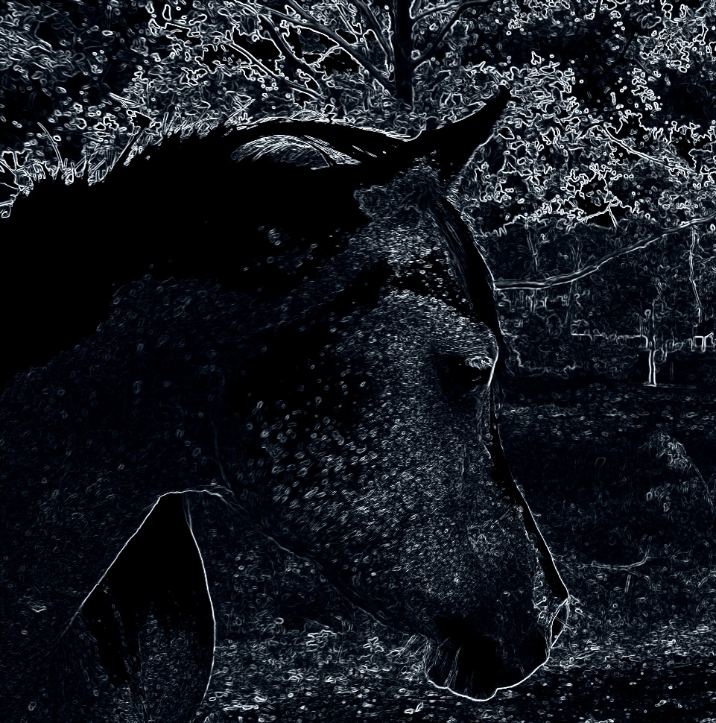
Keldan’s Ridge

Horse Spelling

