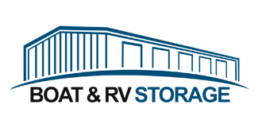
Logo Examples

Like hangar structure – looks too much like mini storage with all the doors.

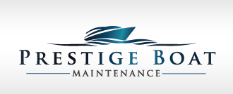
Like the integration between logo and name, polished

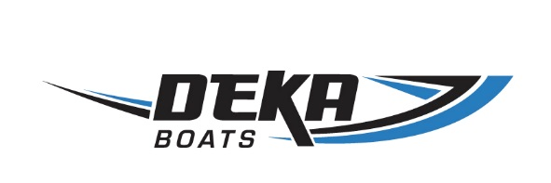
Clean and fresh – good name and logo integration



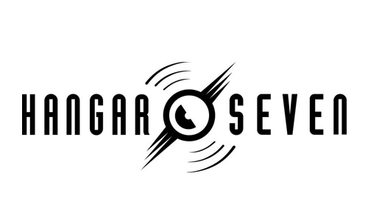

Like hangar theme – change aviation to boat

Trendy feel



Like hangar theme, simple, strong, classic



Classic


Too old school not fresh, scale is off with coastal and boat stuff – just wanted to show integration between hangar and boat industry

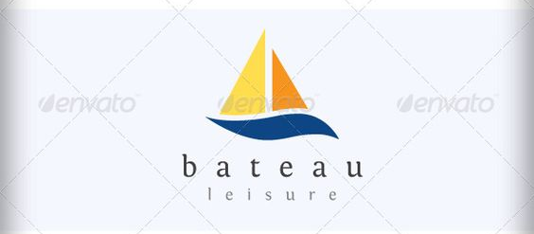
Simply, clean –sailboats are not really our target, but very universal sign for boats – may work.

Simple, clean
