Labelling Requirements
The following shall appear on the packaging of the lighting products mentioned above*:
- The new label in bilingual or separate English and French format.
- The following text, preferably underneath the label:
"To save energy and money, choose the bulb that has the desired brightness and then select the one with the higher efficiency."
"Pour économiser énergie et argent, choisir une ampoule en tenant d'abord compte de la luminosité désirée, puis du niveau d'efficacité le plus élevé."
- The model number of the lamp, placed in a clear visible manner.
- Voltage - If the design voltage of a lamp is other than 120 volts, the data on the label displayed on the principal display panel of its package should correspond to a voltage of 120 volts, with the words "at 120 volts / à 120 volts" above the label.
* NRCan is considering entering into voluntary agreements with manufacturers/dealers to allow the use of this label on product that is outside the scope of the Regulations. This would be allowed under certain conditions (i.e. product is in a third party energy efficiency certification program for the labelled values).
The bilingual label will have to be displayed on the principal panel of the packaging containing the lamp. In cases where there are two principal panels - English and French being treated separately - use English only and French only labels on the appropriate panel.
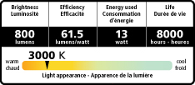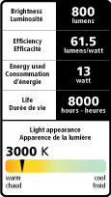
Label templates will be provided by NRCan in horizontal or vertical options along with instructions on where to place the "Light Appearance" indicator and fields that allow data entry. The templates will be provided in Adobe Illustrator File (CS3) and PDF formats (not for editing purposes). The existing coloured (4 colour process) light appearance scale on the templates must be respected.
The templates are provided in the size at which they should appear on the package. However, they can be enlarged to accommodate larger packaging and can also be reduced up to 20% to fit smaller packaging.
CRI (Colour Rendering Index) is optional, but if it is included, the following label templates must be used.
