Losev™
LED Downlight
Dimmable 4” , 8W
50W Replacement
Light Output- 640 lumens
Life- 50,000 hours
Energy Used – 8 watts
Warm White – 3000k
Energy Savings* - $231
Uses 84% Less Energy**
*Electricity savings based on using this LED for 50,000 hours (rated life) at $.11per KWh compared to using 50W halogen lamps for 50,000 hours . This represents a 84% savings.
**The reduction in wattage from 50W to 8W represents a 84% savings

Leave a space for the bottom row of this picture. The PNG file is coming. Might be Ok on the top flap of the package
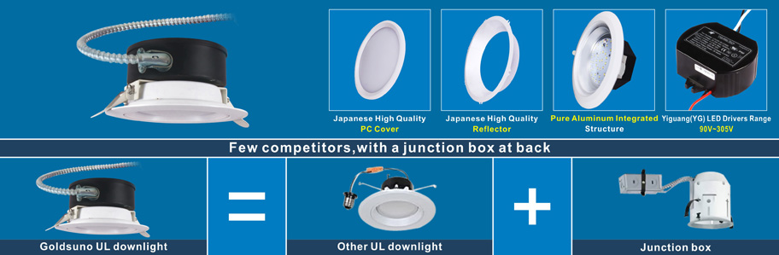



Suitable for Wet locations
Warranty: This lamp has a 5 year warranty. If it fails or you are not satisfied with its performance, contact Losev Electronic Design for instructions on lamp replacement. This replacement is the sole remedy available and liability for incidental or consequential damage is expressly excluded. Do not return the bulb to the store.
Caution: Use only on 120 volt 60Hz circuits. Suitable for damp locations. Minimum starting temperature is -20⁰C.When installing, make sure that power is switched off before installing. Do not look directly into the light. Compatible with most dimmers including Levitron and Lutron. Dimmable to 5% with most dimmers. For more information including dimmer compatibility, visit lwww.osev.com.

Losev Electronic Design Ltd.
Guelph, Ont, Canada
N1G 5J1
Made in China/Fabriqé en China
www.losev.com

Leave a space for the UPC on the bottom of the package.

Cutout size
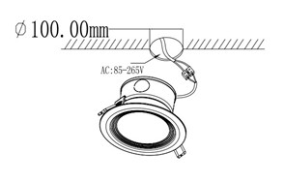
Installation
