5 Sections on the page
Section 1. About us
Section 2. Services
Section 3. How it Works/benefits
Section 4. How we work
Section 5. Contact Form
Section 6. Contact Us

Section 1. About us
About US:
Oryx Solar is a newly established division of the TerraStruc Group to focus on installation and maintenance of solar energy systems.
We are members of the Clean Energy Business Council and the Middle East Solar Industry Association.
TerraStruc is a privately owned, multi-disciplined company that has been in operation since 1998. The group includes TerraGreen, an integrated technologies solutions provider to the construction, oil & gas, mining, aerospace and agricultural sectors.
Oryx Solar enjoys the full support of TerraStruc and TerraGreen resources in order to provide turnkey PM-EPC services (Project Management, Engineering, Procurement and Contracting).
Our mission is to lead the rooftop revolution of the MENA region.

Section 2. Services
What We do: (Intro for “services”)
Oryx Solar designs and install customized renewable energy systems to cater for the specific needs of our clients. We size systems according to current electrical loads, availability of space and/or budget.
Oryx Solar provides turnkey solutions. Functioning as part of the TerraStruc group we have access to all design, procurement, management and labour resources necessary to complete your project 100% in-house.
Before we start, we provide you with Perspective Drawings, Production Estimates, Savings Estimates and Return on Investment (ROI) calculations. We do this in order for you to make an informed decision about your investment.

We pride ourselves in:
- Giving honest advice and realistic savings estimates
- Great customer service, start to finish.
- Installing only top quality, internationally recognized brands
- High quality workmanship
- Speed and precision of installations
- Excellent Health & Safety record. We maintain a strict HSE policy regardless of the size of the job.
- Being flexibility to accommodate our client’s specific needs

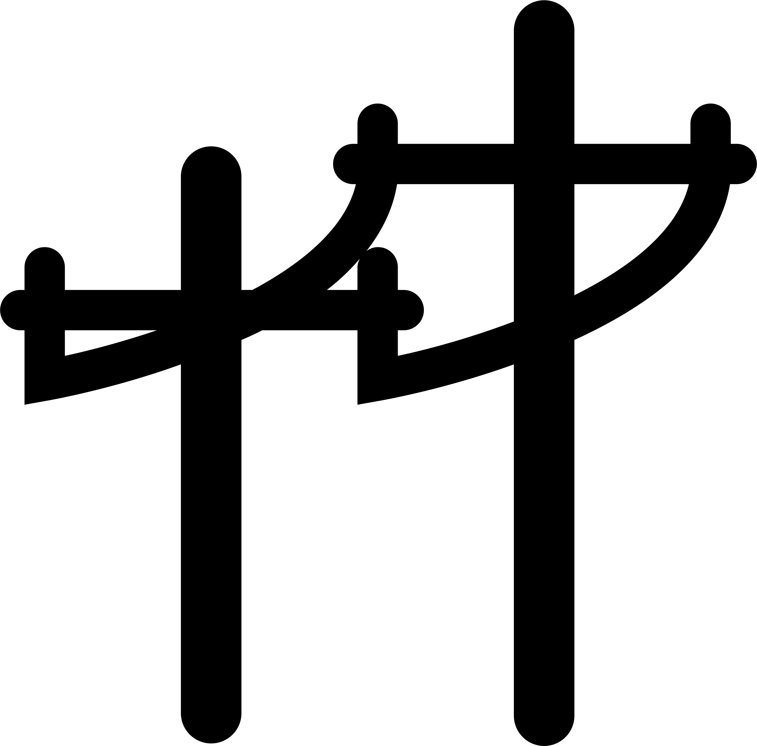Services: (Please insert icons to go with each item, some suggested icons added)
- Grid Connected Residential & Commercial systems:
Working with the goal of making rooftop solar available to all, we design and install small-medium sized systems for residential and commercial use.
We provide you with the opportunity to be part of the change and reap the benefits of solar right at home.

- 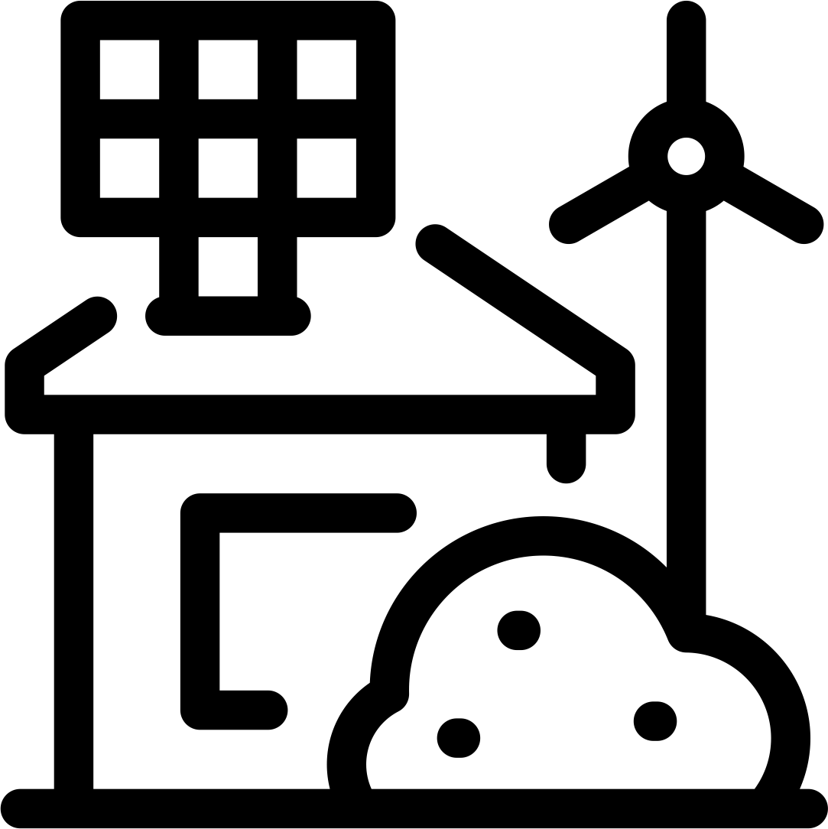Off-Grid:
We provide off grid solar and hybrid (solar + diesel electric generator) solutions for labour camps, temporary sites, desert camps or for any other remote areas. Oryx Solar also provides various solar lighting solutions to best suit your needs.
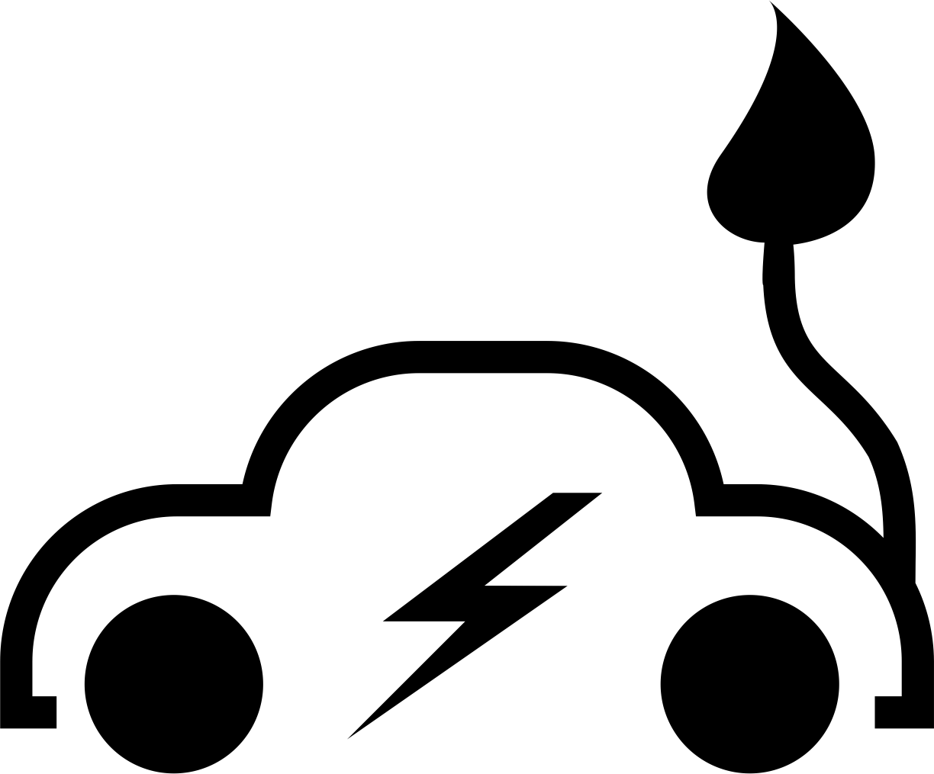
- EV Charging Solutions (Electric and Solar):
As the popularity of electric vehicles rises, Oryx Solar can supply various EV charging solutions. We are currently also exploring the exciting prospect of solar charging EV’s.

- Energy Efficiency Audits:
Adding renewable energy to your home/business is great, but not all buildings are able to accommodate a renewable energy source. We can advise on other changes, additions and controls to implement in order to reduce your overall electricity consumption.

- Maintenance of PV Plants:
We provide regular PV module cleaning and maintenance service packages tailored to your needs. This is a service we can provide for any existing or new Solar PV installations.

- Remote Monitoring in Real-Time:
We provide solutions to remotely monitor and track production of your solar systems. As a client you can see, in real-time, the output of your own system online.
This also enables us to track all installations and automatically send maintenance/cleaning teams when the need arises, or notify our clients of any problems with their systems. Daily, weekly or monthly reports on system performance can be generated as part of after-sales service.

Section 3. How it Works
(Use Infographic – Also Uploaded to DC)

How Grid tied solar works:
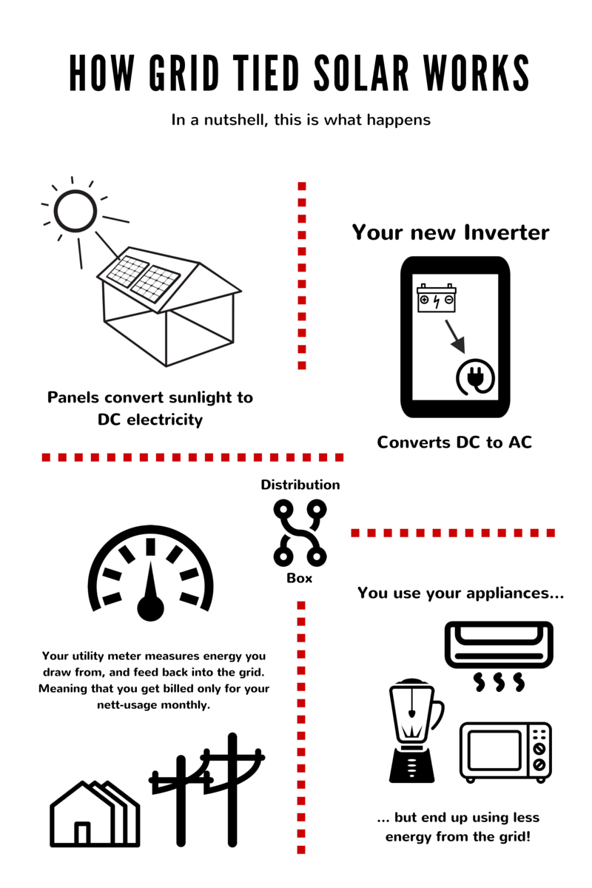

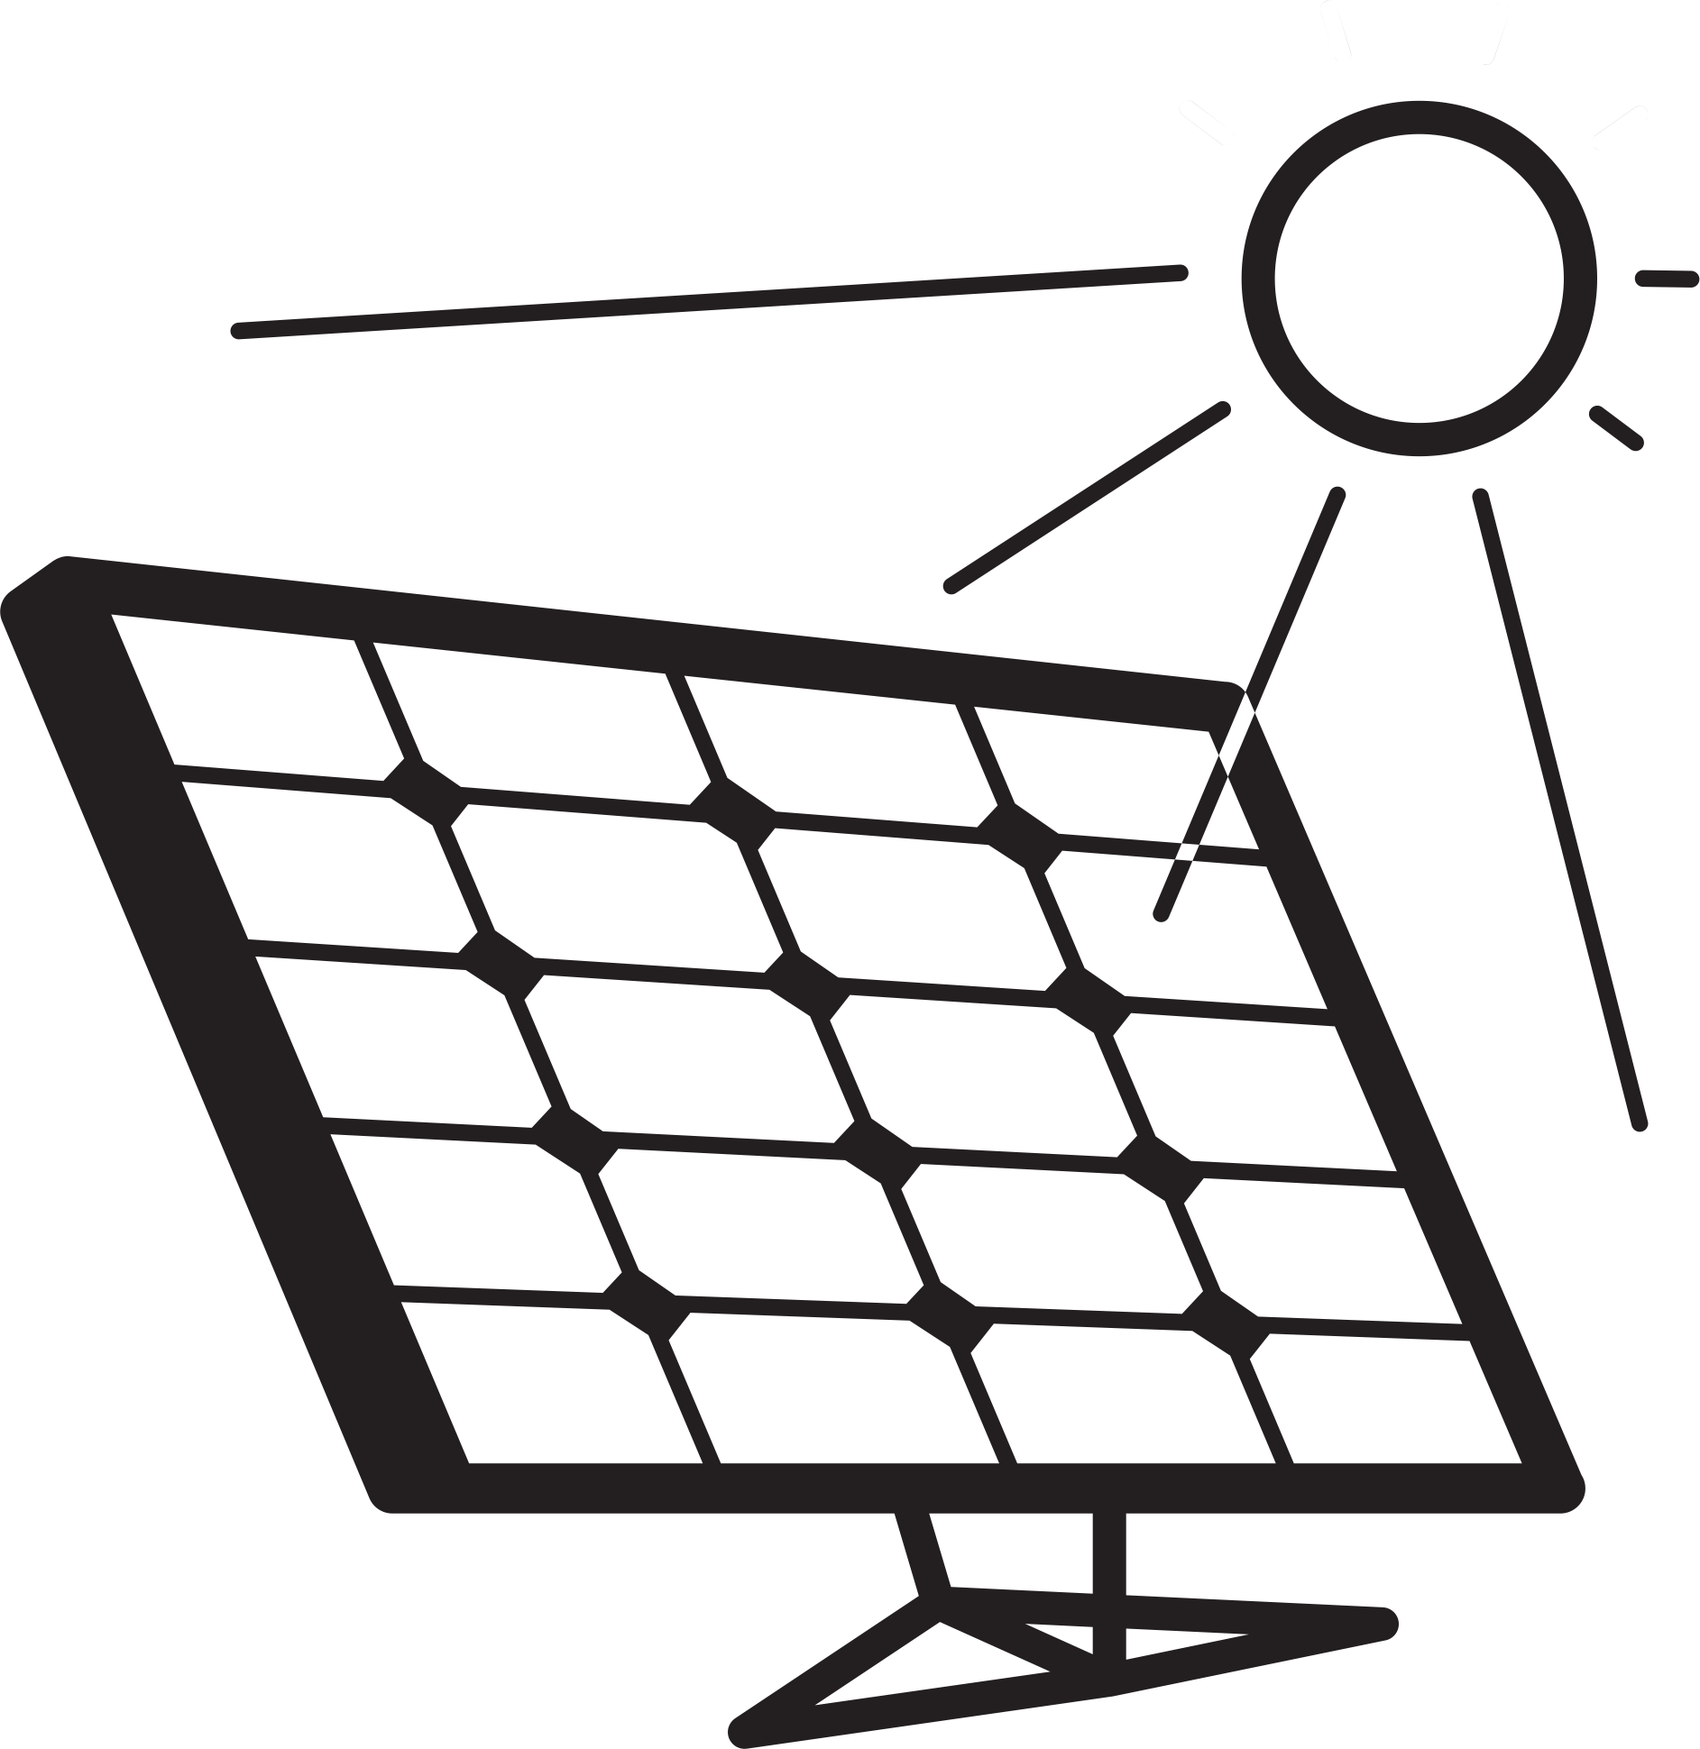Basic System components: (Part of “How it Works”)
(Please insert icons to go with each item, some suggested icons added)
- Solar Panels: Solar panels converts sunlight into direct current electricity (DC). Panels are made up of photovoltaic (PV) cells.
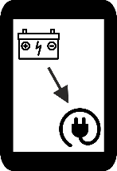
- Inverter: Solar panels produce DC electricity that first needs to flow through an inverter that converts it into alternating current (AC). This is the electricity that powers your home.
- 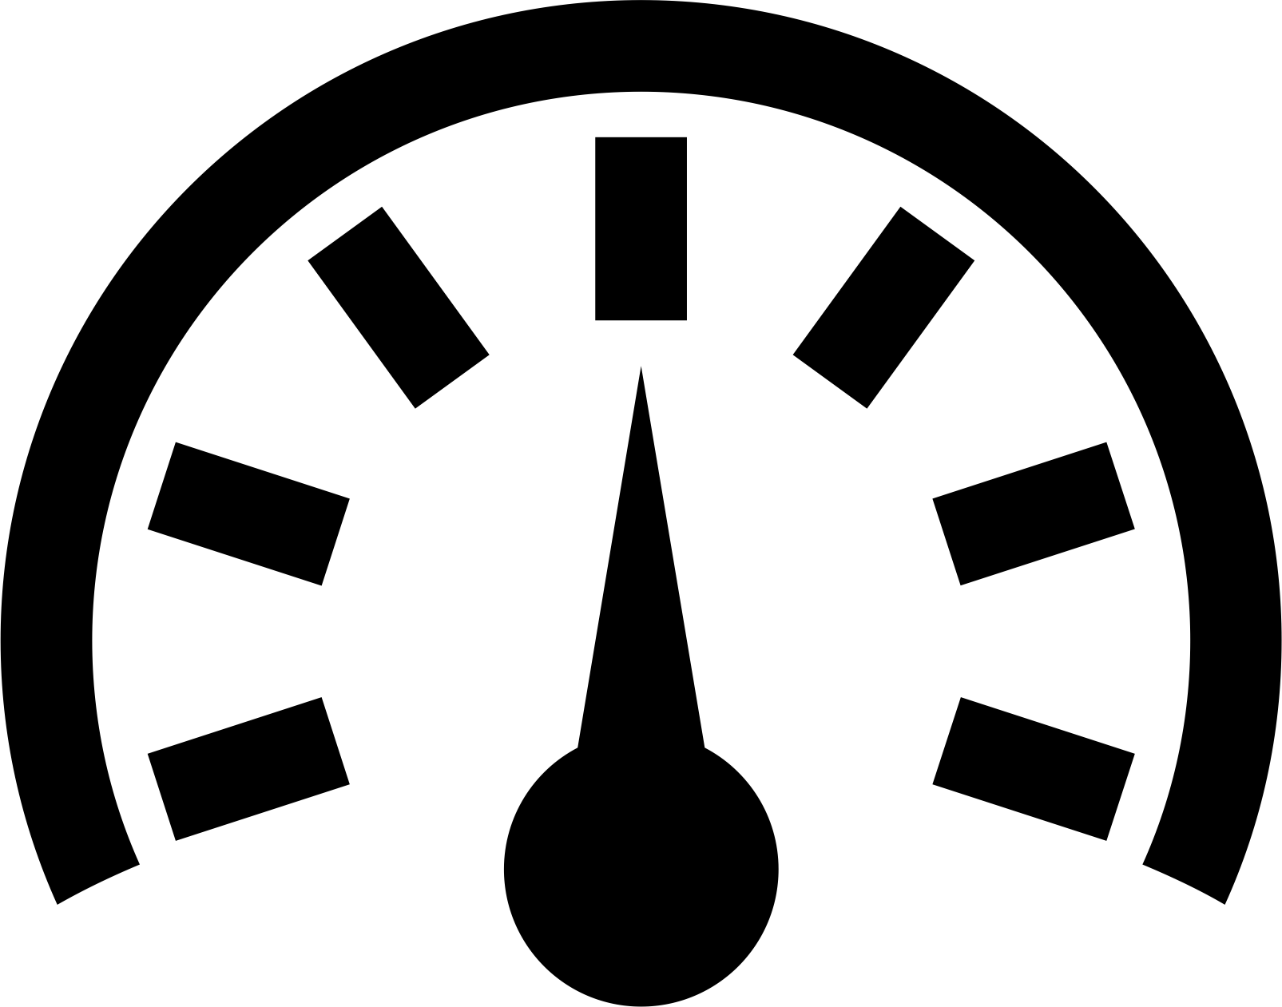Utility Meter: Also known as a net energy meter, a utility meter keeps track of the flow of energy to and from your premises throughout the day. When you generate more power than you can use, the meter actually works in reverse and sends that power to the utility grid, thus offsetting the energy you use at night.
- Utility Grid: Your household or business will still be connected to the utility grid because it will need to still draw power from it. However, the cost of using the grid’s electricity is offset by the amount of energy you put into it during the times you produce.

Benefits of Installing Solar: (Part of “How it Works”)
(Use Infographic – Also Uploaded to DC)
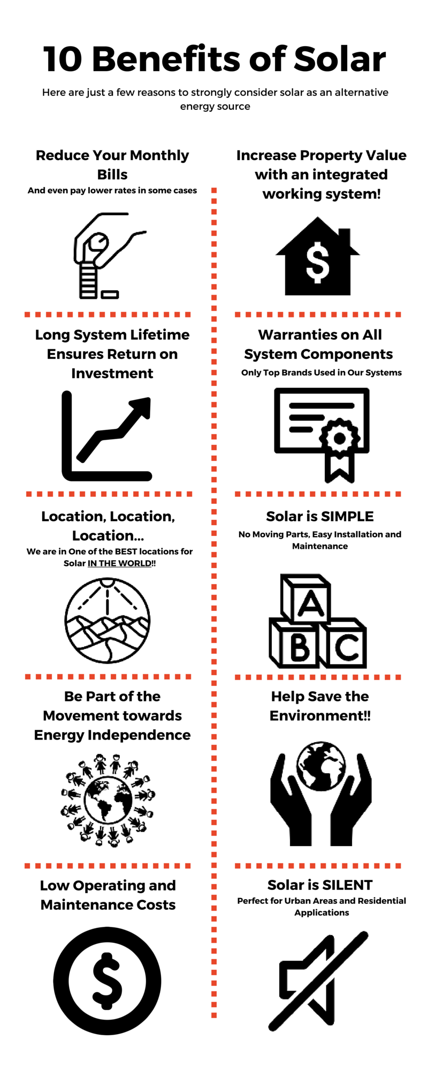

Section 4. How we work (Use Infographic – Also Uploaded to DC)
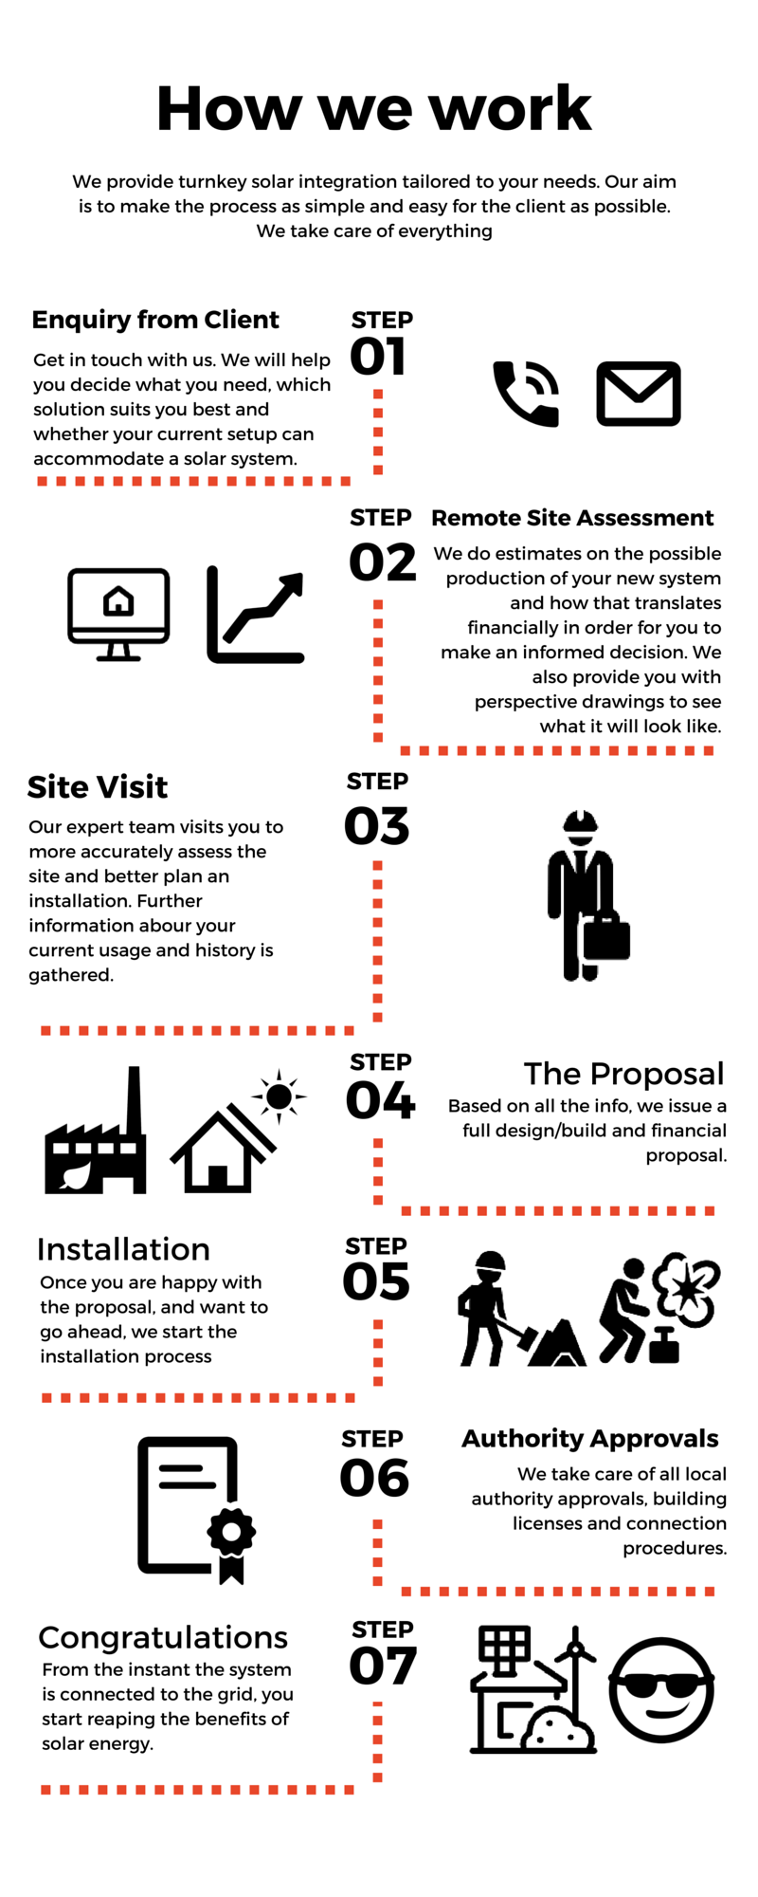

Section 5. Contact Form

Field 1: Name
Field 2: Surname
Field 3: Email
Field 4: Contact Number
Field 5: Building Type
(Dropdown List Options)
- House/Villa
- Office
- Factory/Industrial
- Other (Please specify)
Field 6: Your Location (Google maps input option)
Field 7: Project Details

Section 6. Contact Us

Address:  (Google Maps Insert)  Dubai Sports City, The Bridge, Office 407, PO Box 29331 | Phone:  +971 4 818 9020  +971 50 774 0244 | Email inquiries to:  office@oryxsolar.me  hennie@oryxsolar.me  johann@oryxsolar.me
Web:  www.oryxsolar.me  www.terrastruc.com  www.terragreenafrica.com | Facebook:  www.facebook.com/oryxsolar.me

