Hong Kong – Vienna Music Festival

15 Jul - 28 Aug, 2016

Organized by Vienna Boys Choir Music Academy Foundation (put logo)
Supported by Austrian Consulate General (leave space for 6-8 logos)

Tel : (852) 2339 1132
Email : festival@vbcmaf.org
Website: www.vbcmaf.org

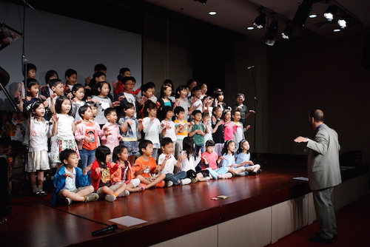
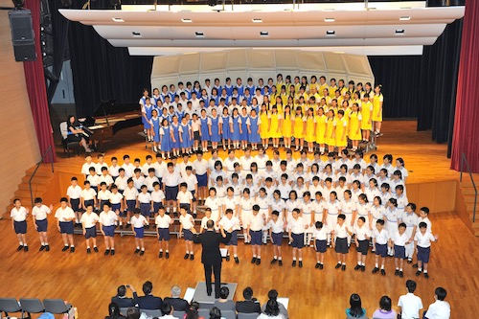
Part 1: opening concert [Hong Kong]

Date
15 Jul, 2016 (Fri)

Venue
Hong Kong City Hall, Hong Kong (Capacity: 1400 seats)

Part 2: Summer Music Academy [Hong Kong]

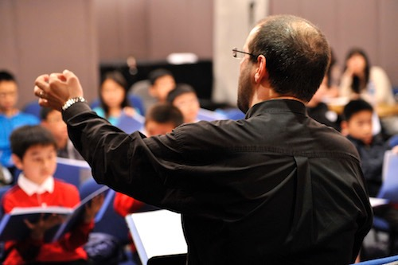
Date
18 - 30 Jul, 2016

Venue
Chinese University of Hong Kong

Part 3: professional training TOUR [Vienna]

Date
31 Jul, 2016 (Sun) -13 Aug, 2016 (Sat)

Venue
Pielachtal — Sekirn — Vienna

Part 4: Hong Kong Week [Vienna]

Date
14 Aug, 2016 (Sun) - 19 Aug, 2016 (Fri)

Venue
MuTh - Concert Hall of the Vienna Boys Choir, Vienna

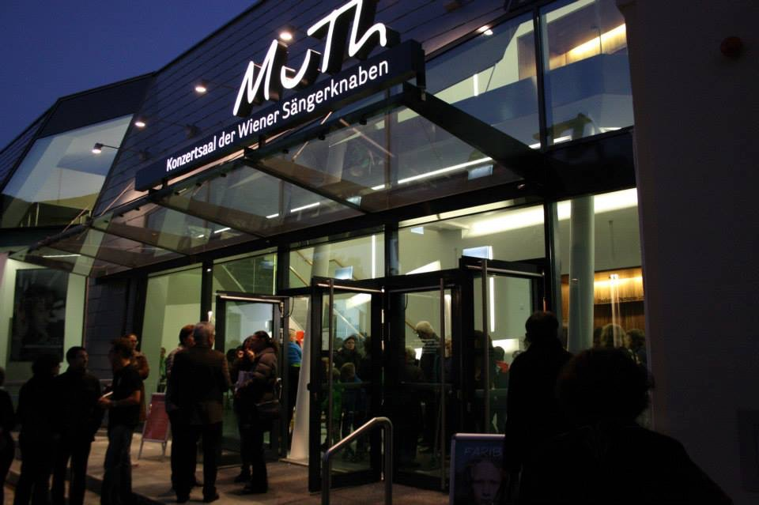
Part 5:

Finale Concert- Mahler Symphony No.8 [Hong Kong]

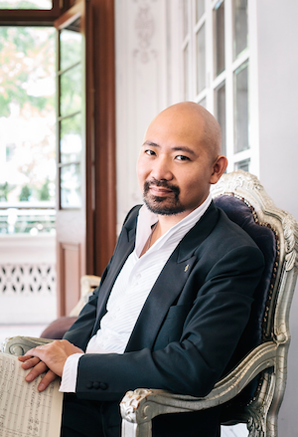

Date
Open Dress Rehearsal: 27 Aug, 2016 (Sat)
Concert: 28 Aug, 2016 (Sun)

Venue
Hong Kong City Hall, Hong Kong (Capacity: 1400 seats)

Artists
Artistic Director and Conductor Jimmy Chiang

Choirmaster Erwin Ortner

Soloist Anna Baxter, soprano
Louise Kwong, soprano
Yuki Ip, soprano
Samantha Chong, mezzo-soprano
Christina Baader, mezzo-soprano
Vincent Schirrmacher, tenor
Clemens Unterreiner, baritone
Apollo Wong, bass-baritone
Choir Arnold Schönberg Choir
Learners Chorus

Children’s Choir Vienna Boys Choir
Hong Kong Treble Choir

Festival Orchestra with members from
Vienna Symphony Orchestra
Vienna Radio Symphony Orchestra
Vienna State Opera Orchestra
Hong Kong Philharmonic Orchestra

Jimmy Chiang, conductor (Hong Kong / Vienna)
’Versatility comes through Hard Work, Discipline and Respect’, a title which described Jimmy Chiang in a front-page article written by the international opera magazine ‘Orpheus’ in 2009. The Hong Kong born conductor and pianist has started his musical career already at the age of 13 with his first public appearance as concert pianist. His major breakthrough as a conductor came with the winning of the renowned ‘Lovro von Matacic' International Competition for Young Conductors in Zagreb in 2007. Chiang was also recipient of awards and honours of numerous international competitions such as the International Competition for Young Choir Directors in Vienna (2004) and the Golden Key International Society Performing Arts Showcase in USA (2000). His versatility as a well-rounded musician has been proven by his convincing interpretation of a wide-ranging operatic, symphonic, choral, solo piano, chamber music and song recital repertoires, whether in opera pits or on concert stages.

While serving as principal conductor of the Hong Kong Pan Asia Symphony since 2008, he has worked as assistant music director of the Wagner’s Ring cycle at Theater Lübeck from 2007 to 2009, as well as Kapellmeister at Theater Freiburg, where he led from 2009 to 2011 numerous premiere productions, including a howling success of Ligeti’s opera Le Grand Macabre with celebrated stage director Calixto Bieito. Starting autumn of 2013, Chiang is appointed as Kapellmeister of the world famous Vienna Boys Choir, with whom he leads in concerts in Vienna as well as concert tours worldwide.
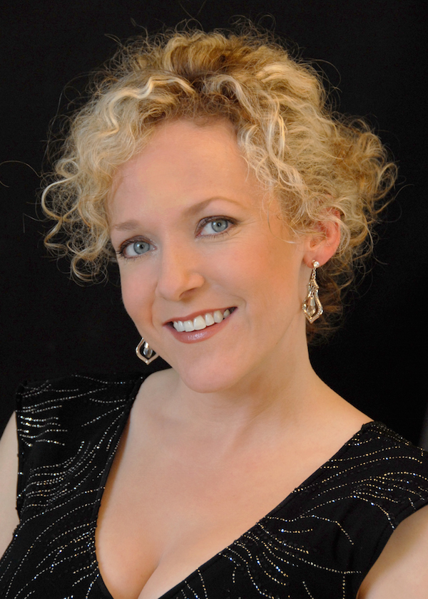
Anna Baxter, soprano (Vienna)
Baxter was a prize winner at the 2007 International Singing Competition of Passau. Her European debut in 2006 as Violetta in La Traviata was highly acclaimed by audience and critics alike. She has also given concerts and recitals in the USA, Europe and Asia. She has sung with orchestras such as the Zagreb Philharmonic, Philharmonic Orchestra of the Hansestadt Lübeck and the Hong Kong Pan Asia Symphony Orchestra. She has been a regular guest soloist at Theater Lübeck, Theater Freiburg, Stadttheater Bern and Oper Halle. Her roles include Arabella, Salome, Vitellia, Elisabeth (Tannhäuser), Rosalinde, Saffi, Freia, Liu, Mařenka as well as a wide range of concert repertoire.

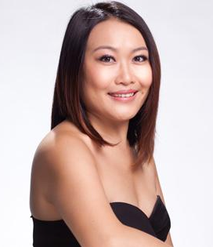
Yuki Ip, soprano (Hong Kong)

Highlights of Hong Kong soprano, Ip Po-Ching's career, so far, included performing as soloist with José Carreras for the inaugural season of the National Centre of the Performing Arts, Beijing, China, taking the role of Cio-Cio San in Puccini’s Madame Butterfly with MusicaViva, and making her European debut at the Basilica di San Vitale, Ravenna, Italy in Pergolesi’s Stabat Mater. Ip was also the soprano soloist in a Hong Kong performance of Bach’s B Minor Mass conducted by Maestro Helmuth Rilling in 2011.

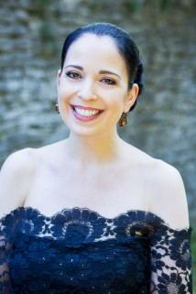
In addition, she recently performed Villa-Lobos’s Bachianas Brasileiras No.5 in Verona and Cremona, Italy, and was guest soloist at the Shanghai World Exposition with Shanghai Opera House Orchestra.

Christina Baader, mezzo-soprano (Vienna)

Christina Baader performed in recitals and as soloist in Vienna, as well as in France and in Germany, including the inauguration of 'Ottobeurer Konzerte im Kaisersaal' together with Taiwanese pianist Yu-Wei Ku, and performed in the musical scores of several films. In 2001 she toured through Japan as soloist with the Vienna State Opera ensemble, returning to Japan in 2009 as soloist in Beethoven's 9th Symphony in Hiroshima with the Hiroshima Symphony Orchestra under conductor Kazufumi Yamashita.

Louise Kwong, soprano (Hong Kong)

Being the awardee of the Hong Kong Arts Development Council Young Artist Award 2014, Kwong is one of the youngest and most active soprano in Hong Kong. She has sung title roles in numerous local and overseas opera productions, such as Liù in Puccini’s Turandot, Santuzza in Mascagni’s Cavalleria Rusticana, Anna in Donizetti’s Anna Bolena and La Contessa in Mozart’s Le Nozze di Figaro and Fiordiligi in Mozart’s Cosi fan tutte in the Grachten Festival Netherlands. Locally, Kwong is one of the most active young solo vocalist in Hong Kong. She has worked with the Hong Kong Philharmonic Orchestra in A National Day Celebration as soprano soloist (Sept 2015), Opera Hong Kong in production Cosi fan tutte as Fiordiligi (August 2015), Learners’ Chorus as soprano soloist in Rossini’s Stabat Mater (July 2015) etc.
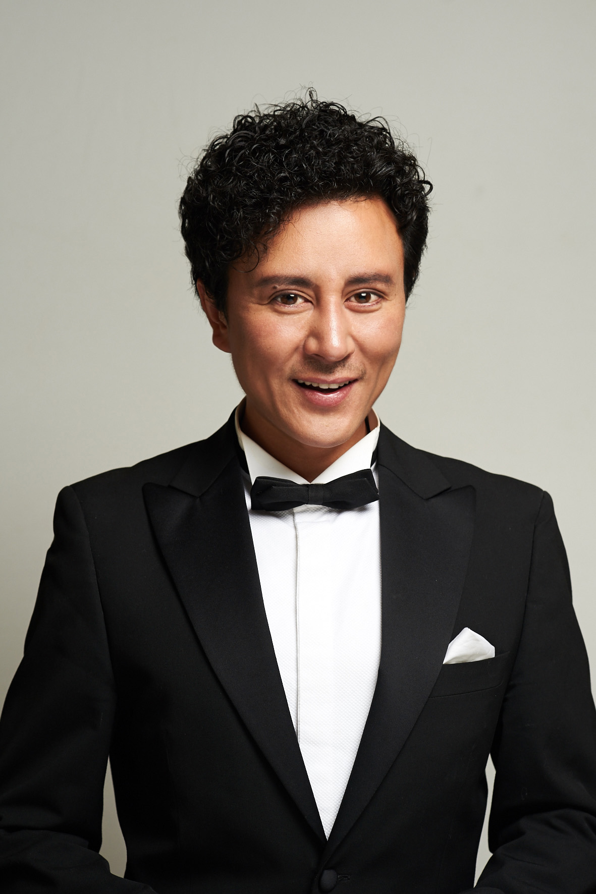
Vincent Schirrmacher, tenor (Vienna)

Vincent Schirrmacher received vocal tuition from Prof. Raimund Gilvan in Saarbruecken, Germany. From 2003 he studied with Prof. Josef Protschka at the Cologne Academy of Music, Germany until his graduation.
The ‘Gottlob Frick’ Medal was given to him in 2006 for his contribution to stage success. In the same year he won the ‘Johan Strauss Prize’ in Coburg, Germany. At the International Robert Stolz competition in Hamburg, Germany in 2007 the jury awarded Schirrmacher the First Prize. He was also the vote of the audience.
At the International ‘Belvedere’ competition, which took place in Vienna, Austria in 2008, he was awarded the 3rd Operetta Prize and Special Opera Prize from the Norske Opera Oslo and the Gran Teatro del Liceu Barcelona. In the same year he was the finalist of the ‘Placido Domingo – Operalia’ competition in Quebec, Canada.
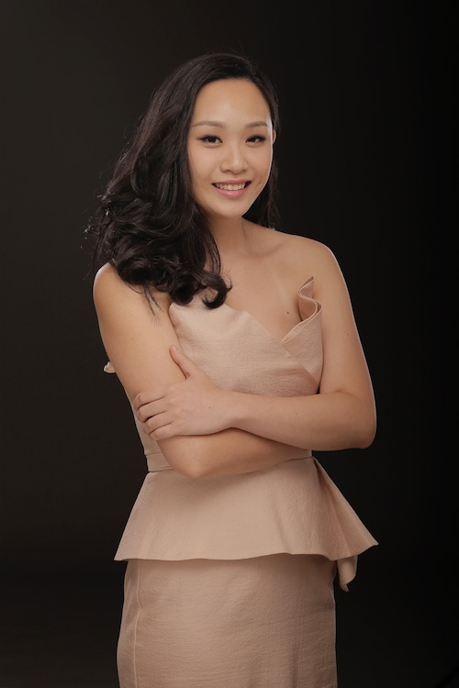
Since 2008, Schirrmacher was engaged at the States Theater Schleswig-Holstein’s ensemble. There he sang roles such as the Octavio in Lehar’s operetta Giuditta, Duke in Verdi’s Rigoletto, Prince in Dvorak’s Rusalka, Julien in Charpentier’s Louise and Busoni’s Doktor Faust.
Samantha Chong, mezzo-soprano (Hong Kong)
Mezzo-soprano Samantha Chong graduated with the Master of Music Degree, having earlier earned her Bachelor of Music Degree both at The Hong Kong Academy for Performing Arts (HKAPA). Chong was a young artist at the Opera Studio Melbourne in 2010-2011.

In 2014, Chong made her débuts with Opera Hong Kong (as Marthe Schwerlein in Gounod’s Faust) as well as the Hong Kong Philharmonic Orchestra. She then sang the role of the Page in Richard Strauss’s Salome, Dorabella in Mozart’s Così fan tutte, again with Opera Hong Kong. In January 2016, Chong will appear as a soloist in Drama Rashomon at the Sunbeam Theater. Chong is now a singer in Opera Hong Kong Young Artist Program.

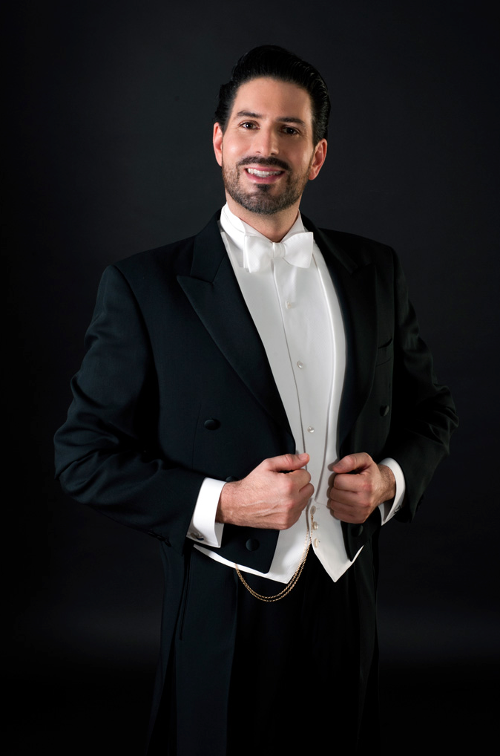
Clemens Unterreiner, baritone (Vienna)

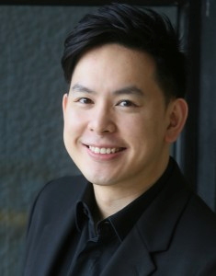
Unterreiner started his career at the annual Vienna Festival (Wiener Festwochen) and performed in concert tours in Bulgaria, Syria, Italy, Spain and Germany. He performed at the Grand Hall of the Wiener Musikverein, at the Vienna Concert House (Wiener Konzerthaus), Palao de la Musica Barcelona and other international concert halls. He sang concert performances of La Traviata as Germont, Fidelio as Pizarro and Tosca as Scarpia. In October 2002 he made his opera debut at the State Theatre in Linz for the European première of 'The Voyage' by Philip Glass. During the summer of 2003 he sang Count Baccellone in La Contessina. Further engagements took him 2004 at the Vienna State Opera where he performed in the première of Massenet’s Werther. He sang Sharpless in Madama Butterfly in Chur, Straßburg and Großes Festspielhaus Salzburg which was awarded the Prize of the Music Theatre 2004 season. During the summer of 2005 he sang the title role in Don Giovanni at the Heidenheim Opera Festival in Germany and Bartolo in Paisiello's Barber of Seville. On September 4th 2005 he had his house debut in Puccini´s Manon Lescaut where he started his career a soloist and ensemble member of the Vienna State Opera.

Apollo Wong, bass-baritone (Hong Kong)

Bass-baritone and conductor Apollo Wong received his education in vocal studies at the University of California, Los Angeles under the supervision of Vladimir Chernov and Juliana Gondek. He has also studied with Sami Kustaloglu in Berlin.

Wong has sung operatic and musical roles including Zuniga in BIZET’s Carmen, the Superintendent Budd and Bottom in Britten’s Albert Herring and A Midsummer Night’s Dream, Frère Laurent and Le Duc in Gounod’s Roméo et Juliette, Ariodate in Handel’s Serse, Benoit and Alcindoro in Puccini’s La Bohème, Barone Trombonok in Rossini’s Il Viaggio a Reims, Javert in Les Miserables, among others. He was also in the role of Lu Xun in 2013 Hong Kong Arts Festival’s world premiere production of Heart of Coral by Dr Chan Hing Yan; and in the roles of King Oryant/Markes in the 2014 premiere of Jeffrey Ching’s Before Brabant in the same festival. His concert and oratorio repertoire include Bach’s St. John Passion and St. Matthew Passion, Beethoven’s Symphony No. 9, Brahms’ Ein Deutsches Requiem, Faure’s Requiem, Handel’s Messiah and Dixit Dominus, Haydn’s Stabat Mater, Mendelssohn’s Elijah, Mozart’s Requiem, Puccini’s Messa di Gloria, among others. He has sung under conductors such as Paolo Olmi, Renato Palumbo, Joseph Rescigno, Helmuth Rilling and Francois-Xavier Roth.
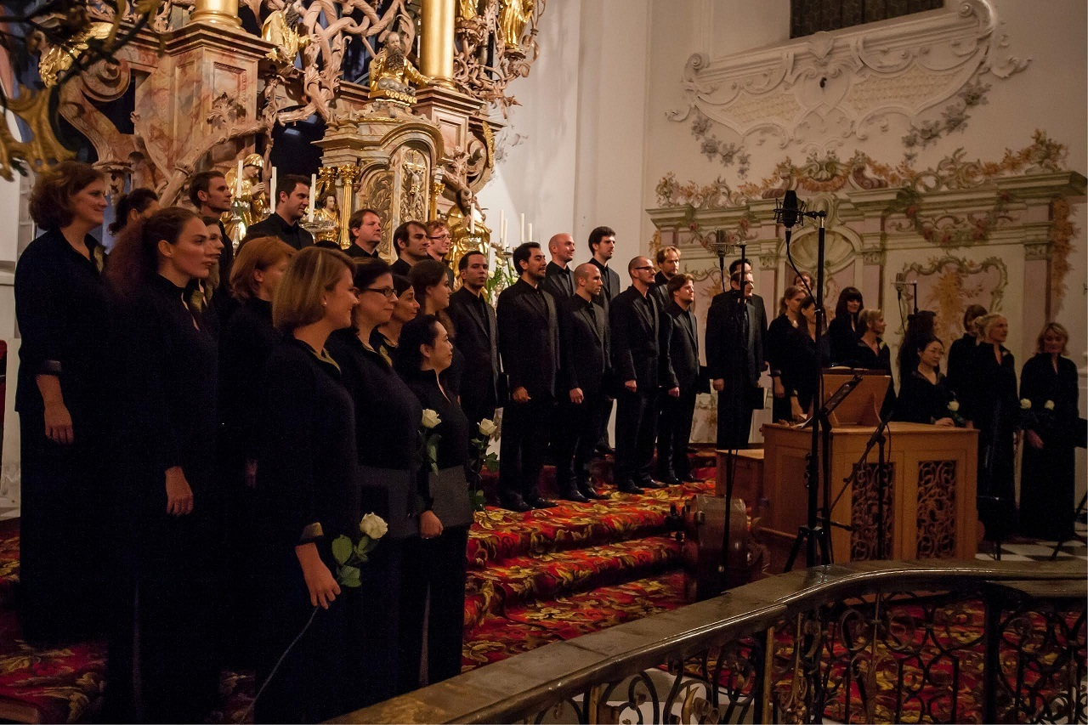
Arnold Schönberg Choir (Vienna)

The Arnold Schoenberg Choir was founded in 1972 by current artistic director Erwin Ortner and remains one of the most sought after and versatile vocal ensembles in Austria. The choir’s repertoire ranges from renaissance and baroque to the present day with a focus on contemporary music. The choir has a particular interest in a cappella music, however it also regularly performs large scale works for choir and orchestra.

As well as concert performances, the choir has also regularly taken part in opera productions, beginning with Schubert's Fierrabras at the Vienna Festwochen in 1988 (directed by Ruth Berghaus and conducted by Claudio Abbado), and including Messiaen's Saint François d'Assise in 1992 (directed by Peter Sellars and conducted by Esa-Pekka Salonen) and the world premiere of Berio's Cronaca del Luogo at the Salzburg Festival in 1999 (directed by Claus Guth and conducted by Sylvain Cambreling).

The Choir is also regularly engaged in opera productions at the Theatre an der Wien; among others Janaceks’ Aus einem Totenhaus, which was directed by Patrice Chéreau and conducted by Pierre Boulez. This production was voted ‘Best Opera production in German speaking countries 2007’.

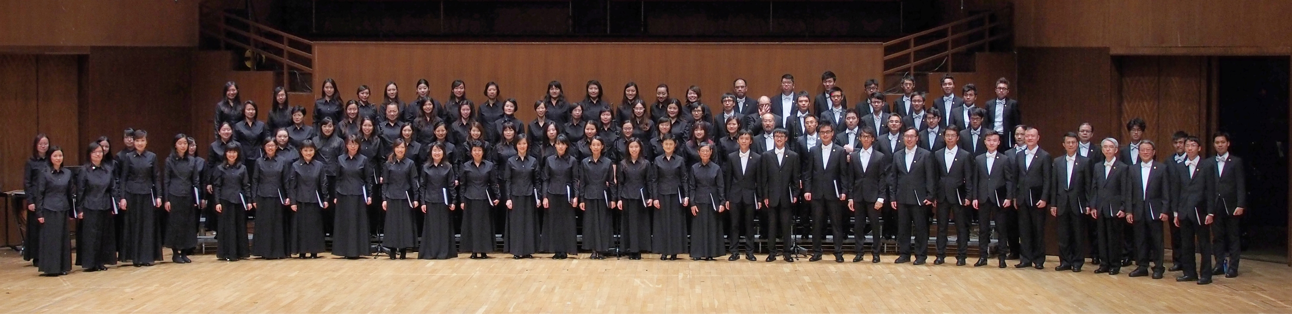
Learners Chorus (Hong Kong)

The Learners Chorus was founded in 1979 by former members of the Hong Kong University Students’ Union Choir. Recent major performances include Brahms’ Ein Deutsches Requiem, Lully’s Te Deum, Mahler’s Symphony Nos. 2 and 8, Rachmaninov’s The Bells, Rossini’s Messa di Gloria and Stabat Mater, Verdi’s Messa da Requiem and Quattro pezzi sacri. In 2013 and 2014, Learners performed Britten’s War Requiem with the Hong Kong Philharmonic Orchestra and its Chorus under the baton of the late Maestro Lorin Maazel, and to celebrate 'Hong Kong Cultural Centre – Celebrating 25 Years', respectively. In May 2015, Learners was invited to perform 'Macao Soul' with Macao Orchestra and the Macao Perosi Choir at the 26th Macao Arts Festival.

Learners is devoted to promoting music among youth. Students are often invited to sing with the Chorus or play in the Learners Orchestra alongside professional musicians. Young choir members are offered the chance to conduct the Chorus. Student members receive sponsored vocal training by our Music Director. Young musicians also give guest performances in our concerts. Over 6,400 students have benefited from our Student Ticket Sponsorship Programme, which aims to extend music appreciation opportunities to the younger generation.

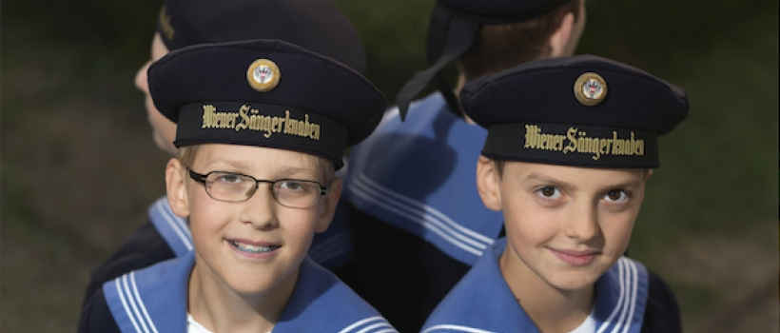
Vienna Boys Choir (Vienna)

The Vienna Boys Choir, with more than 500 years of history, is one of the oldest choirs in the world.

Today there are around 100 choristers between the ages of 10 to 14, divided into 4 touring choirs named after famous Austrian composers – Bruckner, Haydn, Mozart and Schubert. The 4 choirs give around 300 concerts each year for almost 500,000 people in Europe, Asia, Australia and the Americas, which include world leaders and artists.

The Choir’s repertoire includes everything from medieval to contemporary and experimental music. Since 1920s, the Choir has collected music from around the world and recently produced a number of world music projects.

Hong Kong Treble Choir (Hong Kong)

Hong Kong Treble Choir (HKTC) was founded in 2000 as a registered charitable organisation. HKTC is honoured to invite a group of renowned choral experts and masters as directors and consultants, including Honorary Advisor Mdm. Barbara Fei, SBS, Honorary Artistic Director Prof. Wing-wah Chan, JP, Honorary Music Directors Ms. Nancy Loo, MH, Artistic Director and Principal Conductor Prof. Leon Shiu-wai Tong and several overseas advisors.
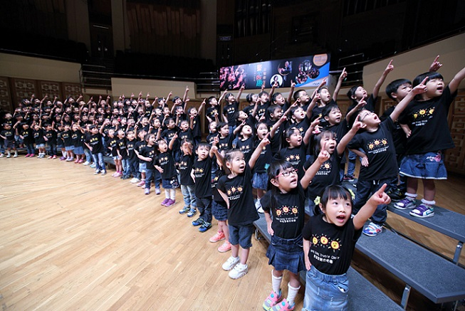
Under the leadership of Prof. Leon Shiu-wai Tong, HKTC has participated in various performances and cultural exchanges. The significant performances includesthe International Society for Music Education (ISME) World Conference in Kuala Lumpur, Malaysia in 2006, the concerts with Les Petits Chanteurs de Saint-Marc in Lyon and Paris, France in 2008, 'The World Sings for Olympics Concert' and 'The World Youth Choir Concert' in 2008 Hong Kong International Youth and Children’s Choir Festival. In 2009, HKTC was invited as the guest performer at the Hong Kong Arts Development Awards 2008 and Les Choristes in Concert. Touring performances were held in different cities in China.

