My Logo
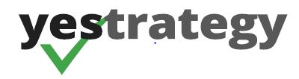
My Business Name:
Your Enterprise Strategy
HEADLINE:
Has Your Business Achieved The Outcomes You Want?
It can and I’m prepared to show you how
My name is John FitzGerald, from Your Enterprise Strategy, the ‘No Cost Business Coach’.
Sub headline:
If I told you that you can increase your profits, give yourself more time, freedom and peace, what would your answer be…? Research says you can and quickly

Because over 90 percent of small to medium sized business in Australia have a minimum of 12 per cent of their annual turnover tied up in ineffective and inefficient processes?
The problem is that most business owners focus on their daily challenges unable to free themselves to consider where the ‘hidden profit’ may be locked up within their business.
I can change this by reviewing your cashflow, systems, staff capability, business culture and Risk. The end result will be more money, time, freedom and peace to live your life that way you desire.
If you would like more information go to yestrategy.com.au/nocost or email info@yestrategy.com.au
Also you can call me on 0437189810
MY PROMISE:
If I cannot uncover at least 5 times my fee from potential profits hidden with your business after one interview then it is free.

