SURVEILLANCE
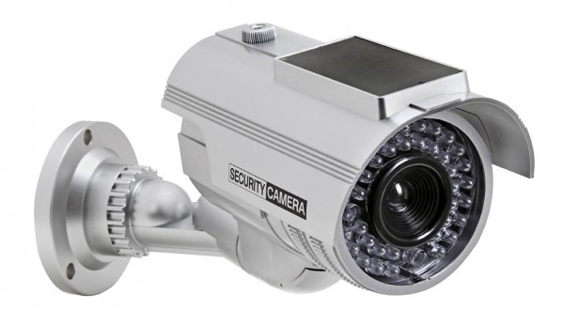
THIS PROPERTY PROTECTED BY CCTV SECURITY CAMERAS

FOR YOUR PERSONAL PROTECTION ALL ACTIVITIES ARE RECORDED ON DIGITAL MEDIA TO AID IN THE PROSECUTION OF ANY CRIME COMMITTED ON THIS PROPERTY.

I would like the camera image to be a line drawing. Remove the wording Security Camera on the camera. I would like to use the colors Red, Black and Yellow

