Tough on hackers.
Easy on your budget.

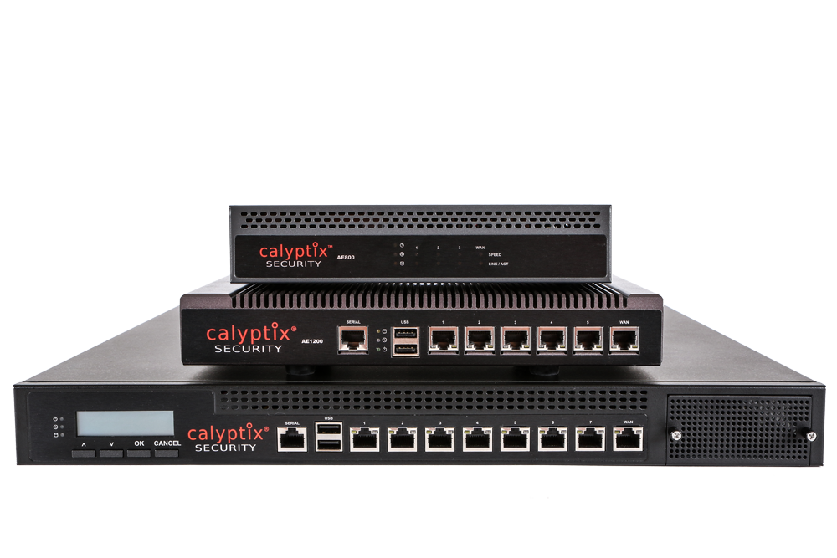

AccessEnforcer

Network security is easy with the AccessEnforcer UTM Firewall from Calyptix. First, you save time and protect clients with an easy-to-use firewall. Second, you solve problems faster with unbeatable tech support. Third, you increase profits with a reseller program that fits your business model.

See what easy security looks like with Calyptix: www.calyptix.com/partners

