Logo should be three leaves placed together. Each leaf is the intersection of two quarter circle circumferences. Leaves are pointed upward and / or outward, with a common central starting point / base. Each outside leaf should be 30 degrees apart from the central vertical leaf. Each leaf will be a base, light aquamarine color. There should be no outline or shadowing of the leaves. At the intersection of two leaves, that color should darken. At the intersection of all three leaves (central lower aspect of the logo), the color should darken again. There should be a total of three colors used, with each clearly, but subtly distinct from each other.

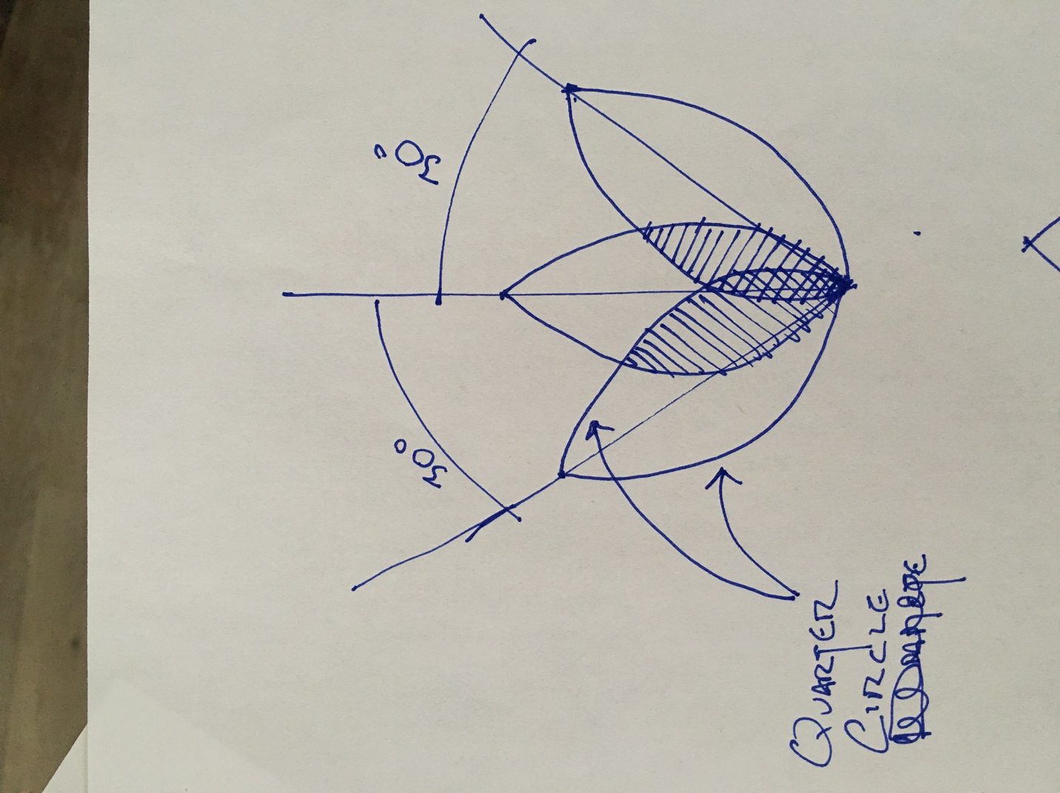

I’d like “Trifecta therapy” to be written at the bottom of the logo, centrally oriented. I like century gothic font, but am open to suggestions. I’m considering having it written as follows (and am certainly open to suggestions):
- Trifecta Therapy
- trifecta therapy
- TRIFECTA therapy
- TRIFECTAtherapy
- TRIFECTA
therapy

About the procedure:

Trifecta therapy is a combination of treatments. It involves a procedure called "microneedling" that uses a tiny needle to puncture the skin thousands of times. In doing so, it stimulates the body to create collagen and by repairing and regenerating the skin, it can actually significantly improve the quality of the skin. As part of this treatment, we add Platelet Rich Plasma ("PRP") to the microneedled skin. The PRP is gathered by taking the patient's blood and spinning it to isolate out the clear, straw colored serum. This serum has stem cells in it that can help regenerate the skin and improve it’s quality. Finally, we also add a special mixture of “growth factors” that stimulate the stem cells in the PRP and skin cells to further regenerate and improve the quality of the skin.
I’ve attached photos below to show the specific components: Microneedling:
PRP:
