Website Brief:
- Website must designed to be compatible with BigCommerce (https://www.bigcommerce.com/) platform and shopping cart,
- Please use Colour Scheme as provided in an attached flyer (designcrowd_126768_6623883_1265940_sourcefile).
- Current website: www.aussiefauna.com – As you can see this is why I am looking at getting a new web page designed!
  - I do not need a “Our newsletter” as currently appears on the homepage
- Company Logo attached (Logo Master)
- Facebook: Please provide link to facebook page (https://www.facebook.com/aussiefauna/?fref=ts)
- Images Provided:
  - Company Logo
  - Bearded Dragon Eating a Silkworm
  - Green Tree Frog and Silkworm
  - Green Tree Frog Group
  - Blue Tongue Skink
  - Frilled Dragon
  - Tarantula
  - Silkworm Life Cycle (good image to take samples of silkworms at various stages of life cycle)
  - Product Photo of Silkworms eating chow
  - Product Photo: Disposable Piping Bag
In regards to design that I am looking for. Please look at the sample of websites provided below…I think it is better to show you examples of websites that I like and give you an idea of what I am after. I like the effect of white background and accenting green colour scheme. I do like classic look with hints of funny/personal/funky touches.
To give you an example of a website that I think is plain and simple yet has that funny/personal/funky touches that I like: http://www.nakedwines.com.au
Related/Competitor Websites – and thoughts on design:
- http://www.coastalsilkworms.com/ - good simple design.
- https://www.everythingsilkworms.com.au/ - good simple design, not too far from what I am looking for, however my site needs to stand out and look different from this site. Try to impress me with creativity
- http://www.peacefulsilkworms.com.au/ - again simple not too far from what I am looking for, but I do not like the set background on the side that the page moves over.

Guidelines:
- Home Page Tab
Silkworms not only spin cocoons that can be turned into luxurious silk, but did you know that silkworms can be part of your beloved insectivore’s healthy diet? Of course you knew, and that’s why you’re here.

Silkworms are naturally high in protein, calcium, iron, magnesium, sodium, and vitamins B1, B2, and B3, low in fat and phosphorus. With such high nutritional value encased in a soft and juicy body, silkworms are the ideal and yummy alternative to the other feeder insects such as crickets, mealworms, and woodies.

Aussie Fauna has been providing silkworm chow and silkworm eggs since 2012. Aussie Fauna’s silkworms are bred in a veterinary approved facility which includes strict biosecurity, use of veterinary disinfectants to clean the facility and all equipment used to rear the silkworms. The silkworms are raised on premium European silkworm chow to ensure highest nutritional value (hyperlink to Nutritional Benefits of Silkworms tab).

Include A featured Products

- Nutritional Benefits of Silkworms Tab
Silkworms are naturally high in protein, calcium, iron, magnesium, sodium, and vitamins B1, B2, and B3, low in fat and phosphorus. With such high nutritional value encased in a soft and juicy body, silkworms are the ideal and yummy alternative to the other feeder insects such as crickets, mealworms, and woodies.

Several commercial feeder insect companies started providing silkworms on a large scale nearly two decades ago in the United States. This commercial availability prompted several studies to be published over the years examining the nutritional content of silkworms compared to that of commonly used feeder insects available commercially. These studies have all concluded that overall the silkworm is a highly nutritious feeder with several advantages over commonly feed insects. These nutritional advantages include lower fat content, high source of calcium with a better Ca:P ratio, and highly digestible protein. In one study silkworms were the only invertebrate tested that contained detectable levels of preformed vitamin A. In addition to high levels of Vitamin A, silkworms have also been found to contain high levels of the Vitamin B Complex – all of which play a major role in reptile health.

There are many health and nutritious advantages to adding silkworms as a staple food source to your pet’s menu. After all variety is the spice of life and we should aim to offer as varied a diet to our captive companions – silkworms are a great addition to the list of commercially available feeder insects.

- Benefits of Silkworms as feeder insects Tab
Silkworms, unlike crickets, are not noisy, smelly, or jumpy and with our Silkworm Chow, silkworms are now easy to keep! You no longer have to worry about finding fresh mulberry leaves to feed your silkworms.
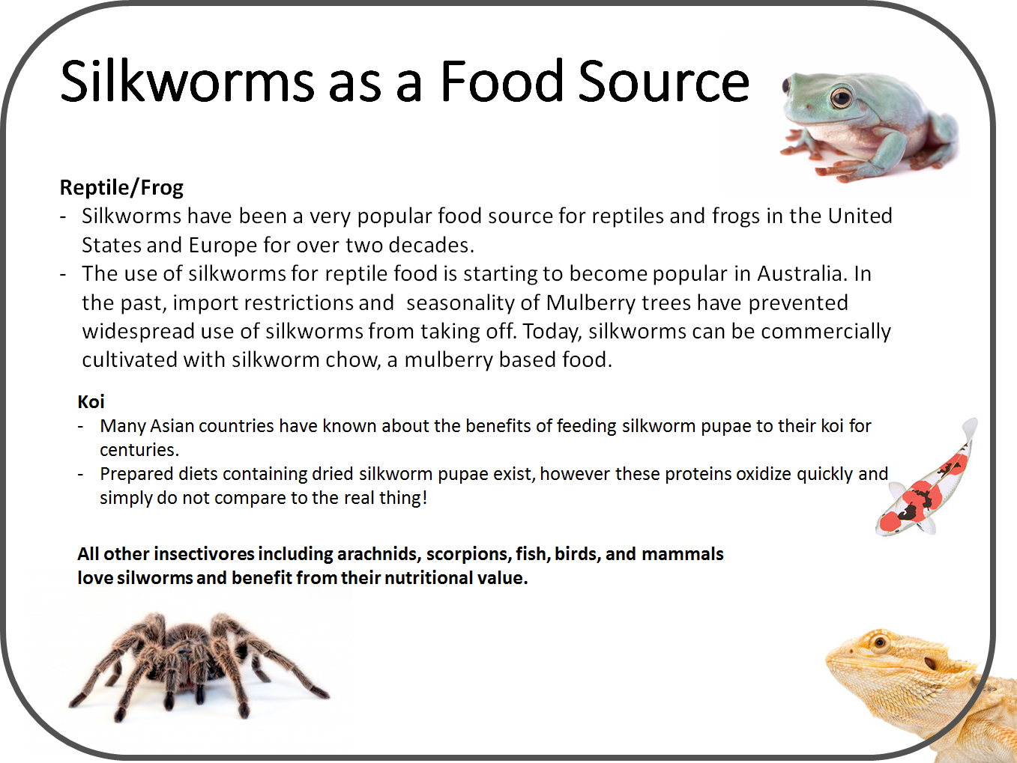
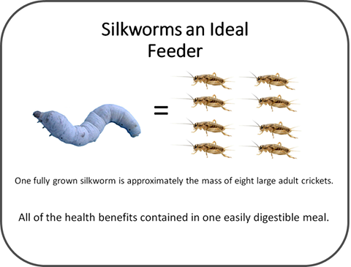

An additional advantage that silkworms offer is the modest exoskeleton which allows optimal nutritional absorption. Mealworms, crickets, and other insects with have an indigestible chitinous exoskeleton making up sclerotized cuticles which may be difficult to digest. Often, intact mealworm and cricket bodies are passed in the faeces of some insectivorous amphibians and reptiles resulting in minimal nutrient absorption from that meal.

Another component of silkworms is a proteolytic enzyme called serrapeptase, which allows the moths to dissolve the cocoons when they are ready to emerge. This protein is widely used in human alternative medicine and is associated with anti-inflammatory properties and arterial plaque reduction. Although no clinical studies have been performed on its benefits in reptiles, certainly these benefits have been reported by reptile keepers around the world rehabbing sick and injured reptiles. Unpublished reports have also reported success in slowing the progression of corneal lipidosis in green tree frogs due to their low fat levels and the serrapetase benefits of plaque reduction.

***Please note we only sell silkworm chow and silkworm eggs on this website and do not
currently sell live silkworms to the public.***

- Silkworm Care Tab:
For the keen reptile keeper that enjoys raising their own food for their collection silkworms are fairly easy to keep and breed. They are tiny (about the size of the “i” in tiny) when they hatch from their eggs and within four weeks grow to over 10,000 times in size – making them an ideal feed from the smallest of hatchlings right up to the largest of lizards.

Silkworms are best maintained at temperature over 22°C (ideally 24°-27°C). Other than maintaining the temperature and sourcing food (mulberry leaves or silkworm chow) very little equipment is required to rear silkworms – remember the shoebox worked great in primary school! Once the worms are set up, provide a constant supply of food and the silkworms grow very quickly. Traditionally mulberry leaves were required to grow and successfully rear silkworms. A mulberry based food, often referred to as “silkworm chow” is now available which allows silkworms to be raised year round and no need for access to a mulberry tree. From the time they hatch until they cocoon they will go through five different instar stages, and moult between each instar. Prior to moulting they will take a break from eating and raise their head in the air and appear as if they are praying – it is best to not disturb at time.

Being clean is the key to successful silkworm rearing. Silkworms eat a lot and as a result poop a lot. Staying on top of the cleanliness of their container is very important. Mould and bacteria love to grow on old moist chow, mulberry leaves and frass (silkworm lingo for poop) so it is important to clean out old food and frass daily and transfer them to a new clean container often. It is also important to thoroughly wash your hands with soap and water before handling the food or silkworms to prevent contaminating their environment with unwanted “bugs.”

To easily transfer the worms put a plastic net (cheap plastic gutter guard works well) on the larvae and then put fresh chow or leaves on the net. Leave it there several hours and the worms will climb through the net onto the new food. Please, notice that the larvae will climb very quickly on the new diet, only if the old one is completely dried.
At this point you can transfer the larvae to a new clean box, by lifting the net out of the old container and place into the new clean container.

Four to five weeks after hatching and nearly constant eating the silkworms are ready for the next step in their life cycle - to spin their cocoons. When the silkworm is ready to spin their appearance changes and they begin to look more translucent, begin to shrink in size, and they pass larger wetter stools. They will begin to go walk about and leave their food looking for the ideal location to build their home. Taking advantage of objects around the house – provide the cardboard tube from finished toilet paper rolls as it is the perfect scaffolding required for the silkworm to spin their cocoon. After a day or two the spinning process will be complete, and the silkworm will moult one last time into a pupa. You can remove the excess silk, or floss, around the cocoon which will prevent the moths from getting entangled when they emerge ten to fourteen days later.

Once the moths emerge their sole mission is to breed and lay eggs. They cannot fly, they do not eat, and they do not drink. Females are larger than the males and have very round abdomens which are full of yellow unfertilized eggs. Males will franticly flap their wings and spin in circles once they sense the presence of a female this continues until they meet and the male attaches to the female. Most pairs typically copulate for over 12 hours. Males are persistent and if given the chance will attempt to continuously breed. In order to let the female lay her eggs separate the pair and place the females in a separate container, a paper lined container is ideal for her to lay her eggs on. She will lay between 100-500 yellow eggs. If the eggs are fertilized over the next few days the eggs will change from yellow to black. If they are not fertile they will remain yellow.

The vast majority of silkworm strains in Australia are univoltines – meaning they produce only one generation per year. The eggs of univoltines remain in diapause, or dormant, until the next spring. Therefore in order to continue breeding these silkworms the eggs must be “wintered”. Seal the eggs in a plastic zip lock bag and place into the refrigerator for a minimum of three months. Eggs can be stored much longer in the refrigerator and I have successfully hatched eggs stored for over 18 months.

After the minimum of three months in the refrigerator, simply remove a batch of eggs and warm up to over 22°C (ideally 25°-27°C) and provide 12light/12dark photoperiod. Place the eggs into a sealed plastic container – plastic take away containers work well. For air flow small holes can be punched into the lid or you can simply leave a small crack open between the lid and container. Keeping the container in an incubator is ideal however homemade incubators can be made. Other warm areas that can be used include placing the container near the heat source of your reptile’s tank. To increase the humidity place a small piece of damp paper towel (or sponge) in the container but avoid excess moisture and do not allow contact between the damp paper towel and the eggs. Generally the eggs will hatch between 10-12 days after they are removed from the refrigerator. The eggs will change from a dark purplish colour to a light bluish/gray colour a couple days before they hatch.

When the eggs begin to hatch provide young mulberry leaves or prepare cooked mulberry chow. If they do not all hatch within 24 hours, it is okay to place a small amount of food in the container to allow the early hatchers to feed. All worms must be fed within 24 hours after hatching or they will starve. Sometimes the hatchling silkworms (known as kego) may not find the their first meal; if this is the case a fine paint brush can be used to carefully place the silkworms onto the food for their first feed. Fresh leaves needs to be offered a couple of times a day. In addition to providing food, maintaining humidity is crucial to rearing kego. Preventing condensation build up is mandatory as too much moisture with drown the small silkworms, on the other hand if it is to dry the food desiccates quickly and the kego will not be able to eat. Many factors will affect the humidity including food quantity provided, container size, temperature, ambient humidity. Once the right balance is found, the kego will grow very quickly. Keep up with the feeding and cleaning and you will soon have the right sized silkworm to feed to your collection!

- Products
  - Silkworm Chow
Description: Silkworm chow is a mulberry based complete silkworm diet that can be used for the entire life cycle of silkworms. Aussie Fauna’s Silkworm Chow is a premium quality chow imported from Europe.

    - Dry Chow
Product Description: Until the development of Silkworm Chow, silkworm propagation was limited to the availability of fresh mulberry leaves which restricted growing silkworms during the winter months and regions without mulberry trees. With our silkworm chow you can raise and grow silkworms to feed off to your pets or to just keep the silkworms as pets themselves anywhere within Australia all year round! Silkworm Chow contains all the nutritional requirements for the silkworms to complete their entire life cycle or to become a nutritious meal for your pet. The Silkworm Chow will arrive as a powder form that simply requires adding some water and microwaving. All of our food comes with detailed cooking and feeding instructions. The uncooked food can be stored in the fridge for up to one year or up to three months if kept in a cool dry area. Once the food is cooked it can last in the refrigerator for up to one month. You can rear up to 1000 worms to about 4cm or 100 worms to cocoon on half a kilogram of the uncooked silkworm chow.

      - 250g
      - 500g
      - 4.5kg
      - Disposable Piping Bags
        - Product Description: Disposable Piping Bags are a useful way to prepare and store silkworm chow. The use of piping bags helps reduce the amount of chow wasted and by simply cutting the tip of the bag the amount of chow expressed can increase as the worms grow.

    - RTU Chow (Ready to Use)
Product Description: RTU (Ready To Use) Silkworm Chow is already cooked and placed into a sterile disposable piping bag ready to be used to feed your silkworms straight away. This is the most economical and cleanest way to provide food to your silkworms. Simply cut the tip with scissors and squeeze strands of chow right over the worms. With newly hatched worms strands about the width of spaghetti noodles are ideal; as the worms grow cut further up the piping bag to increase the diameter of the strands to correspond with the size of the worms. Store the bags in the refrigerator for up to one month. The bags can be “sterilized” prior to feeding your silkworms by placing into the microwave for 5 seconds on high.
      - 500g
      - 1000g
      - 2000g
  - Silkworm Eggs
Product Description: Aussie Fauna silkworm eggs have been “wintered” and are ready to hatch on arrival. All of our silkworm eggs are shipped lose and include a petri dish to hatch your eggs in. Detailed rearing instructions are also included with each order
    - 50
    - 100
    - 200
    - 500
    - 1000
  - Reptile Feeder Kits
Product Description: Massive savings with our egg/chow kits designed with reptile keepers in mind. Rearing silkworms from eggs is by far the most economical way to provide your pets with the nutritional benefits of silkworms.

    - Silkworm Eggs with RTU Chow (Prepared Chow Ready to Use)
Product Description: Kits with RTU Silkworm chow are designed for reptile keepers to rear silkworms with the least amount of work possible. Simply wait for the eggs to hatch and start feeding. All eggs are shipped lose and with a petri-dish to hatch out the eggs and initial rearing. The silkworm chow is pre-cooked and arrives in a disposable piping bag - simply cut the tip of the bag and start feeding. Detailed care instructions are included with each order. Please note the quantity of chow provided is enough to raise silkworms to be raised as feeders, additional chow is required if you plan to grow silkworms to cocoon and breed them.
      - 100 Egg Feeder Kit
      - 250 Egg Feeder Kit
      - 500 Egg Feeder Kit

- FAQ Tab

  - Why are your silkworm eggs cheaper than other suppliers in Australia?
    - Aussie Fauna’s goal is to provide silkworms as an affordable staple feeder insect for Australian reptiles, invertebrates, fish, and insectivorous mammals. Rearing silkworms from eggs is by far the most economical way to provide your pets with the nutritional benefits of silkworms. Over the last several years Aussie Fauna has strived to improve production standards with decreased costs and increased quality control with great success. We are excited to pass on these savings to those that are interested in growing silkworms for their pets. Most importantly low costs does not equate to low quality. Aussie Fauna’s silkworms are bred in a veterinary approved facility which includes strict biosecurity, use of veterinary disinfectants to clean the facility and all equipment used to rear the silkworms. The silkworms are raised on premium European silkworm chow to ensure highest nutritional value (hyperlink to Nutritional Benefits of Silkworms tab). All of the eggs that you will receive have been “wintered” and are ready to hatch soon after arrival. You can expect over a 95% hatch rate of eggs provided, even so we still include extra eggs with every order to ensure that you start with the highest number of hatchlings possible!
  - Do you sell live silkworms?
    - We only sell silkworm chow and silkworm eggs on this website and do not currently sell live silkworms to the public. Please contact your local pet store for live silkworm supply.
  - Are the eggs you sell ready to hatch?
    - Yes, the eggs supplied have been “wintered” and have completed diapause. Before eggs are sold to the public, samples from each batch are hatched at our facility for quality assurance. If eggs have not hatched within 15 days of arrival please ensure that environmental conditions match that of the hatching instructions provided with each shipment. If you have having problems please contact us.
  - How soon will my eggs hatch once they arrive?
    - Silkworm eggs will hatch in approximately 2-7 days, depending on temperature and days in transit.
  - Can I return the eggs to the refrigerator and hatch at a later date.
    - Eggs sent out have been removed from cold storage and have started to develop on their journey to your home. Once the eggs have arrived to your home it is too late to place into the refrigerator, and doing so may result in death of the developing worm and failure to hatch. For an extra fee, large orders can be shipped in a Styrofoam esky with a cooling pad. If shipped in this manner these eggs should be suitable for cold storage to hatch at a late time; however we cannot guarantee that refrigerated eggs will hatch due to improper temperature and storage procedures.
  - How much Silkworm Chow do I need?
    - You can rear up to 1000 worms to about 4cm or 100 worms to cocoon on half a kilogram of the uncooked silkworm chow. So the amount of chow required really depends on how large you grow your silkworms before feeding them to your reptiles/frogs/birds/tarantulas, etc or if you plan on completing the life cycle of the silkworms and breeding the silkworms yourself.
  - How long can I store the silkworm chow for?
    - Uncooked dry chow can be stored in the refrigerator for up to one year. Once the chow is cooked it can be stored in the refrigerator for one month.
  - Please contact us is you have any additional questions.

- Shipping/Return Policy
Orders are shipped Monday-Wednesday, any orders received after 5pm Tuesday will be shipped the following week.

Orders are shipped via Australia Post, and shipping costs are based on weight and packaging.

Refunds are not available on the silkworm chow or silkworm eggs. However, if there is a problem with the chow on arrival please contact us immediately and we will be happy to discuss possible options. Before eggs are sold to the public, samples from each batch are hatched at our facility for quality assurance. If eggs have not hatched within 15 days of arrival please ensure that environmental conditions match that of the hatching instructions provided with each shipment. If you have having problems please contact us.

- Contact Us
Big Commerce contact us form is appropriate

