- Please update the tabs at the top of the page in accordance to the original design below:
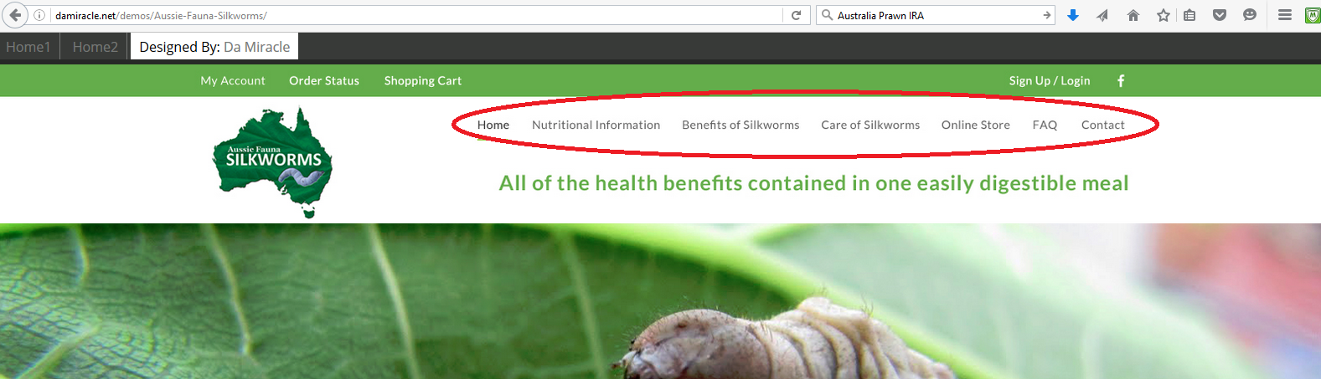

- As previously requested please add several more images to the jquery slider, there are several images in the briefing upload such as the bearded dragon eating a silkworm, frogs, tarantulas, koi, etc.

- Please add Facebook link to Aussie Fauna Page

- Please remove Wish Lists from top left of page
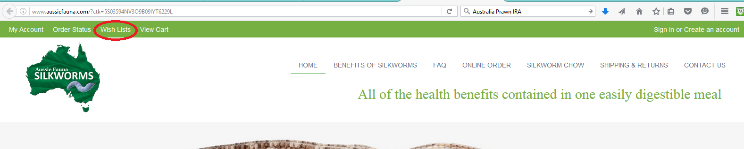

- The “Buy Now” button under the jquey does not take to products page

- For the products in the online order, when you click on the product it does not currently take you to a new page which tells the information about the product.

- It does not seem that the products that are on the website are actually linked to the BigCommerce products platform. I.e. the control functions of adding products, updating photos, prices, adding new products, removing products, and selecting which are featured products etc.

- For the actual content to be included under the tabs please refer to the word document of the brief at the start of the project. (Home Page, Nutritional Information, Benefits of Silkworms, Care of Silkworms, Products, FAQ, Shipping/Return Policy

- The FAQ section on the bottom of the home page will need to be updated with the correct answers. Please refer to brief word file.

- The “Our Newsletter” Subscribe function does not work.

- Is it possible to not have the Made with POWr displayed below the contacts form?

- On the m

- bottom of the Homepage, the “Read More” button can be removed and please replace the test with:

Aussie Fauna has been providing silkworm chow and silkworm eggs since 2012. Aussie Fauna’s silkworms are bred in a veterinary approved facility which includes strict biosecurity, use of veterinary disinfectants to clean the facility and all equipment used to rear the silkworms. The silkworms are raised on premium European silkworm chow to ensure highest nutritional value and available year round.

