SAKATAY GLOBA – more ideas to convey what I envision. I hope this helps to give an idea of different elements that I am hoping for:
- I like the shape of the RAYS on this sunrise. I like the half sunrise shape


- I like the ARC of the sun on the horizon – I like the rounded shape ( too much sun though – I only want a half sun)

- I like the ANGLE of these suns – set on the side (2 examples shown)


- I like the STYLE of the SUN – Just the black and yellow OUTLINE and INSIDE SHAPE of the SUN. (note I want different rays as mentioned in number 1)
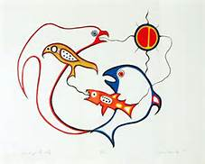

- I like the PROFILE idea for the turtle – imagine this idea with the sunrise arc’d to the side instead of the trees…
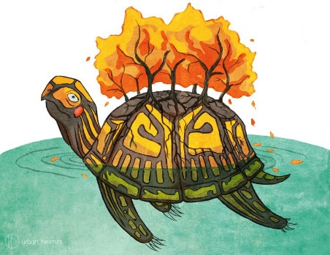

- I like the STYLE of this artwork, overall, and for the detail on the turtle and turtle shell

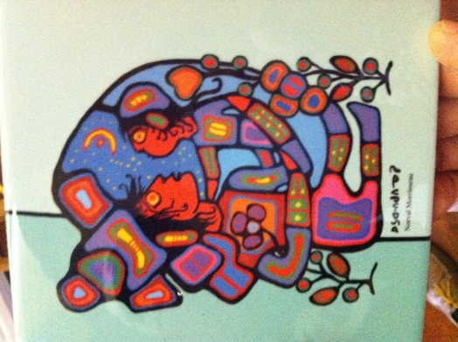
Ss
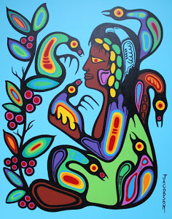

- I also like the COLOUR AND RIM of the SUN in this picture (but I like the divided sun detail as mentioned in number 4)
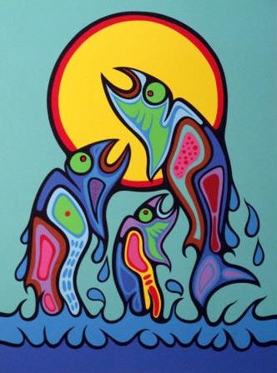
- Style influences to google for inspiration:
  - Woodland School of Art
  - Mark Anthony Jacobson
  - Norval Morriseau
  - Jackson Beardy
  - Roy Thomas
  - Lloyd Kakapetum
  - Peter Kakegamic

