From the purse you carry to the cookies you buy in the supermarket this social entrepreneur reveals how consumers and business can do better by doing good.

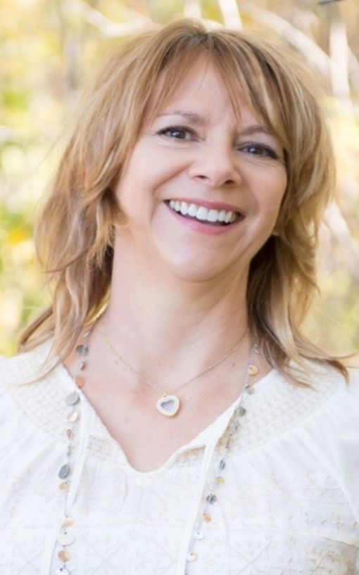
Carole Murphy, Social Entrepreneur and Radio Host
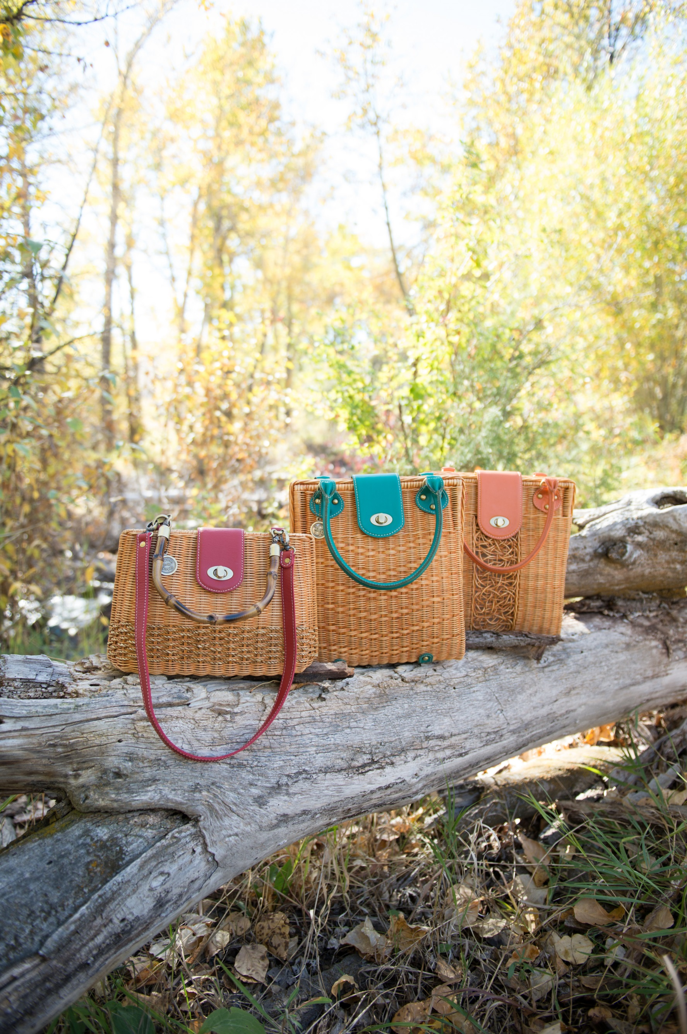
Story Ideas
- How to make empowered choices when shopping for fashion and accessories.
What natural materials and seals of approval to look for
- How the foods you purchase at the supermarket may be killing the Rain Forest.
All about palm oil, it’s impact on our environment and use in the snack industry.
- Why it’s time to bring back made in the USA.
How our re-shoring efforts can improve the economy and the environment.
- What is a Social Entrepreneur and can it be more profitable?
Studies have revealed socially conscious businesses tend to be more profitable over the long-term

Media and Speaking Experience:
Heart Stock Radio Podcast Host: topics of social enterprise, conscious business practices and the impacts business can have on social, cultural and environmental health Production of Butte America Radio KBMF 102.5
Indiegogo: Crowdfunding Campaign
product launch and publicity campaign via social media and press: $9180 raised
Public Speaking : Health Care Industry
topics of practice management, orthodontics and Invisaline as far away as China

Contact: cmurphy@purseforthepeople.net
Phone: 559-681-4020
P.O. Box 3682, Butte, Mt. 59702

