I like the site design shown below – like the flow – This inspirational and will need to change to make own and not a ripe off of this
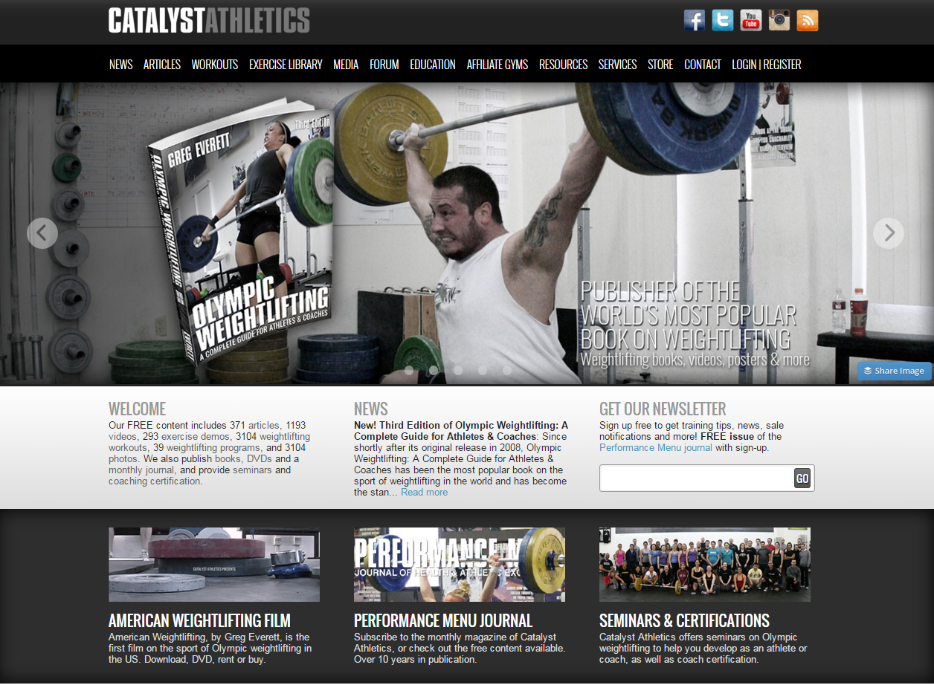
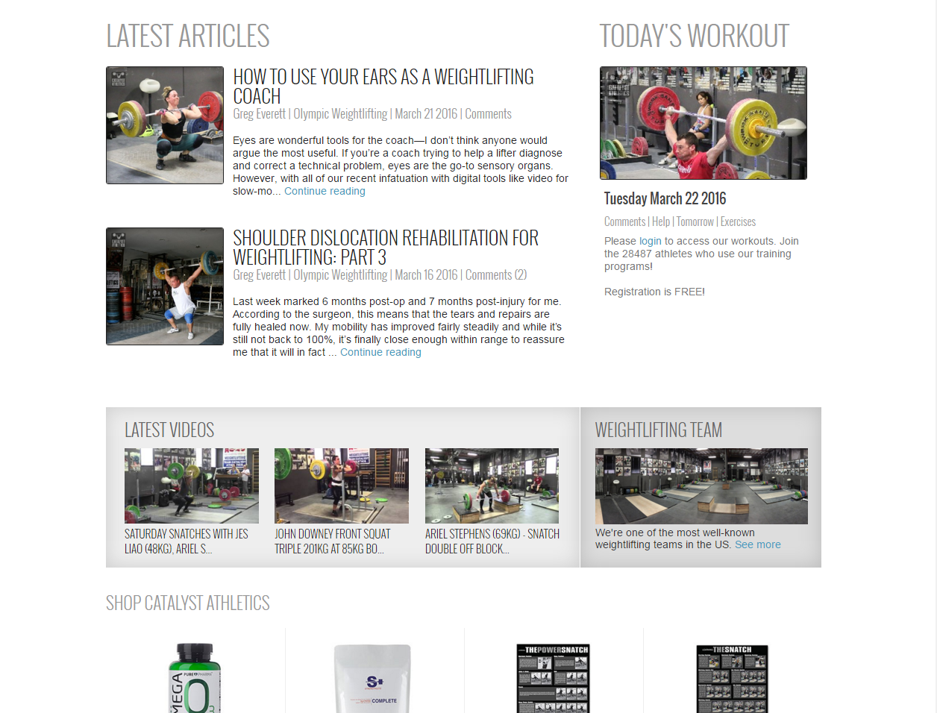
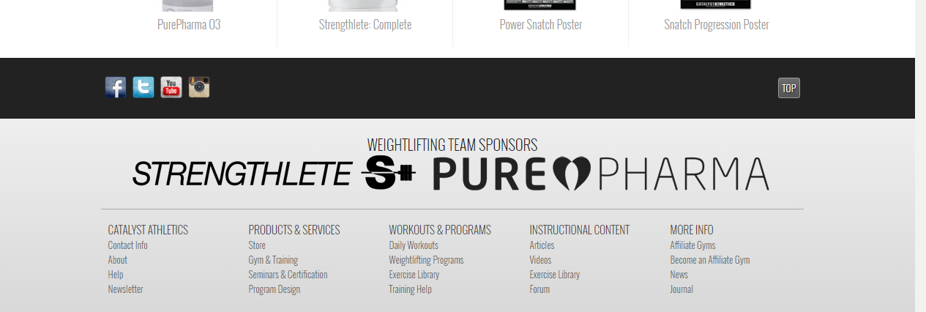

It has a sections and on the top and index on the bottom
Has a place for newsletter on the front and articles and blog info on the front page

