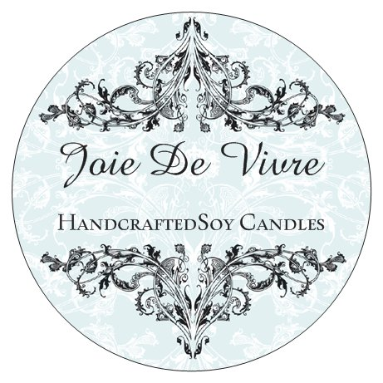
- Joie de Vivre – an exuberant enjoyment of life – these candles will fill you with “Joie de Vivre.
- Candles are lovingly hand-poured and use only the finest of ingredients and fragrances
- Hand crafted soy candle creations
- Completely non-toxic
- Exquisite fragrances
- Clean burning
- Environmentally friendly.
Why soy wax?
- Soft smooth wax that burns clear – no soot or smoke
- Soy wax candles burn up to 50% longer than traditional paraffin candles
- Made form soya beans, a renewable natural resource that supports and sustains agriculture – it is biodegradable and environmentally friendly.
- Soy wax burns cooler than paraffin and disperse the fragrance more fully.
Containers can be refilled
- I offer a refill service -if you return you containers to me I can refill with the fragrance of your choice
- Or if you have a special container you would like to use for your candle just contact me for a quote.
- I have a wide range of fragrances - please contact me for details.
Email: beverly.watson@gmail.com
Mobile: 021 2420725
Website: www.myjoiedevivre.co.nz
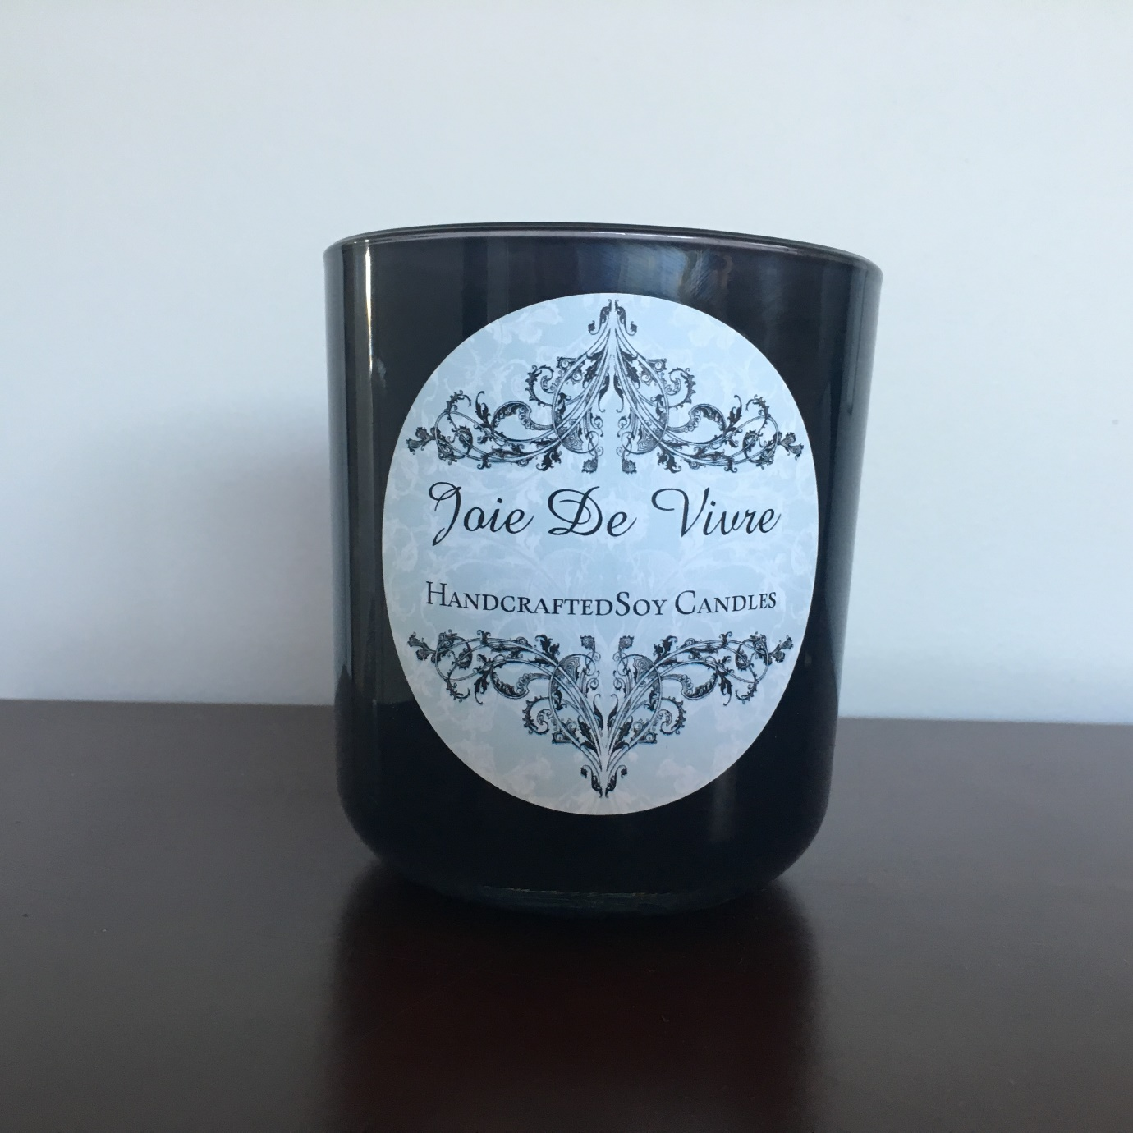

How to care for your candle – the following tips will ensure you have a long lasting, fully fragranced candle
- When lighting you candle for the first time, allow the wax to melt all the way to the sides of the container – this creates a ‘memory’ and avoids ‘tunnelling’ as the candle burns.
- Always trim the wick to about 6-8mm before re-lighting your candle. This will ensure a long lasting candle, minimise soot and remove any mushrooming of the wick from a previous burn.
- It is preferable to use a candle ‘snuffer’ to extinguish the flame, or a lid if the candle has one. Alternatively, you can dip the wick into the melted wax and then straightening. This wil stop the wick from smoking and help with relighting.
- All Joie de Vivre candles are hand poured not massed produced – although every effort is made to ensure consistency, every candle may be different.
- Sometimes you may notice darker patches or wet spots - this is not a fault it is just the natural way the wax has set – it does not affect the candle in anyway.
- The top of the candle may also appear slightly uneven – this is just a sign of natural soy wax being hand poured.
- Do not leave your candle in the sunlight as it may turn a yellow colour – again this does not affect the candle in anyway – it just loses its creamy white colour.
- As these candles contain no preservatives or chemicals it is recommended that they should be used within 6 months.

