AGILITY JUMP HURDLES AND TYRES

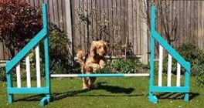
This is a hurdle.. would though be perfectly happy if the dog was just jumping the pole (ie. not showing the wings)

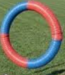

This is the shape of the tyre.. colours/design vary – can be single colour or two colours

