Design notes:

- The site is modelled on airbnb.com. Kerb™ is the ‘airbnb for parking’ but needs its own distinct style
- Need fully responsive mobile site. We can adapt for our own hosting environment (eg, Wordpress/Cake PHP), depending on your needs
- Primary design colours are black and white, but some colour (see AirbnB examples), particularly as it relates to parking slots, might be nice
- Have included the original iPhone and iPad design concept. We plan to localize the home page based on where the user is logging in. Eg, if the user is logging in in Paris, they will see a B+W picture of Paris, with Kerb™ Votre parking privé on the home screen; a Brazilian logging in from Rio de Janeiro would see an aerial picture of Rio with the text Kerb™ Sua vaga particular”. We envisage that the homescreen will switch out after 7 seconds to the next city in that particular country.

- Home page (above the line)

 | Lease your parking space for FREE | Help | Sign Up | Log in
Kerb™

Your private parking space…

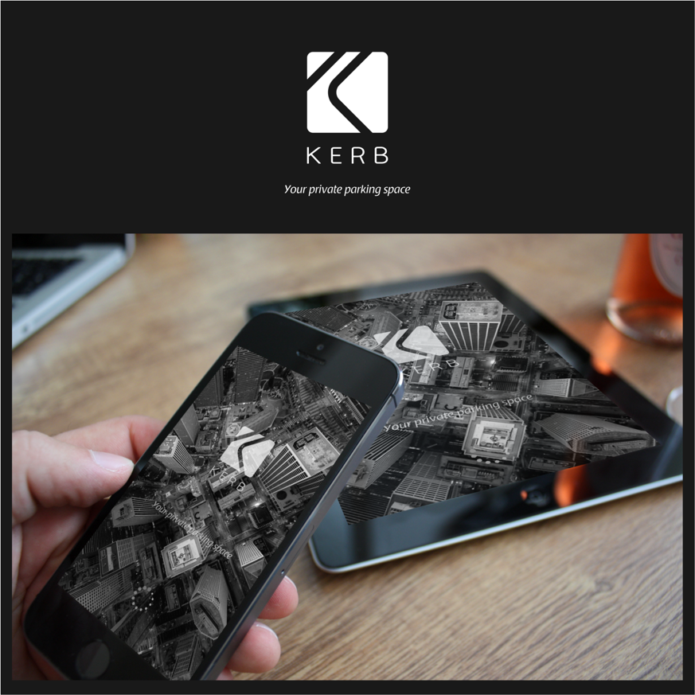

How it works

Car icon | Boat icon | Scooter icon | Helicopter icon

Where do you want to park? | Check in | Check out | Vehicle Type

- Home page (Below the line)

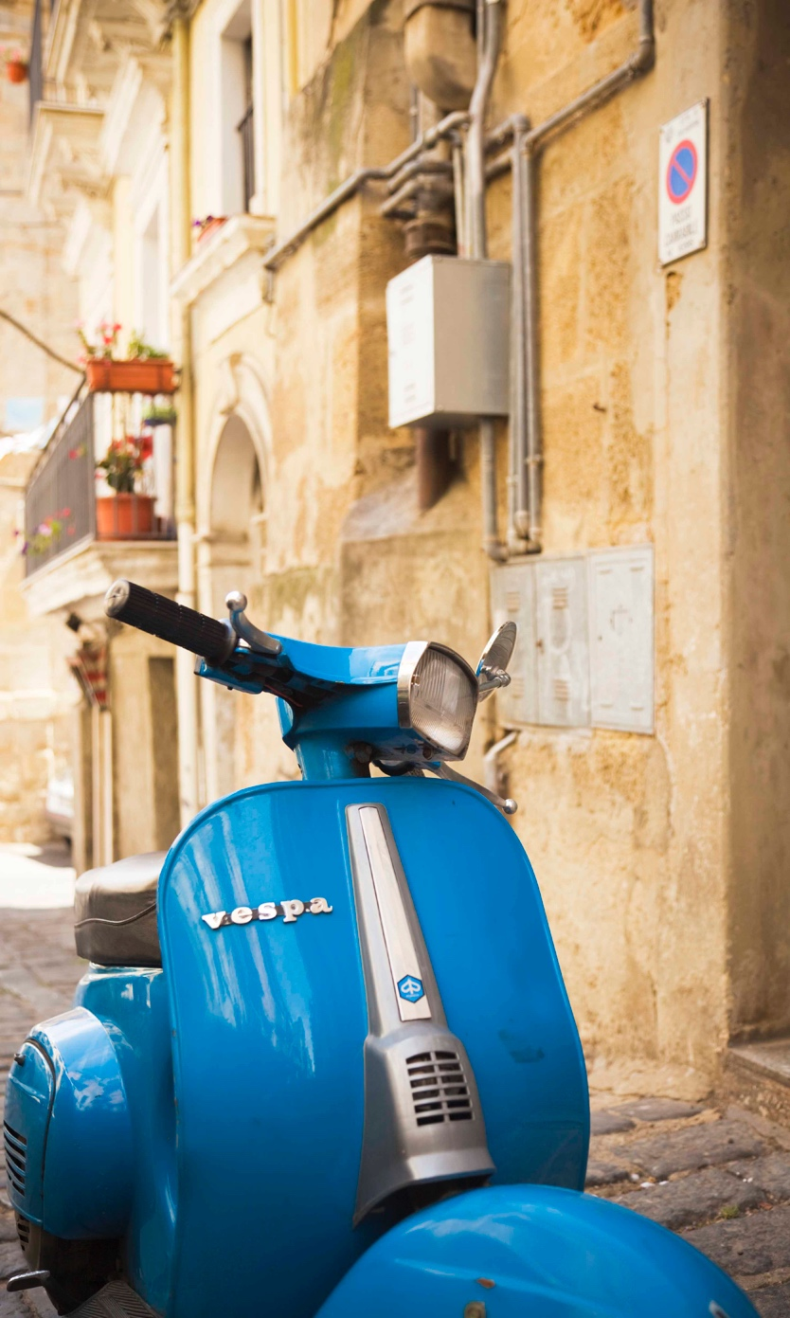 |  |  |  |  |  | Parking your vehicle just got easier
 |  |  |  |  |  | Leasing your private parking space just made more sense  Earn money sharing your extra space with people seeking a parking spot like yours.
Explore the world of Kerb. See where other people are parking.
Sydney | Adelaide | Melbourne
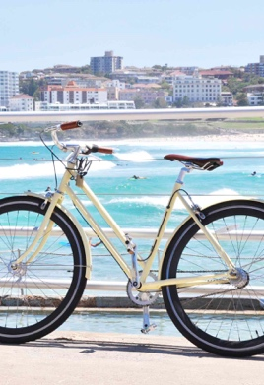 | 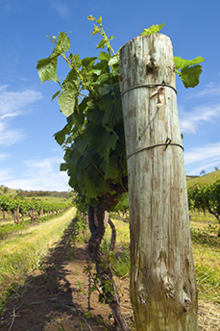 | 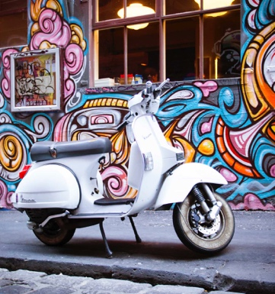
Paris | Barcelona | San Francisco
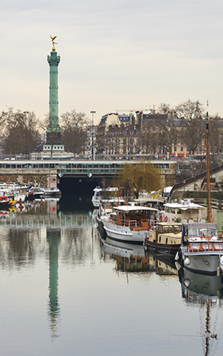 | 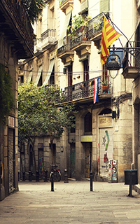 | 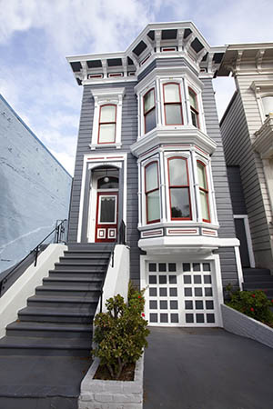

Just for the day

Discover private parking spots in your city
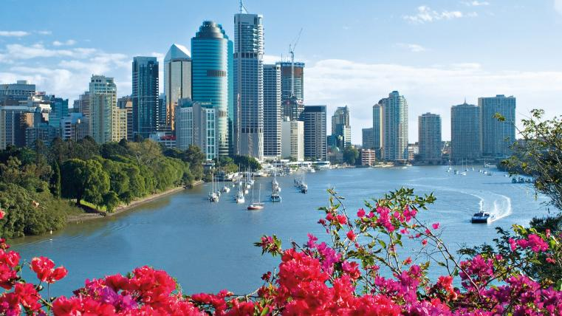

Our Community of Parking Owners & Renters
Maya  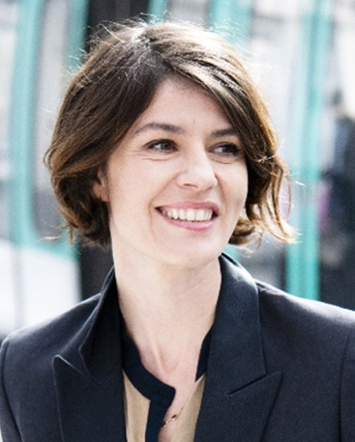 |  | Simon  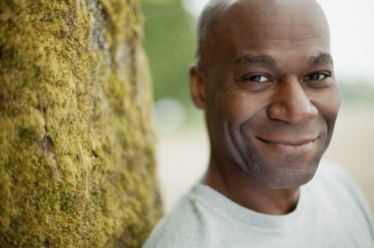 |  | Barbara  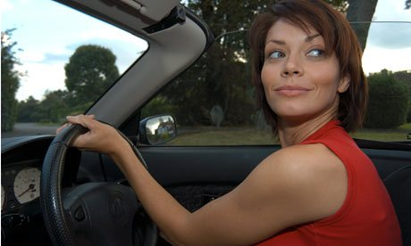 |  | Hasif  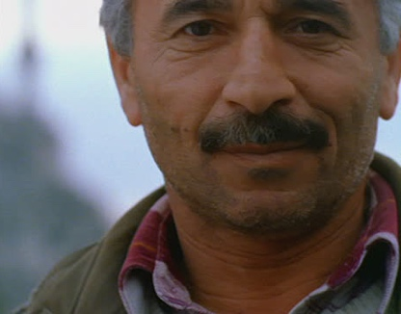
Maya Weidenham travels into Geneva for work Monday-to-Friday. She rents an affordable garage through Kerb, right next to Geneva train station.  Learn more about renting a parking space through Kerb. |  | Simon Hardcastle leases his vacant driveway in Wimbledon, London, for £190/month. “Kerb allows me to make some extra money each month, for a space which would otherwise be sitting empty.”  Find out how to lease your empty parking space with Kerb. |  | Barbara Cohelho commutes from Campinas to Sao Paulo every day. Through Kerb, she has found a private spot to park her car, right behind her office building.  Learn more about renting a parking space through Kerb. |  | Hasif Kundak leases his garage in Istanbul to two motorbike owners who work nearby. “The extra money I make from leasing my garage helps me pay the bills.”  Find out how to lease your empty parking space with Kerb.
Find your private parking space through Kerb Alerts

Your first name | Your last name | Your email
Your mobile | Where do you need to park? | SIGN UP

English | Kerb™ |  | Discover |  | Leasing
 | About  Kerb Services  Press  Work for Kerb  Help  Policies  Terms & Privacy  Contact Us |  | Trust and Safety  Invite Friends  Parking Alerts  Kerb Picks  Mobile  Site Map |  | Lease your space for FREE  Responsible leasing  Kerb Community  Safe Parking

