(Kerb logo)
   | Lease your parking space for FREE | Help | Sign Up | Log in
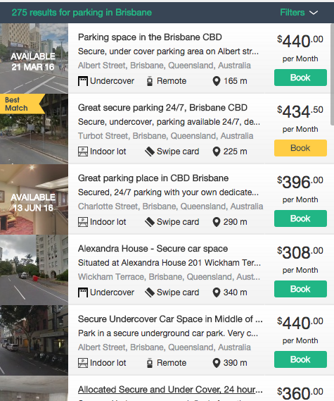 | 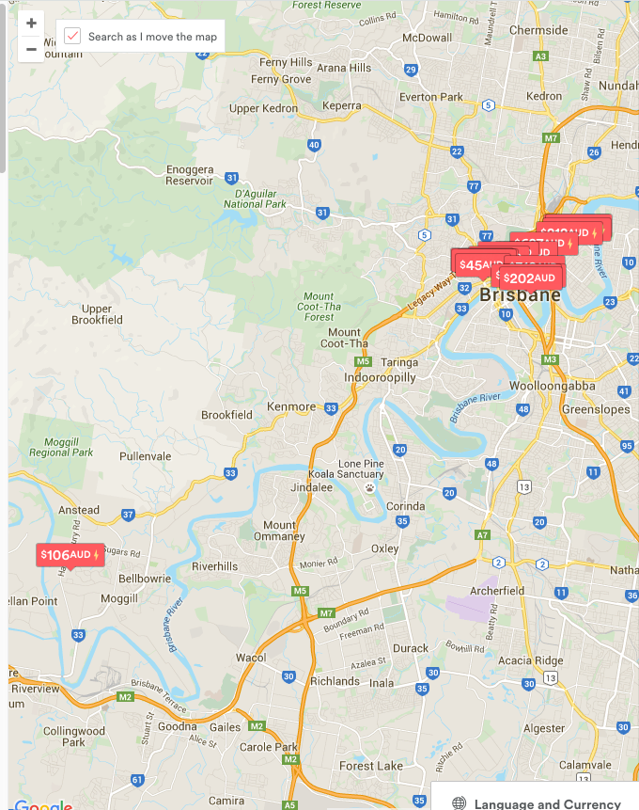
  Dates | 23-06-2016 | 23-6-2016
  Time | 08:00 | 18:00
  Vehicle Type | Car (icon)
Notify me when a new private parking space becomes available in Brisbane |  | Notify Me
  Your email address
English | Kerb™ | Discover | Leasing
 | About  Kerb Services  Press  Work for Kerb  Help  Policies  Terms & Privacy  Contact Us | Trust and Safety  Invite Friends  Parking Alerts  Kerb Picks  Mobile  Site Map | Lease your space for FREE  Responsible leasing  Kerb Community  Safe Parking

