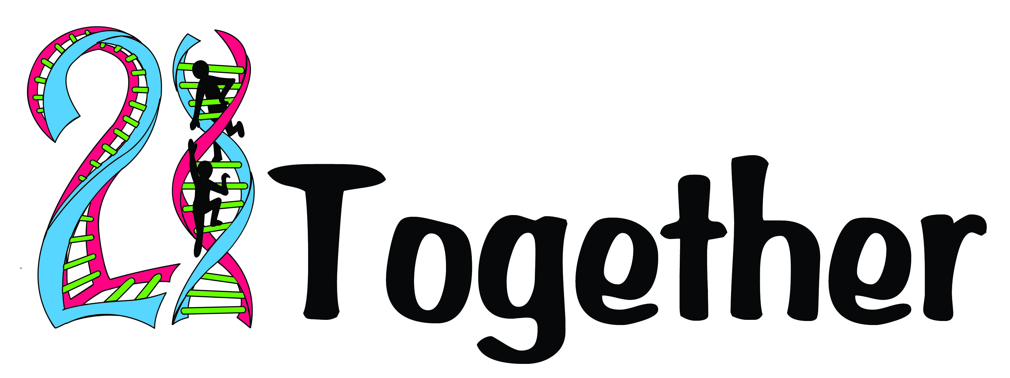

Raising Expectations

We believe that everyone has the right to live their lives to the fullest of their potential. We will work together to raise expectations within the Down's syndrome community and to empower those around us to promote inclusion and achieve aspirations.
With raised expectations and empowered voices, anything is possible.
Aims
Raising expectations of
- The public. By educating the community and showing them how much people with Down’s syndrome can achieve we can raise expectations and change attitudes. We want to help build a community in which people with DS are not merely accepted and catered for but one in which they make meaningful positive contributions to the community. Often the community wants to help but needs the information and support to empower them to do so.

- The parents and carers. The day of diagnosis, that moment when we stop being the public and become the parent. Many parents will never have encountered people with Down’s syndrome in their lives before, they won’t know what to expect and we want to help support, inform and train those parents to understand what their children may be able to achieve. To see past the diagnosis and to unlock the potential in their loved one.

- The person with Down’s syndrome. If no one around us expects us to do well then the chances are we won’t. We want to empower those people caring for a person with Down’s syndrome to have high expectations and in turn pass those high expectations on to those they care for. To drive aspiration and empower people with Down’s syndrome to have high expectations of themselves.

- Professionals. Many professionals do not have specific training in enabling a person with Down’s syndrome. We aim to raise the expectations of the professionals working with people with Down’s syndrome and their families. If they are empowered with the knowledge and skills to truly unlock potential and drive aspiration then they can go on to help so many families. Seeing that person as part of a network, part of a community, part of a family can empower people to not just treat impairments but to drive change and promote inclusion.

What we do.

- Training. We are going to provide a range of training aimed at both parents and professionals. The training will cover many areas including but not restricted to SEN law, education, therapies, social/behaviour approaches, independent living, transition to adulthood.

- Education and awareness. We are working with Canterbury Christchurch University to run education sessions with undergraduate midwives, we are now moving on to participate with a collaborative module between all health and social care students. We will be presenting about our experiences of person centred working and team work. We hope to build on this and help provide awareness training in many settings from acute hospitals to voluntary organisations like scouting.

- Information. Our goal is to provide pertinent information on our website and link to other useful sources. This is a work in progress and we will look to build upon this as we go. We hope to provide local advice so that each family can use the experience of the community to find the best resources and build a database of all useful local information.

- Support. Potentially the most important aim of our charity. At every step our families need support; we aim to provide support to the families and carers so they can continue to support the person with Down’s syndrome to live life to the fullest of their potential.

Would your business be able to support us? We are a local, dynamic and driven team who are determined to make an impact in our community. Could you be a part of it? Could you sponsor a specific event? Could you help us with advertising, venues, catering? Is your business looking for a charity to support over a set period of time? If you have any questions or just want to chat to one of the team then please contact us on info@21together.org.uk

