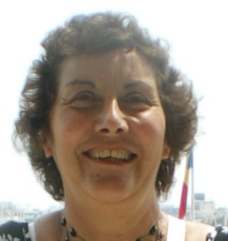
About me.

I have been an enthusiastic user of Signalong for many years. In 2008 I became a registered tutor which enables me to offer Signalong introductions, workshops and foundation courses to anyone interested in learning this excellent method of augmentative communication.
With access to the numerous Signalong manuals available I can offer training specifically to meet the needs of individual or group learners . These may be children or adults in a variety of locations, for example - at home, in playgroups, nurseries, schools, health care and work settings.
The unique Signalong methodology means that once learned users are able to perform any signs they need from the thousands of signs available from Signalong.

