Company Overview
We are a company that sells a large range of tarpaulins that are used for a broad range of applications. We have over 10 different grades and 50+ different sizes varying in prices and quality.
Brief
- A4 Multi Page Catalogue
This catalogue will be used by local hardware stores to sell our products to their account customers. The idea of this catalogue is to enable the hardware store to have a snapshot of our products that will be relevant to their customers whom are largely builders. This will be not be given out to their customer and will be used only in store as a selling tool.
We do not want the whole catalogue to be set out in tables but I have presented it here in tables so the information is easier to view, where information is import to be set out in tables I have highlighted. We really want someone to help us create an interesting style and bring experience regarding the styling of the catalogue. I have included an example of one of our previous catalogues which has been used over and over but are tired of the design.

Cover Page
Branded

Featuring section for ‘your local distributor’ which should be approximately the size of a business card preferably in the bottom right of the page.
Page 1-2 –
We would like the customer to be able to compare the sizes across the grades, but not have just a standard grid lines. All photos do not need to be used.
Roof tarps
We have a huge range of roof tarps available to suit any building project big or small for the short or long term. Ultimately, all of our tarps are suitable for covering roofs. Which one is most suitable depends on the job and preference of the builder.
PVC tarps are great as they are extremely durable, repairable and heavy enough to stay down on the roof and are less prone to flapping.
The main disadvantage is obviously the upfront cost and the limited size due to the weight of the fabric. Generally we feel that anything over 55kgs becomes unmanageable which is why we don’t have standard sizes bigger than what is displayed in each grade.
Poly Tarps can be more suitable than PVC tarps as they are more cost effective, available in larger sizes and therefore require less tying down and overlapping. They can also be used for covering timber/ sand etc when they have become well worn.
We have selected our most popular sizes as a guide as every house is different we do have sizes ranging from 1.8m x 2.4m up to 25.0m x 60.0n, so if you cannot find your required size please ask!

 |  | Picture | Picture | Picture | Picture
 |  | 240gsm Poly | 300gsm Poly | 550gsm PVC | 650gsm PVC
Tear Resistance
Abrasion Resistance
Puncture Resistance
Repairable |  | - | - | - Easily repaired with head weld patch | - Easily repaired with head weld patch
Waterproof
UV Treated
Centre Tie Downs |  | - | -
Sizes available up to |  | 250m2 (12x21m) | 180m2 (12x15m) | 110m2 (8x14) | 80m2 (7x11m)
Additional Features |  | Easy to fold & manoeuvre | Easy to fold & manoeuvre | Less prone to flapping | Less prone to flapping & fire retardant
Sizes | SQ.M  Coverage | 240gsm Poly  Silver/Green  Range Code - SG | 300gsm Poly  Green/White  Range Code - GW | 550gsm PVC  Green  Range Code - VG | 650gsm PVC  Blue  Range Code - VB
6.0m x 9.0m | 54m2 | 12.5kg | 16.0kg | 29.5kg | 35.0kg
6.0m x 12.0m | 72m2 | 17.5kg | 22.5kg |  | 47.0kg
7.0m x 12.0m | 84m2 | 20.0kg | 25.0kg
7.2m x 9.0m | 64m2 | 15.5kg | 19.0kg |  | 41.5kg
7.2m x 11.0m | 79m2 |  |  |  | 51.0kg
7.5m x 15.0m | 112m2 |  | 33.5kg
8.0m x 10.0m | 80m2 |  |  |  | 52.0kg
8.0m x 14.0m | 112m2 |  |  | 61.5kg
9.0m x 9.0m | 84m2 | 19.5kg | 25.0kg
9.0m x 12.0m | 108m2 | 24kg | 32.5kg | 59.5kg
9.0m x 15.0m | 135m2 | 32.5kg | 40.5kg
9.0m x 18.0m | 162m2 | 38.5kg
10.0m x 12.0m | 120m2 | 28.5kg
12.0m x 12.0m | 144m2 | 34.5kg | 43.0kg
12.0m x 15.0m | 180m2 | 43.0kg | 54.0kg
12.0m x 18.0m | 216m2 | 51.5kg
15.0m x 15.0m | 225m2 | 60.5kg
12.0m x 21.0m | 252m2 | 60.5kg

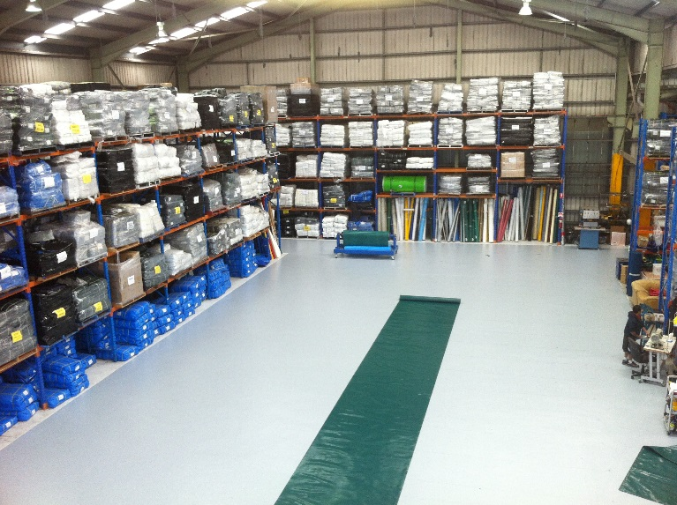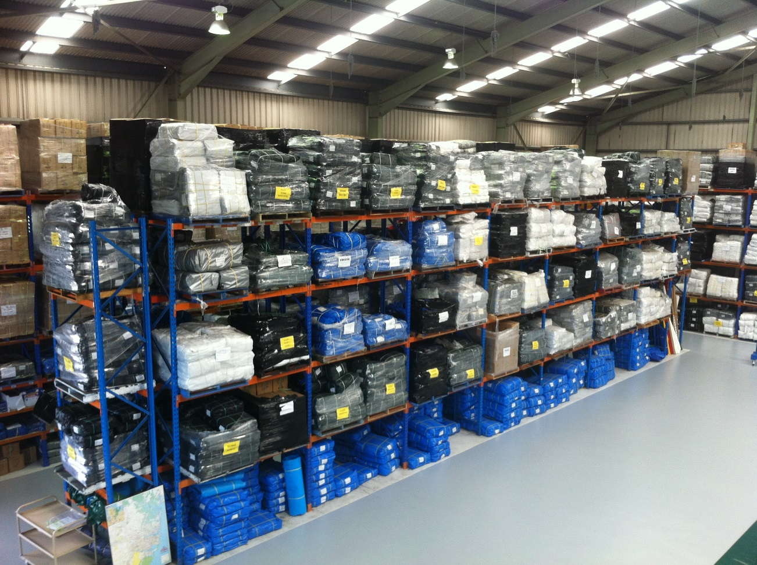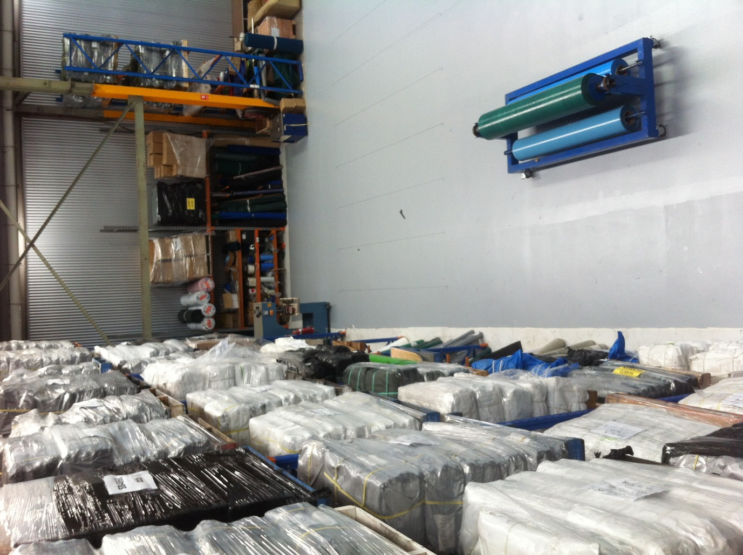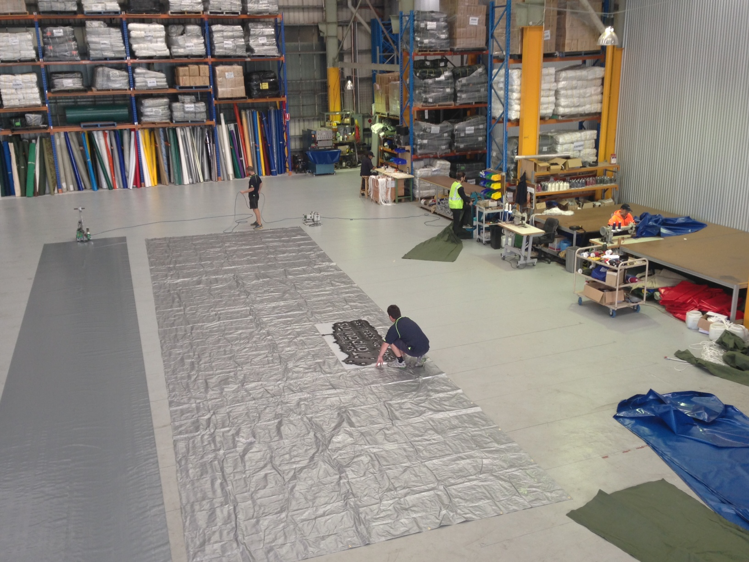

Pages 3-4 –
The Care and Use of Builders Sheets should be on the second of the two pages with the other details worked across the first page.
Floor Sheets
Builders Sheets have been a useful product in upper story extensions, particularly in Sydney as a lack of new housing space has seen many property owners add value to their existing dwellings with minimal disruption.
The floor sheet acts as a waterproof membrane thus limiting the risk of water damage to ceiling and other property below the work area as well as protect the newly laid floor from damage during the roofing process.
Our floor sheets are manufactured from a high-density polyethylene with a specially formulated coating. It is a tough, versatile fabric offering excellent UV, water and moisture resistance, outstanding tear and tensile strength and abrasion resistance. These materials are best welded to give maximum seam strength and have coatings of 50+ microns to give the maximum abrasion resistance for the price.
A range of stock sizes is available however custom sizes can also manufactured to your specification.

Sizes | Product Code | SQ.M Coverage | Weight
7.3m x 11.0m | FS7311 | 80m2 | 24kg
9.0m x 9.0m | FS9090 | 81m2 | 24kg
9.0m x 12.0m | FS9012 | 108m2 | 32kg
9.0m x 15.0m | FS9015 | 135m2 | 40kg
10.0m x 14.0m | FS1014 | 140m2 | 42kg
12.0m x 12.0m | FS1212 | 144m2 | 43kg
9.0m x 18.0m | FS9018 | 162m2 | 48kg
12.0m x 15.0m | FS1215 | 180m2 | 54kg
13.0m x 16.0m | FS1316 | 208m2 | 62kg
12.0m x 18.0m | FS1218 | 216m2 | 64kg
10.0m x 22.0m | FS1022 | 220m2 | 66kg
15.0m x 15.0m | FS1515 | 225m2 | 67kg
15.0m x 18.0m | FS1518 | 270m2 | 81kg
12.0m x 24.0m | FS1224 | 288m2 | 86kg
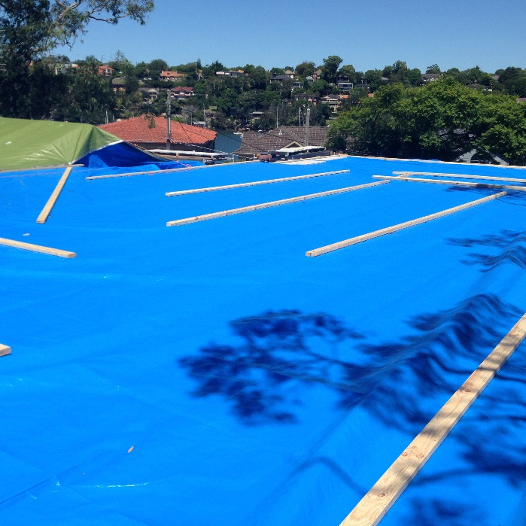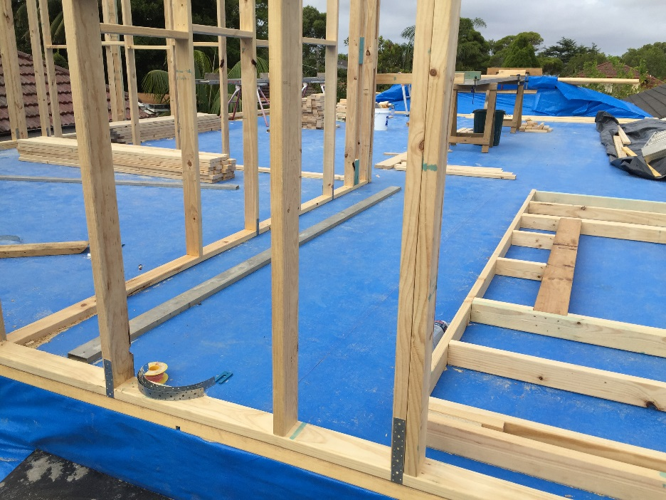
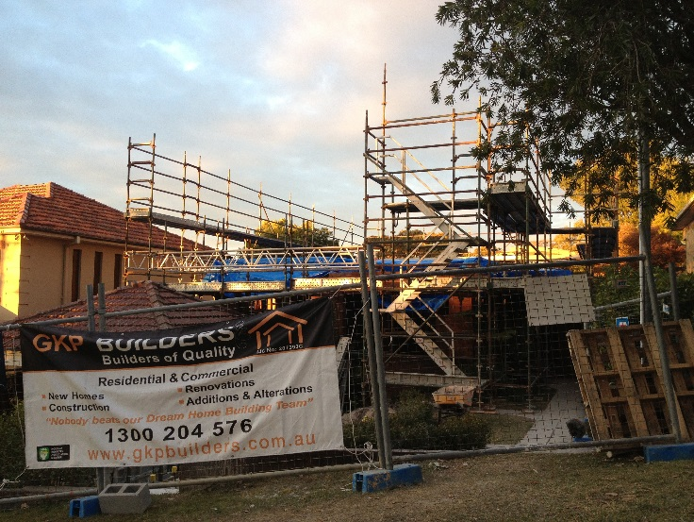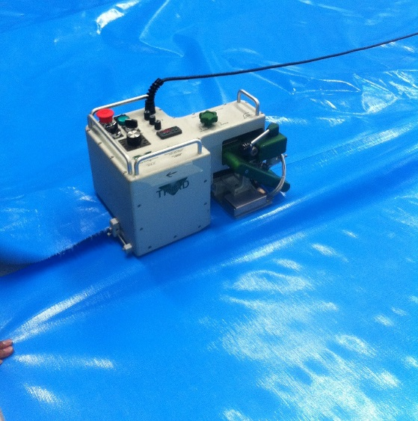

The Care and Use of Builders Sheets
First floor addition floor sheets have been in use in NSW since around 1972. They have proved to be a valuable addition to the techniques used in general building and second story work. With proper use the sheets minimise the risk of water damage to ceilings and other property below the work area and protect the newly laid floor from staining and damage during framing, roofing and fitting out activities. Floor sheets are NOT TARPAULINS. They are a watertight welded membrane made to a specific size and shape. The sheet is dimensionally larger than the proposed floor to enable the edges to be folded over and battened down to provide a waterproof cap. THEY ARE NOT DESIGNED TO BE USED TO PROTECT PARTIALLY STRIPPED ROOF STRUCTURES OR PARTIALLY COMPLETED FLOORS where the potential accidental damage to the sheet is high. A floor sheet should not actually be on site until the old roof has been removed and the new floor has been fixed, nailed, punched and swept down. Protection until this time should be with standard heavy duty tarpaulins.
General Usage and Tips
1. Your Floor sheet will come to you folded and rolled. Place it on a newly swept floor. Prepare plenty of half nailed battens to secure the sheet after it is unfolded. Never unfold the sheet in windy or unsettled conditions as loose sheets can be extremely dangerous. Carefully move the sheet in position, take one edge and carry it over the floor side and batten into place. Tighten sheet across floor to eliminate and folds and wrinkles. Fully batten around the edge to eliminate the chance of wind getting under the sheet.
2. OUTSIDE FLOOR PLATES must be checked out 150mm x 20mm approximately every 2 metres. This minimises ponding on sheets and saves a 50mm head of water in storms. It is also of great advantage to remove plates at doorways and build up wet areas ie, bathroom etc level with the rest of the floor to save ponding in these areas.
3. SWEEP SHEETS DOWN – it is really important that each day the sheet is carefully checked for any holes or abrasions. When located, clean and dry area thoroughly. A suitable material for patching is Floor Mate Glue. Do not forget to clean saw dust and debris from checkouts on floor plates. Obvious signs of holes in sheet after rain are dark patches in the material.
4. KEEP SHEET CLEAR – If stacking timber or roof trusses on sheet pack under with timber to ensure minimum damage and free flow of water but is our advice for the best results to keep the sheet clear. The membrane is your insurance against the elements.

Pages 5-6 –
Hire Tarps
PVC roof tarps available for hire to suit any building project big or small for the short or long term.
All PVC Hire tarps come folded and strapped and are readily available for same day delivery in the Sydney metro area.
SIZE | WEIGHT
6.0M X 9.0M | 35kgs
7.0M X 12.0M | 55kgs
9.0M X 12.0M | 54kgs
8.0M X 14.0M | 54kgs
- 8mm x 4m ropes spliced on every eyelet
- Comes checked for holes, folded and strapped
- Minimum charge 7 days
- Delivery & pick up service
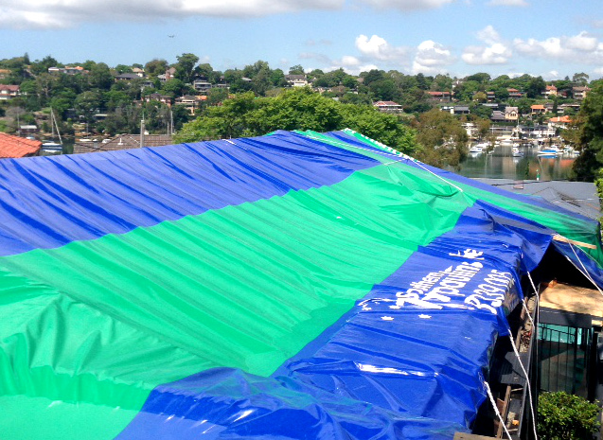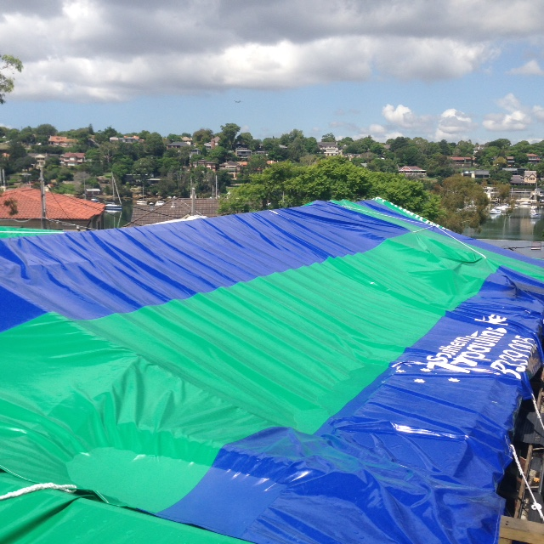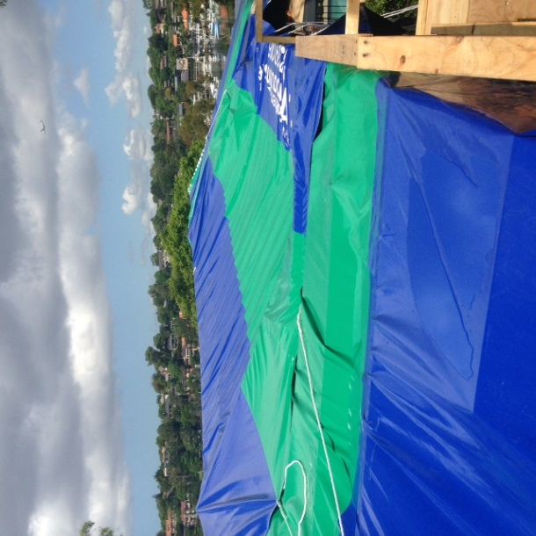

We have a fleet of near new PVC tarps ready and available for same day delivery. Our prices are almost half the major hire companies and what’s more, we can deliver and pick up straight to site.
HIRE FAQ’s
Q: Do you hire out for parties?
A: Unfortunately we do not hire our tarps for parties and functions. This is because our tarps are heavy and need the support of a roof or frame. (It is also cheaper to purchase a Poly tarp and own it outright than hiring a tarp!)
Q: I only need a tarp for 2 days, why is the minimum hiring charge 7 days?
A: Hiring a tarp is not like hiring a DVD! They are heavy and require 2 people to fold and service each tarp. After every hire, we hoist the tarp in our factory to check for holes, sweep, clean and fold ready for the next hire.
Q: Do you install the tarps?
A: No. Unfortunately we do not have the insurance required on building sites. We recommend a qualified tradesman to install the tarp.
Pages 6
Heavy Duty Mesh Covers
Purpose designed for covering loads of rubbish, tree & landscaping debris.
Over 24 sizes available off the shelf to suit most small trucks, hook bins & tippers.
These covers are manufactured from a durable & hard wearing 250gsm Black Mesh. They have a reinforced double stitched webbing perimeter and come with spliced ropes for a quick & easy application.
Size | Product Code
1.2m x 1.7m | TC1217
1.8m x 2.8m | TC1828
1.8m x 3.2m | TC1832
1.8m x 3.6m | TC1836
2.2m x 2.7m | TC2227
2.2m x 3.0m | TC2230
2.2m x 4.0m | TC2240
2.4m x 6.0m | TC2460
2.5m x 2.8m | TC2528
2.5m x 3.6m | TC2536
2.5m x 4.0m | TC2540
2.5m x 5.0m | TC2550
2.7m x 4.1m | TC2741
3.0m x 4.2m | TC3042
3.0m x 5.0m | TC3050
3.0m x 7.0m | TC3070
3.2m x 5.5m | TC3255
3.2m x 6.5m | TC3265
3.5m x 6.0m | TC3560
3.5m x 7.5m | TC3575
3.7m x 7.5m | TC3775

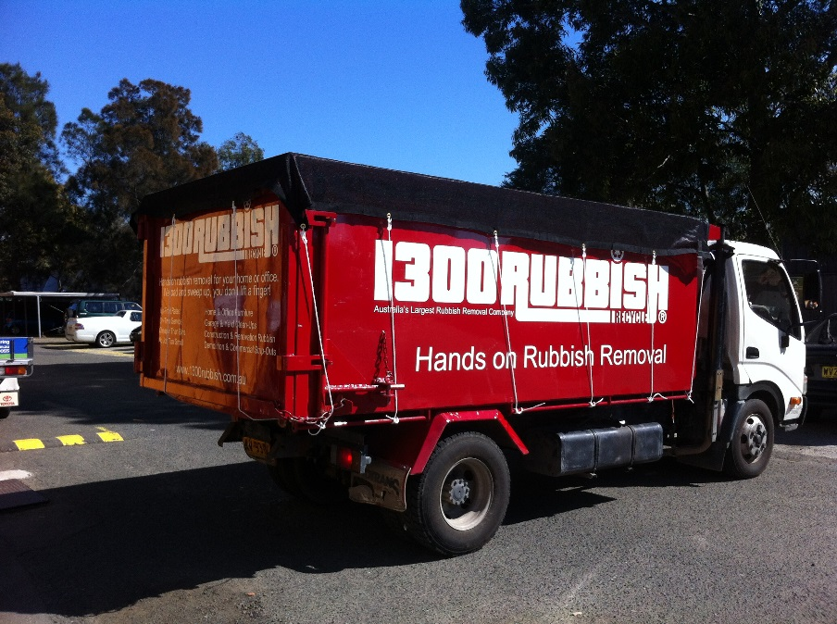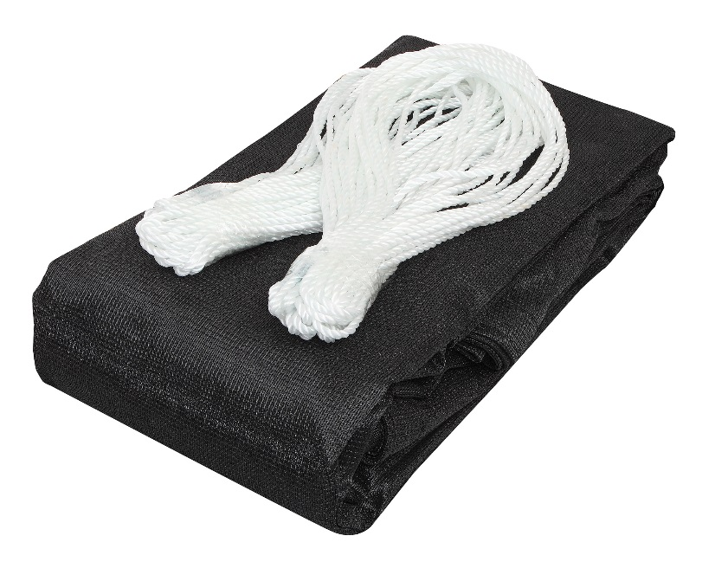

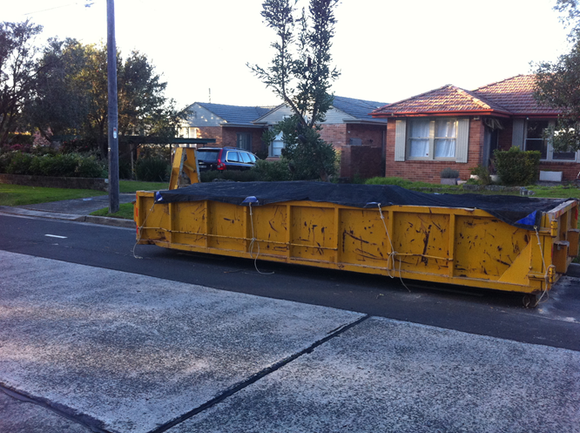

Page 7 –
Comparison table important but should not be the complete forcus.
Canvas Tarps - Truck & Trailer
Canvas Fabrics are usually made from Cotton, Polyester or a blend of both. Cotton is a natural fibre that expands when wet enhancing the water resistance while Polyester gives the fabric strength.
With two different stocked grades to choose from we offer a large range of sizes to best fit your application.
 | 14oz  100% Cotton  Range Code – CT | 22oz  50% Poly, 50% Cotton  Range Code - CS
Tear Resistance
Abrasion Resistance
Water Resistance
Shorteners | - | Yes – selected sizes only
Size Range | 1.2m x 1.8m up to 9.0m x 12.0m | 1.2m x 1.8m up to 9.0m x 12.0m
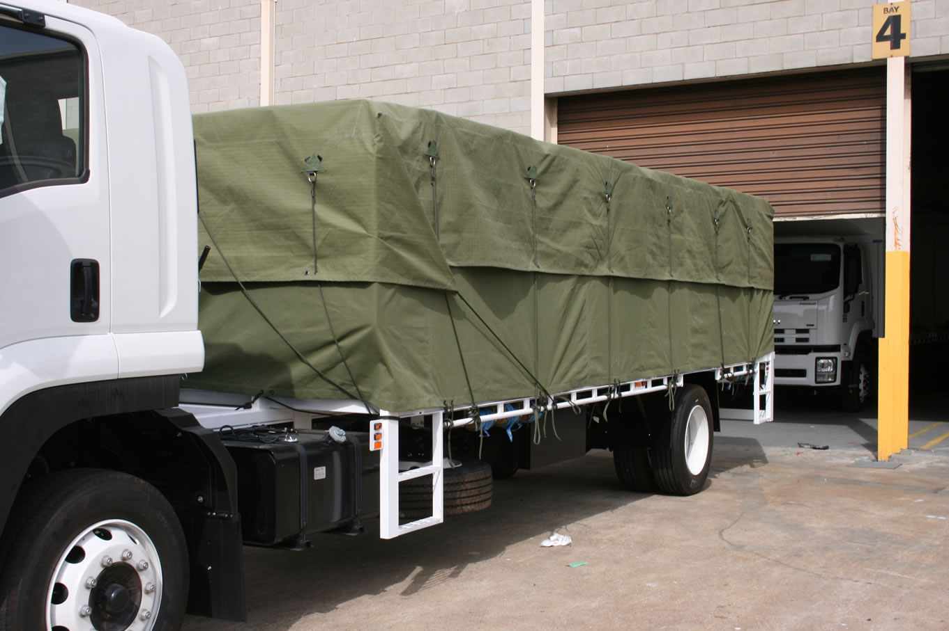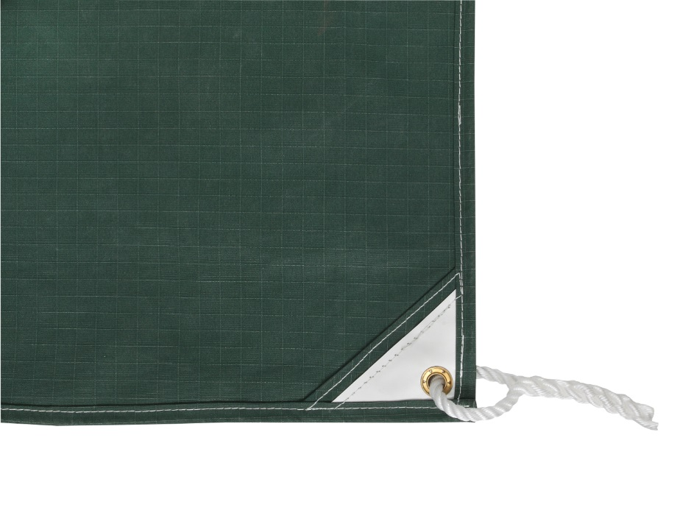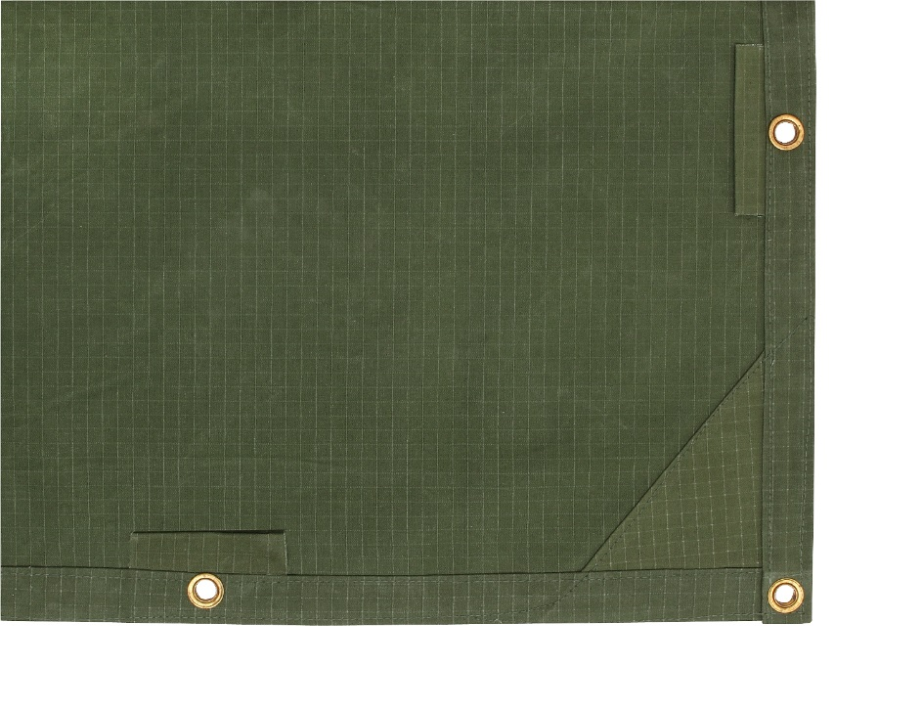
Back Cover –
Southern Tarps has grown into once of the largest suppliers of tarps in Australia. We specialise in supplying to the building industry & have large range of poly, pvc, canvas & mesh tarps available.
3B/62 O’Riordan Street
Alexandria NSW 2015
info@southerntarps.com.au
