This is the logo Header SALA uses which describes the event. BAALA would want something along these lines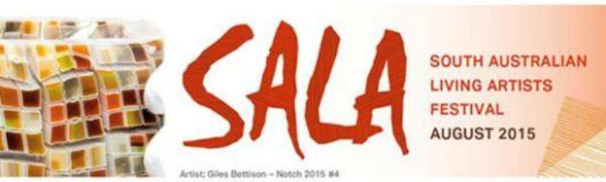
This is the more simple graphic


Mt. Buller official log


Current BAA logo adapted from the official logo


