SnapWall Mobile Redesign

Landing Page
The landing page needs to have four options (instead of three currently)
- CREATE
- ACCESS
- MY WALLS (new)
- HELP
Needs to have the tagline “Creating memories together”

Current UI (iPhone)
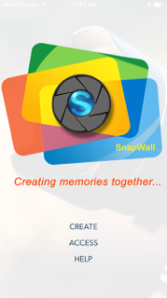

CREATE
The create page allows user to create a new wall to share. The following fields are included on this page
- Wall identifier
- Administrator access code
- Contributor access code
- Email
- Expiration date
- Checkbox to agree to terms
- “Create” button
Look at other mobile apps for nice watermarks for each boxes

Current UI (iphone)
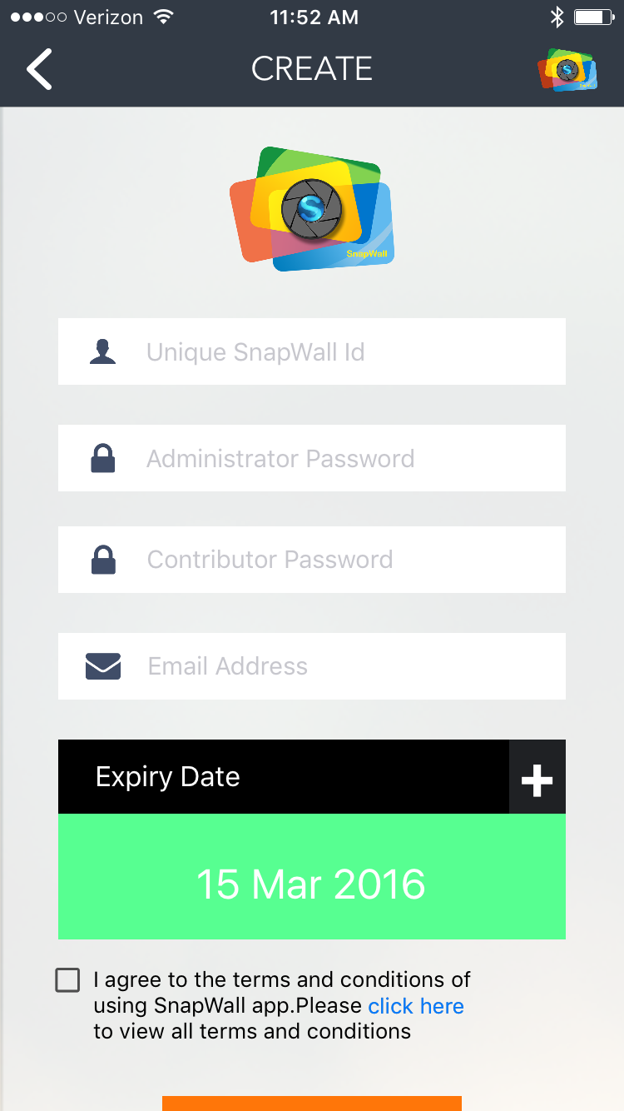

ACCESS
This page is used to access a wall (album). It has the following user inputs available
- Wall identifier (make sure we use same text/name across)
- Access code (currently it reads password. Need more consistency. It needs to be access code)
- Button to “login”, or “Access”
- Forgot Password Link at the bottom
- (new) Request Access link at the bottom
Make sure there is a way to go home from this page

Current UI (iPhone)
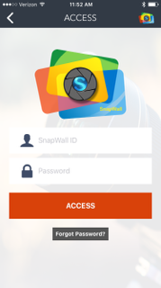

Forgot password pop-up
The forgot password pop-up currently looks very clugy. Needs to be nice looking pop-up where the user will enter the wall identifier and the email address registered with it. On Submit, the pop-up should read that “Details of your Snapwall have been sent to the registered email address”.

Request Access (new)
This is a new pop-up which will have the wall identifier as input and the users email address as input. On hitting submit, a message should read “Your request to access the SnapWall has been sent to the administrator of this wall”.

Landing Page (PHOTOS)
Displays pictures in a list view (thumbnails). At the bottom currently for a user there are these options “Add, Facebook, Download, Help”. Other otpions on this page are hidden behind right top menu “Share/logout”.

Bottom Bar
I would like to take the help out of bottom and move it to top menu or something like that, but all the actions user can take need to be at the bottom
Add, Facebook, Download, Share, Subscribe (get notified), Logout
If that’s too many, those can be broken down into
Add, Share, Subscribe, Logout (when no pictures are selected)
Add, Facebook, Download
When user has selected 1 or more photos

Top Bar
Maybe the top bar needs to just have the wall identifier. It also needs to have a nice “Select” button/link which when clicked changes “cancel”. Once user has clicked “Select”, somewhere, it should provide the option to “Select All”. When the user has selected “Select”, the bottom bar moves to option two

Current landing Screen
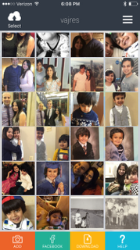

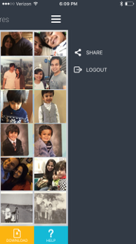

MY WALLS
My walls is a new screen and should show blocks of walls you’ve access to (you’ve logged in once). Display could be similar to some blocks and titles below it
Sample schematic (the box should show one of the pictures from that wall). Some option to go back/home from the top or bottom

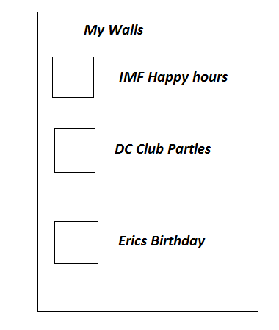

Admin Landing Screens
Landing Screen if same as user landing screen. Except on hitting select, admin has an additional delete option and a “approve” option (approve option is used if the wall is set to “admin approval required”)

ADMIN UPDATE SCREEN
This screen allows updating of album properties

