
EASTER WORKSHOPS
This spring, your child will enjoy a joyous journey to the magical world of Once Upon a Time for a fabulous springtime treat.

We will work our magic to ensure your child enjoys every minute. Guiding each child every step of the way and inspire and encourage them to project their voices, learn energetic dance routines, sing catchy songs, and more importantly HAVE FUN!

Tuesday 5 & 6 April 2016
Age 3 – 7 years
10 – 12pm 18 per day
or 30 for both days

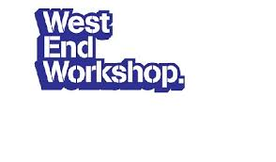

Our Easter dance camps are fun, fresh and funky, mixed together with a little musical theatre!

WEST END WORKSHOP
Tuesday 5 & 6 April 2016
8 – 16 years
1-4pm

30 per day/ 55 for both

Venue The Parish Hall of St Nicholas Thames Ditton KT7 0QQ

Email starlightsdancebiz@gmail to book or text 07825619699

STARLIGHT SUMMER SCHOOL

A WICKED WEST END WIZ

8 August – 12 August 2016

10 – 4

150.00

Summer school is designed for young people who enjoy performing. The course introduces you to various disciplines of theatre: Acting, Singing and Dance.
Everyone is able to develop at their own pace, no-one is forced to perform and there are opportunities for you to explore performance techniques.
Students will develop key skills in teamwork, communication and confidence whilst building friendships and having fun!
The week ends with a showing, to friends and family, of the skills and musical numbers achieved during the course.

A flash funky flyer that will appeal to teenagers

Venue The Parish Hall of St Nicholas Thames Ditton KT7 0QQ

Email starlightsdancebiz@gmail to book or text 07825619699

