  Passion
  Progress
  Purpose
  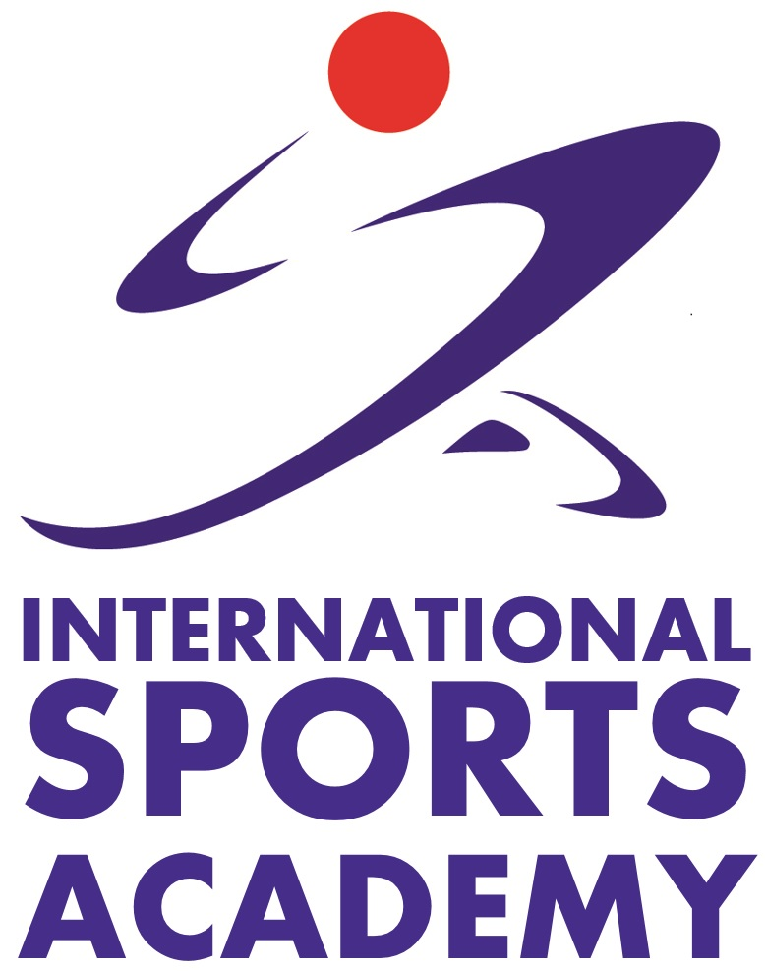 | International Sports Academy  1 Stadium Place, Kallang Wave Mall, #01-11  Singapore 164027
  Course Catalogue
  
  
  International Sports Academy

About Us
Why is ISA so Awesome?
Because we interact with students as though we are classmates instead of management and students as well as friendly and fun management team. We want to stand out from all the private schools in Singapore to make International Sports Academy for fitness enthusiasts who wish to upgrade themselves as a sport leader.
What do we do?
International Sports Academy provides professional courses for future sport leaders who are willing to upgrade themselves with skills that allow them to have the expert knowledge for different aspects for sports.
Our Mission
Developing the Next Generation of Sports Leaders.
Our Values
Passion | Progress | Purpose

NOTES |  |  | Message from principal

Table of Contents  Sports Coaching Level 1 1  International Olympic Committee – Sports Administrators 2  Essentials Sport Science 3  Applied Exercise Science 4  Basic Fitness Nutrition 5  Advanced Fitness Nutrition 6  Fitness Training 7  Aerobic and Anaerobic Exercise Description 8  Applying Exercise Prescription Principles 9  ACE Certified Personal Trainer 10  ACE Fitness Nutrition Specialist 11  Fitness Training 0  Aerobic and Anaerobic Exercise Description 0 |  |  |   NSCA – Certified Strength & Conditioning Specialist  Price  $2100 Inclusive GST  Duration  5 session x 8 hours  Venue  International Sports Academy  COURSE OVERVIEW  Certified Strength and Conditioning Specialists (CSCSs) are professionals who apply scientific knowledge to train athletes for the primary goal of improving athletic performance. They conduct sport-specific testing sessions, design and implement safe and effective strength training and conditioning programs and provide guidance regarding nutrition and injury prevention. Recognizing that their area of expertise is separate and distinct, CSCSs consult with and refer athletes to other professionals when appropriate.  COURSE OBJECTIVES  Upon successful completion of the course, Learners will be able to understand:  - Structure and Function of the Muscular, Neuromuscular, Cardiovascular and Respiratory System  - Bioenergetics of Exercise and Training  - Endocrine Responses to Resistance Exercise  - Biomechanics of Resistance Exercise  - Adaptations to Anaerobic and Aerobic Training Programs

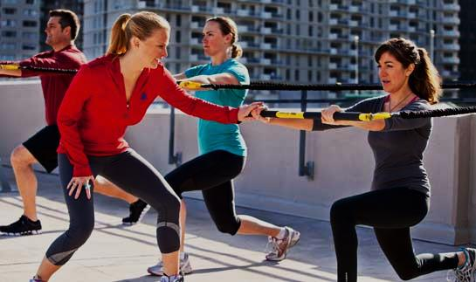  ACE Group Fitness Instructor  Price  $1712 Inclusive GST  Duration  2 months  Venue  International Sports Academy  COURSE OBJECTIVES  This course is designed to give students the knowledge and understanding necessary to prepare for the ACE Group Fitness Certification Exam and become effective group fitness instructors. This course enables GFIs to design safe and effective exercise classes for a variety of populations performing various exercises.  COURSE GOALS  Upon successful completion of the course, participants will be able to:  - Human Anatomy, Exercise Physiology, Applied Kinesiology, and Nutrition  - Who is the ACE-certified Group Fitness Instructor?  - Group Exercise Program Design  - Teaching a Group Exercise Class  - Principles of Adherence and Motivation  - Exercise and Special Populations  - Exercise and Pregnancy |  |  |   Sports Coaching Level 1  Price  $469 Inclusive GST  Duration  8 Sessions  Venue  International Sports Academy  COURSE OVERVIEW  This course is an assessment based programmed designed as an introductory level course for those who are interested in coaching. By providing both theoretical and practical knowledge on the fundamental aspects of coaching.  COURSE OBJECTIVES  Upon successful completion of the course, Learners will be able to understand:  - How to establish and maintain an effective, fair and equitable coaching environment  - the principles of coaching  - How to establish and maintain a safe coaching environment  - How to plan coaching activities and safe coaching environment  - How to prepare facilities and equipment for coaching and participants for coaching activities

  International Olympic Committee – Sports Administrators  Price  $439 Inclusive GST  Duration  3 days 20 hours total  Venue  International Sports Academy  COURSE OVERVIEW  This course is designed for students to understand the Olympic Movement by defining the values, attitudes and philosophy of Olympic Sport. The course includes theory and requisite skills for administration and management and discusses possible solutions to various needs, problems and concerns. Finally, information is provided on technical aspects related to athlete development and the leading of an Olympic Games mission.  COURSE OBJECTIVES  Upon successful completion of the course, Learners will be able to understand:  - The Olympic movements  - Who is the International/National Olympic Committee Members?  - The different types of Olympic Games  - The values of Olympics  - Ethics and Fair-play in Sports |  |  | ACE Fitness Nutrition Specialist    COURSE OBJECTIVES  This course is designed to give students the knowledge and understanding necessary to prepare for the ACE Fitness Nutrition Specialist Certification Exam. This course presents the theoretical nutrition concepts that will enable fitness professionals to provide practical and useful tips to their clients while staying within the boundaries of their scope of practice  COURSE GOALS  Upon successful completion of the course, participants will be able to apply complex content to real life scenarios in:  - ACE Position Statement on Nutrition Scope of Practice for Fitness Professionals  - Nutrition and Digestion  - Governmental Nutrition Guidelines and Recommendations  - Macronutrients, Micronutrients, Engineered Foods, Alcohol, Drugs and Stimulants  Price  $856 Inclusive GST  Duration  2 days  Venue  International Sports Academy

  ACE Certified Personal Trainer  COURSE OBJECTIVES  This course is designed to give students the knowledge and understanding necessary to prepare for the ACE Personal Trainer Certification Exam and become effective personal trainers. This course presents the ACE Integrated Fitness Training™ (ACE IFT™) Model as a comprehensive system for designing individualized programs based on each client’s unique health, fitness, and goals.  COURSE GOALS  Upon successful completion of the course, participants will be able to:  - Human Anatomy, Exercise Physiology, Applied Kinesiology, and Nutrition  - Principles of Adherence, Motivation, Behavior Change, and Health Psychology  - Communication and Teaching Techniques  - The ACE Integrated Fitness Training Model  - Building Rapport  Price  $1995.55 Inclusive GST  With CPR: $2065.10  Duration  3 Months  Venue  International Sports Academy |  |  |   Essentials Sport Science  COURSE OVERVIEW  This course aims to provide students with the basic knowledge to become a personal trainer, physiologist or nutritionist. The topics covered will give students the knowledge of basic exercise science, human anatomy, fitness and nutrition. Upon completion, students will be awarded a certificate from the International Sports Academy.  COURSE OBJECTIVES  Upon successful completion of the course, Learners will be able to understand:  - The basic human anatomy and its terminology.  - The functional anatomy of the heart, arteries and veins  - The nervous systems, skeletal systems and muscular systems  - Components necessary to achieve optimum fitness  - Physiology of cardiopulmonary system and energy pathway systems  Price  $359 Inclusive GST  Duration  3 hours x 4 sessions  Venue  International Sports Academy

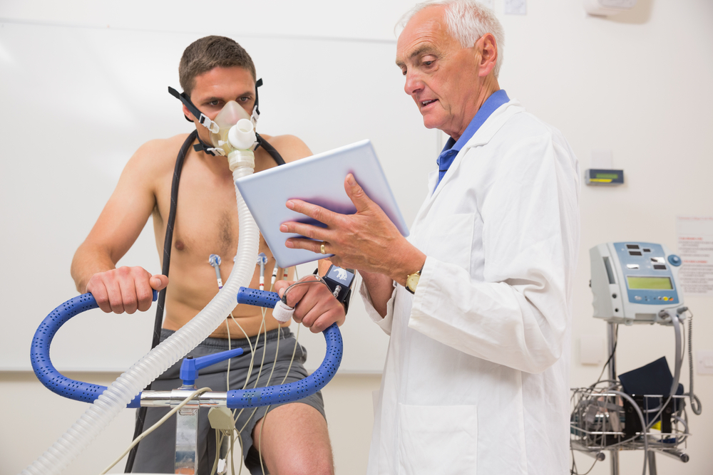  Applied Exercise Science  COURSE OVERVIEW  This course is an assessment based programmed designed as an introductory level course for those who are interested in the fitness industry. The course provides both theoretical and practical knowledge on exercise physiology, biomechanics, sports psychology and nutrition.  COURSE GOALS  Upon successful completion of the course, Learners will be able to understand:  - Structure and function of Muscular, Neuromuscular, Cardiovascular and Respiratory systems  - Bioenergetics of Exercise and training  - Endocrine Responses to Resistance Exercise  - Biomechanics of Resistance exercise  - Adaptations to anaerobic training programs  - Adaptations to aerobic endurance training programs  Price  $469 Inclusive GST  Duration  3 hours x 6 sessions  Venue  International Sports Academy |  |  |   Applying Exercise Prescription Principles  COURSE OVERVIEW  This course aims to provide students with the knowledge of periodization and program design. Topics covered will give students the knowledge of periodization cycles, periodization periods, rehabilitation and reconditioning  COURSE GOALS  To provide students with the detailed knowledge in which to upgrade themselves as a sports coach/instructor. The course will equip students with information and skills on:  - Responses to training stress  - Periodization cycles/periods  - Applying sport seasons to periodization periods  - Undulating versus linear periodization models  - Sports Medicine Team  - Types of injury  - Tissue healing  - Rehabilitation and reconditioning strategies  Price  $569 inclusive GST  Duration  3 hours x 2 sessions  Venue  International Sports Academy
  Aerobic and Anaerobic Exercise Description  COURSE OVERVIEW  This course is designed for students to allow them to understand more about aerobic and anaerobic trainings and how to design different types of trainings programs. By providing them specific knowledge on each of the components that is required for.  COURSE OBJECTIVES  Upon successful completion of the course, Learners will be able to understand:  - How to perform a needs analysis for athletes to evaluate their requirements and characteristics of sport  - How to do a selection of exercise for athletes to train  - How to plan and determine the training frequency  - How to put these exercise in order  Able to determine the training load and repetitions for athletes  Price Duration Venue  $419 Inclusive GST 4 hours International Sports Academy |  |  |   Basic Fitness Nutrition  Price  $419 Inclusive GST  Duration  3 hours x 4 sessions  Venue  International Sports Academy  COURSE OVERVIEW  This course is an application based, interactive approach to presenting theoretical nutrition concepts in a way that will enable participants to provide practical, actionable tips for others.  COURSE OBJECTIVES  This course aims to provide students with the knowledge to confidently provide safe and appropriate nutrition education and service to others in order to attain optimal health and weight management.

  Advanced Fitness Nutrition  Price  $469 Inclusive GST  Duration  3 hours x 7 sessions  Venue  International Sports Academy  COURSE OVERVIEW  This course is designed for students to allow them to understand more about nutrition principles, new research, special diets and assessments to evaluate and optimize nutritional status. By providing them specific knowledge on each of the components that is required for.  COURSE OBJECTIVES  To provide students with the advanced knowledge that can be implemented into trainings and nutritional planning. They will be taught on dietary guidelines, weight management and selection of food and provide recommendations on how to design a food intake plan. |  |  | Fitness Training  COURSE OVERVIEW  This course aims to provide students with the basic knowledge to become a gym instructor. The topics covered will give students the knowledge of basic exercise science, human anatomy, fitness, nutrition and coaching. Upon completion, students will be awarded a certificate from the International Sports Academy.  COURSE OBJECTIVES  Upon successful completion of the course, Learners will be able to understand:  - Human anatomical terms and planes  - Human skeletal system, joints and their range of motions.  - Kinematics and kinetics  - Exercise Physiology and skeletal muscle adaptations of endurance and strength training  - Energy systems and pathways  - Cardio-respiratory fitness and exercise techniques  - Principles of fitness and wellness  Price  $519 Inclusive GST  Duration  3 hours x 8 sessions  Venue  International Sports Academy

