Brief for Business Branding/Logo

Business Name: The Heart of Happiness
Partners: Penny Rixon
Carolyn Woodruff

Requirements

We need to develop some corporate branding, which includes a logo, colour scheme, background theme, font style. With variations to be used on:
- Website header
- Business cards
- Flyers
- Letter head/stationery
- In presentations
- Product labels

Colours:
We are looking for a combination colour theme of soft red, gold, blue, but not limited to these. That is, we are open to various shades of these such as yellow, aqua, pinkish red. Some sample colour palettes we like are:
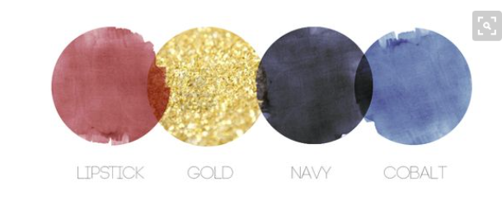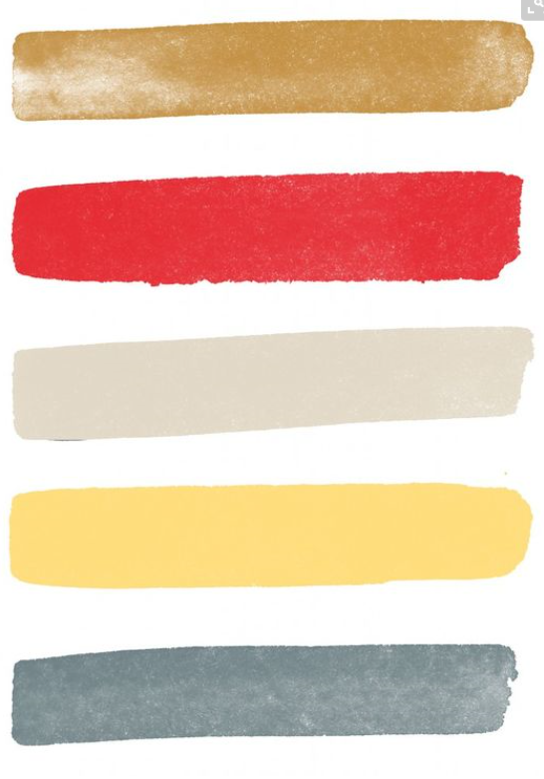

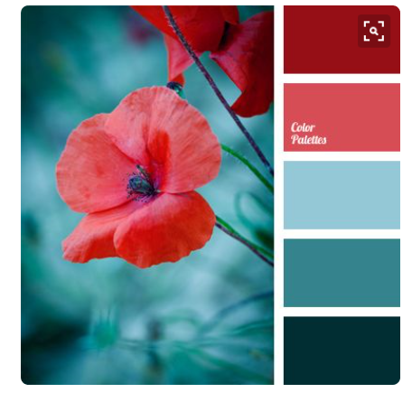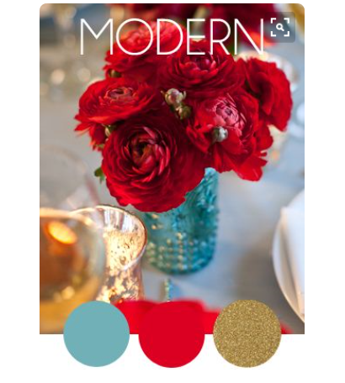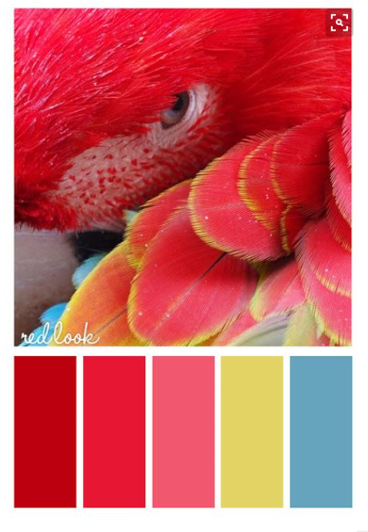
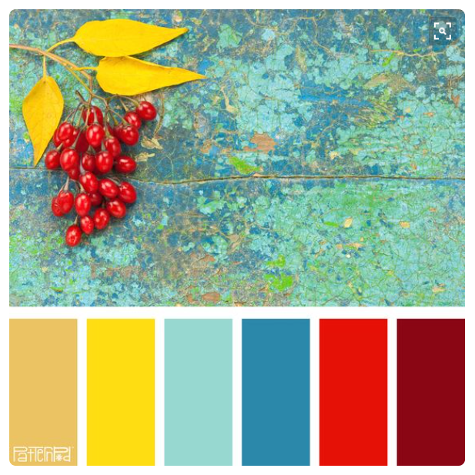

Logos:
Need a few styles/versions, such as:
- logo only
- logo with tagline – our tagline is s still under development but some ideas are:
  - The Heart of Happiness – inspired living
  - Empowering and inspiring people to live happy
  - Life and wellness coaching and services
- logo with clear background
- logo with coloured background
- Plain black version of logo
- Ideally, we are looking for a set of business branding options. See examples below – these examples do not demonstrate the look we want, but is just to show a ‘set’ of branding ideas which could be used for different purposes.

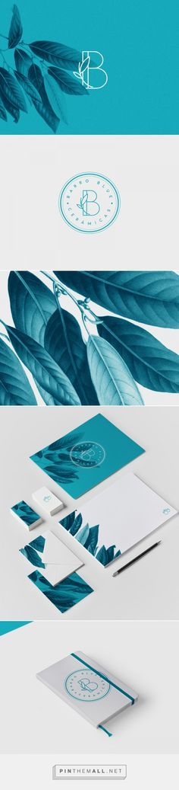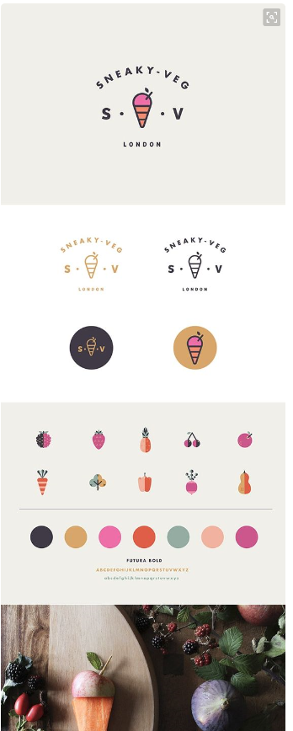

Business vision:
We are a health, wellness, and happiness coaching service, which offers one on one personal coaching services as well as a range of custom workshops, and limited products such as marketing merchandise (eg tea bags with custom labels), inspiration card packs.
We are a very small startup company with limited resources and want to get a business identity developed so we can start marketing.
- The feeling we want to convey is:
  - Quality
  - Natural
  - Little bit Hippy
  - Inspiring
  - Happy
  - Nurturing
  - Joyful
  - Blissful
  - Clean

