42 SOUTH LOGO BRIEF:

PRODUCTS: AUSTRALIAN MADE RUGBY JERSEYS
ABOUT PRODUCT: STRIPED IN VARYING COLOURS, DURABLE, HIGH QUALITY
BRAND NAME: 42 SOUTH
ABBREVIATION: 42S
WEBSITE: 42S.COM.AU (not currently active)
BRAND LOGO: SIMPLE SILHOUTTE OF FALCON, POSSIBLY INCLUING "42S" OR "42 SOUTH"

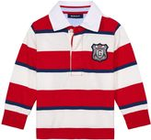
42 SOUTH
LOGO IS TO BE EMBOIDERED ON CHEST

THE LOGO WILL BE RELATIVELY SMALL ON THE CHEST, APPROX 20MM X 20MM

RUGBY JERSEY STRIPE COLOURS WILL CHANGE WITH EACH DESIGN.

NOTE:
THERE WILL BE A NAVY "PIP TAG" - A TAG SEWN IN TO THE SIDE SEAM OF THE JERSEY, WITH THE BRAND NAME "42 SOUTH" EMBROIDERED IN WHITE OR POSSIBLY RED AND WHITE "42 SOUTH"

LOGO SUGGESTIONS NEXT PAGE...
PLEASE NOTE THESE IDEAS....
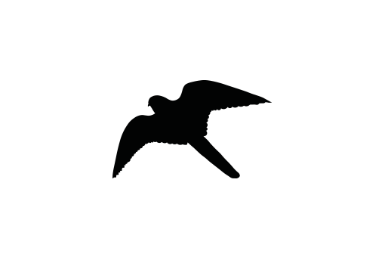
THIS FALCON SHAPE:

42 SOUTH

AND I LIKE THE NAVY BLUE AND RED NAUTICAL FLAG BELOW:

Perhaps try a white falcon image on the blue and white nautical flag square background:



42 SOUTH
42 SOUTH

