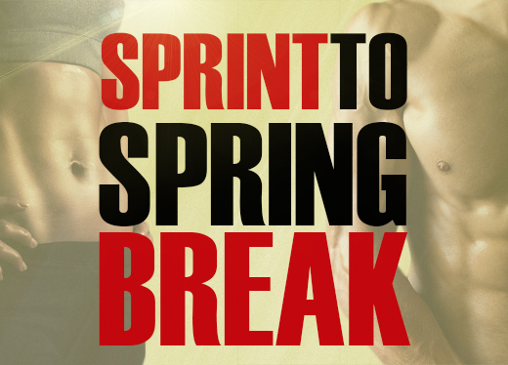
Discover the Secret to a Beach-Ready Body in Just 21 Days!
- 9 total training sessions designed to incinerate fat off your midsection, thighs, and arms
- 21 days of nutritional guidance, including delicious recipes
- A Success Session to map out your individual plan for success
- Your very own Personal Accountability Coach to ensure you get results
You get all this—a $399 value—for ONLY $99!
Insert Testimonial
I’ve never been more fit in my life—at age 41!
~Francine Telluride

HURRY! SPACE IS LIMITED TO ONLY 20 PARTICIPANTS!!!
CLAIM YOUR SPOT NOW: WEBSITE AND PHONE NUMBER

