PD PAC TM Ultimate 1000

PARTIAL DISCHARGE PORTABLE ANALYSIS CONSOLE (PD PAC TM )Ultimate 1000 Series is a ruggedized Partial Discharge (PD) Diagnostic System that offers real time PD Recording and Pattern Analysis using our powerful PDFusion Max for effective analysis of PD Data in high noise environment. It is a dual integrated system that is capable of performing both Snap-Shot and Short-Term Monitoring. It is also designed with unique bandwidth range covering both VHF and UHF Measurement for different type of High Voltage Equipment such as Vacuum Switchgear, Motors, Tap Changers, Transformers and SF6/GIS System.

Features:
- Non-Invasive Measurement.
- 1 Integrated Unit For Both VHF and UHF PD Measurement.
- Typical ‘Snap-Shot Test’ Time Of 1 to 5 Minute Per Equipment & Short-Term PD Monitoring (< 7 days).
- 6 Channels For Data Acquisition (3 For UHF & 3 For VHF PD Measurement).
- Flexible PD Measurement For All Medium Voltage & High Voltage Equipment Such As SF6/GIS &Vacuum Systems.
- Confirm PD Measurement Due To Harmonics & Variable Loads In Monitoring Mode.
- Complement PD Measurement Taken By Dissolved Gas Analysis (DGA) With PD In Oil Measurement.
- Locate The PD Source & Identify The Type.
- Determine PD Severity & Equipment Health Status.
- User-friendly DataAcq Software For PD Data Collection.
- Powerful PDFusion Max Analysis Software For Noise Rejection In PD Analysis.
- Access to our powerful Data Analytics system for benchmarking of equipment health with other similar equipment.

Description | Performance
Casing (Weight) | Approximately 16 kg
Casing (Dimensions) | Length (610), Width (472), Height (275) mm.  With handle and wheels.
Casing Material | Engineer Resin Plus Glass Fiber
Electrical Power Input | 230Vac, 50Hz
Acquisition Signal Inputs | ± 1000mV (UHF channels)  ± 50mV to ± 20V (VHF channels)
Number of Channels | 6 channels
Digital Signal Recording | VHF (EM) : Sampling rate 250MS/s  UHF (Antenna) : Sampling rate 1.25GS/s  450GB Harddisk storage
Computing and Processing Unit | High speed instrument controller  Intel Core i7 processor (32 bit)
Sensors | 3 x Electromagnetic (EM) Sensor - VHF  (With In-built Magnetic coupling)  300MHz Bandwidth  Size: 90 (L) x 90 (W) x 40 (H) mm  3 x Antenna Sensor - UHF  (With In-built Magnetic coupling)  1GHz Bandwidth  Size: 90 (L) x 90 (W) x 40 (H) mm
Operating Temperature Range | 10°C – 50°C
Storage Temperature Range | 10°C – 60°C
Humidity | <=95%, non-condensing
Software | DataAcq1000.exe and PDFusionMax.exe
Trade Logo | 
Trade Name | PDPAC TM
Safety Approval | 
*All specifications and dimensions are subjected to change without prior notice.

EM Sensor
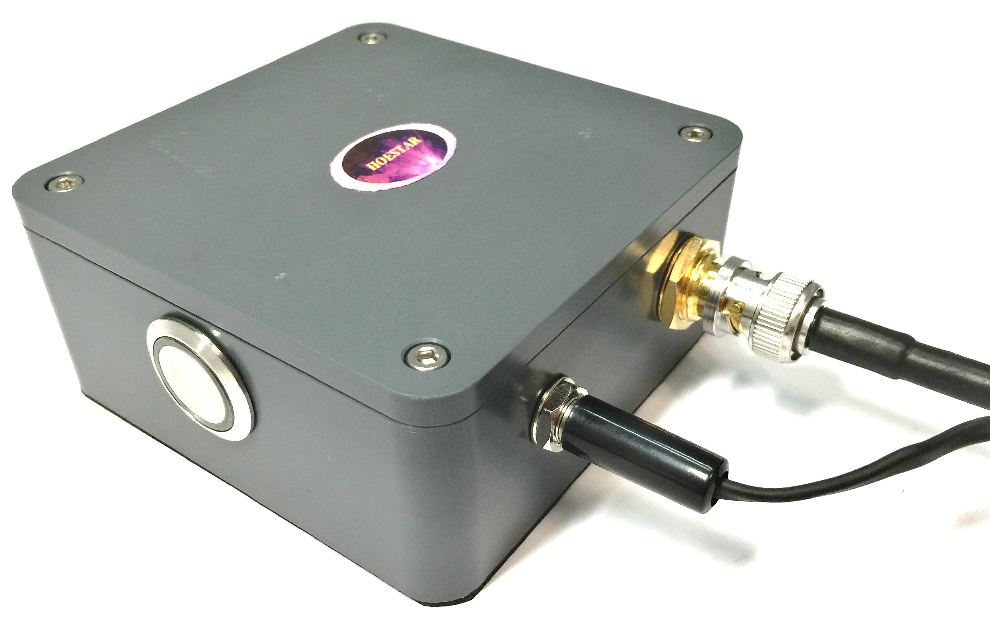

Antenna Sensor
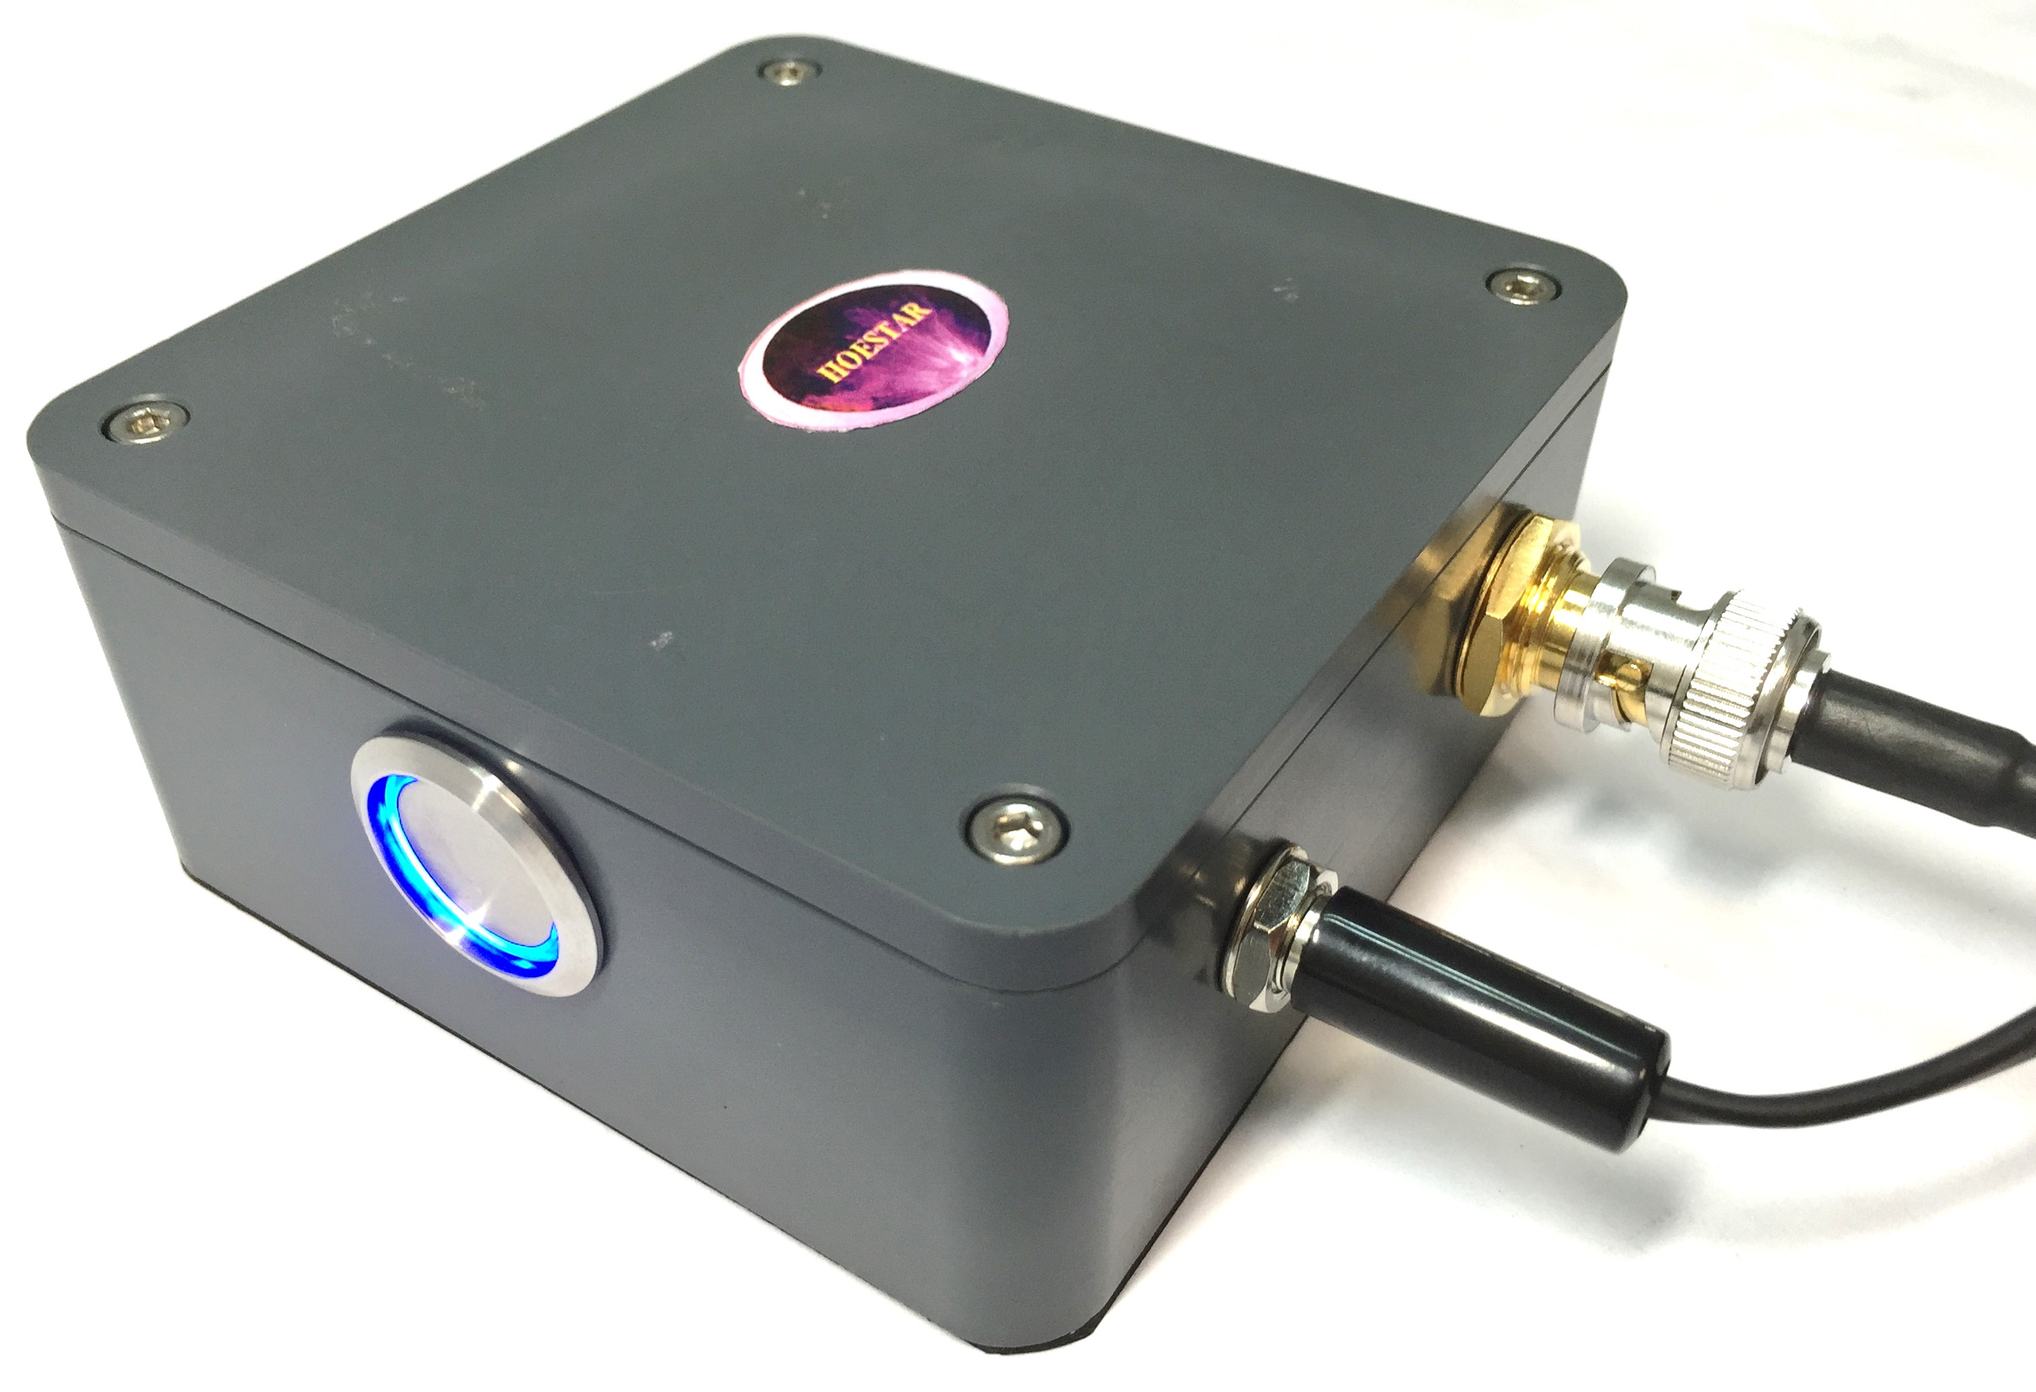

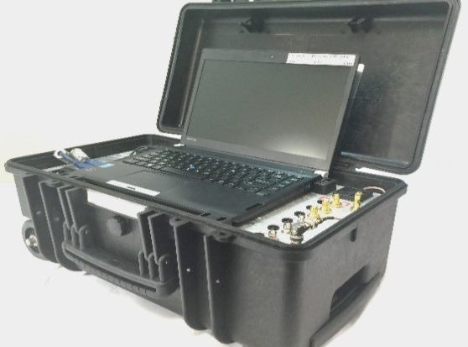

Main Console



OUR PROPRIETARY DATA ACQUISITON & ANALYSIS SOFTWARE ARE USER FRIENDLY &
IT IS A MOBILE AND RUGGED SYSTEM FOR ALL SITE CONDITIONS.
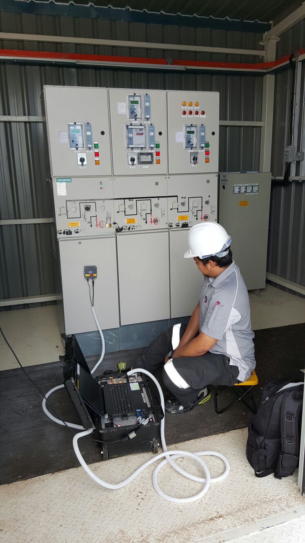
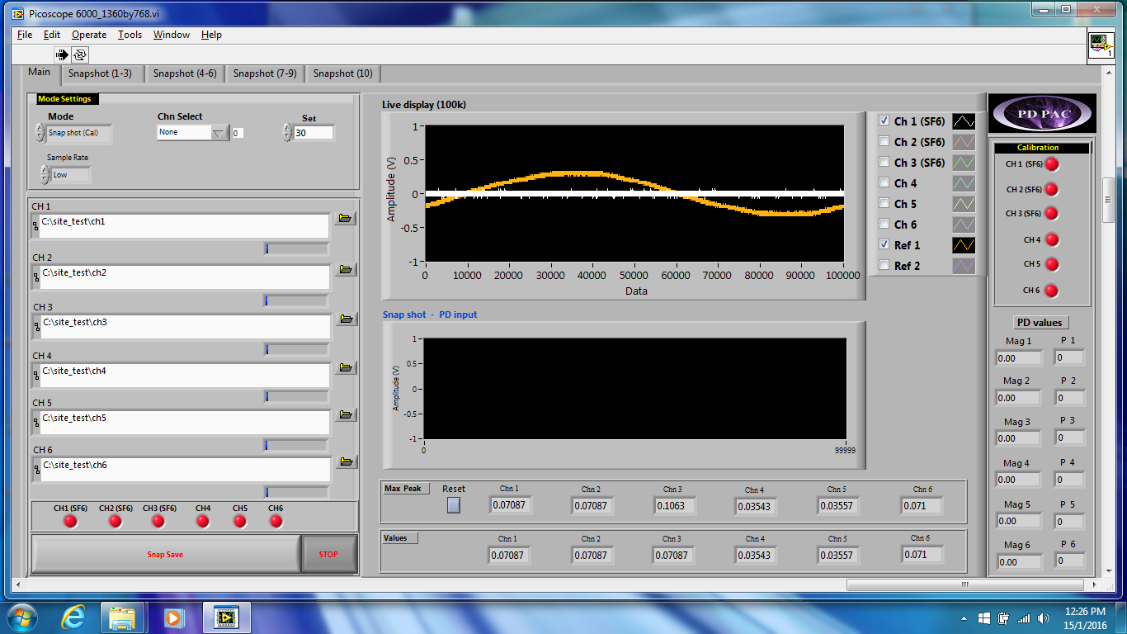
Site work
DataAcq1000 Software

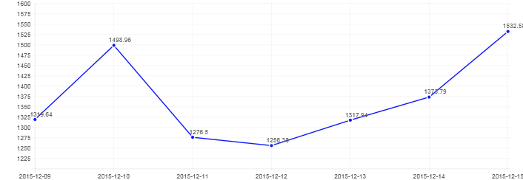
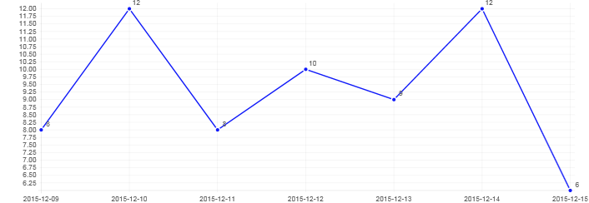
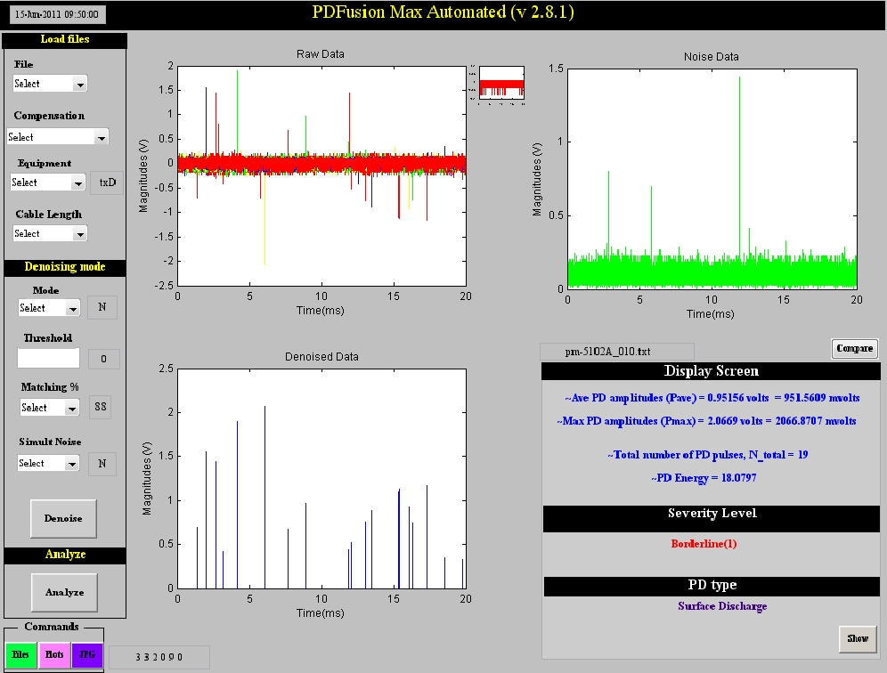

Trending PD Average Chart
Trending PD Pulse Chart
PD FusionMax Software

