1.
https://www.pinterest.com/lgolab/seed-packets-fruit-labels/
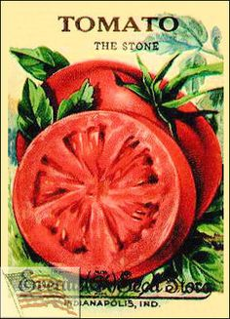

2.
https://www.spicherandco.com/product.php?productid=26709
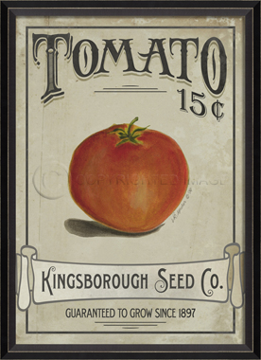

3.
https://www.pinterest.com/whatsup4now/vintage-antiques/
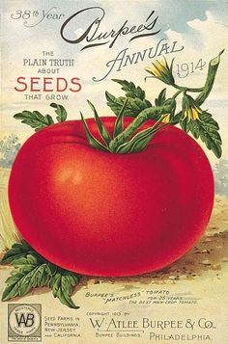

4.
https://www.pinterest.com/tomatodirt/tomato-art-just-for-fun/
