Random DJ
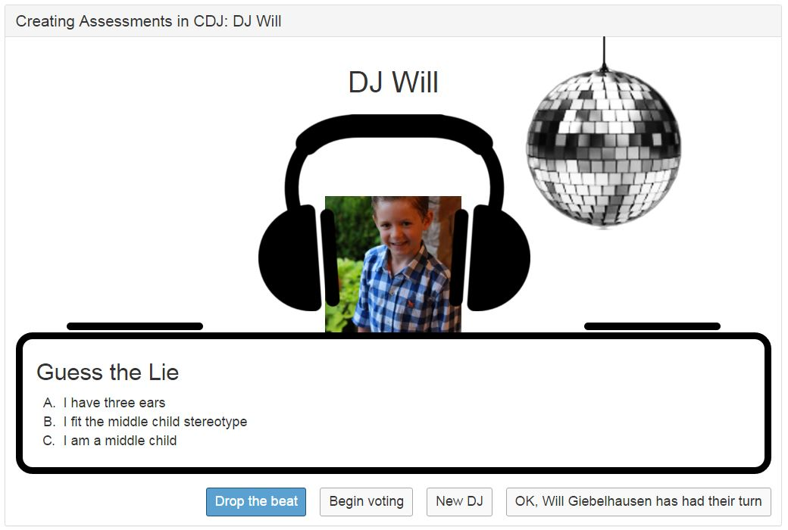

When students create an account on classroomdj.com, they are asked to provide a YouTube playlist of upbeat music that will energize the classroom when it is their turn to be the DJ. Before the start-time of each class, the instructor selects “Today’s DJ” and clicks a button to play their music. Playing music prior to class has a number of benefits. First, it can help to energize students and get them ready to process the lecture material (Jensen 1998). Also, a music filled classroom (compared to an intimidatingly silent classroom) seems to encourage students to chat - an important step in building a classroom community (Astin 1993). It’s also a great tool for letting students know that the class is ready to start. When the music stops, student get the hint that it is time to stop chatting (kind of like Oscar’s speeches in reverse).

When filling out their classroomdj.com profile, students are also asked to supply two truths and a lie about themselves. “Two truths and a lie” is a common icebreaker activity that has a number of benefits in a classroom setting. First, getting to know one another is always a helpful step in building a classroom community. Secondly, if you are using “i-clickers” (or any other class poling technology). It’s a great way of encouraging students to get their clickers out and ready to go. If you use clickers to take attendance, two truths and a lie game will accomplish this task. Also, it really seems to energize the class. Students really seem to like sharing something about themselves. It is not uncommon for quieter students to start engaging more in class after they have been the DJ.

Astin, Alexander W. What matters in college?: Four critical years revisited. Vol. 1. San Francisco: Jossey-Bass, 1993.

Jensen, Eric. "Teaching with the brain in mind." (1998).

Flashcards

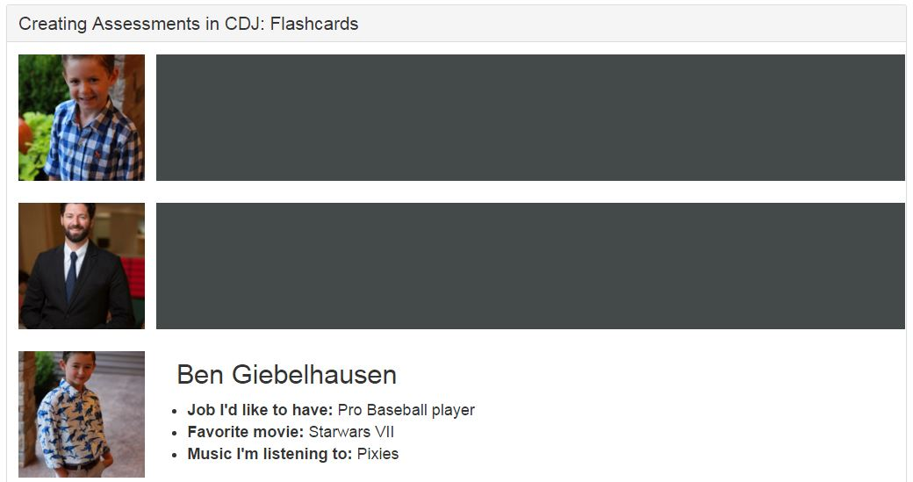
Flashcards are a fun way for students to get to know each other and for instructors to get to know students. Click the box next to their picture to reveal the student’s name and a few details from their classroomdj.com profile. Knowing each other’s names is an important part of building a classroom community. Also, when instructors can call on students by name, engagement goes up and students are more satisfied with their experience (Astin 1998).
Astin, Alexander W. What matters in college?: Four critical years revisited. Vol. 1. San Francisco: Jossey-Bass, 1993.

The Claw

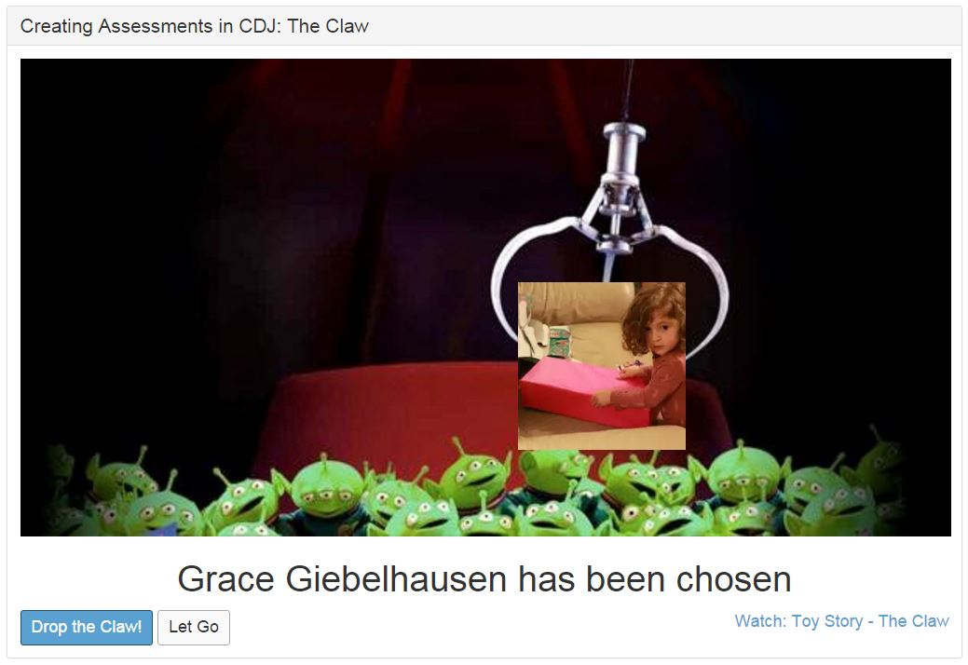

“The claw” is simply a tool that randomly selects a student from the class roster and displays their name and picture on the screen. Basically, it is a more light-hearted approach to “cold-calling” where the claw (rather than the instructor) decides who will be asked to speak. There are a number of benefits from using the claw in class. One is that cold-calling provides quieter students with an opportunity to speak and makes it harder for the more extroverted students to dominate the discussion. Also, if you do “one minute papers” or active learning exercises in class, dangling the claw on the screen during the exercise lets students know they can’t count on one of the extroverted students volunteering the answer - a subtle but effective motivator.

Virtual Clicker

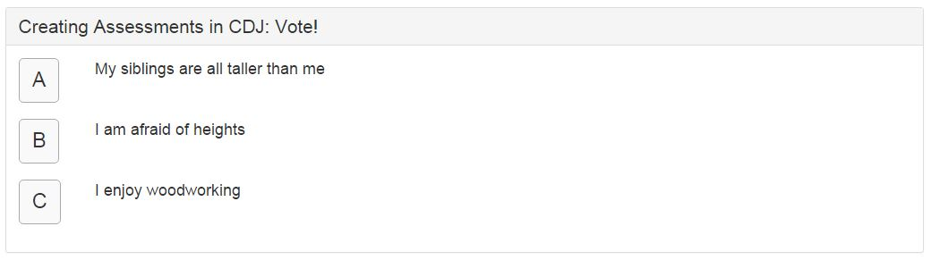
Clickers and peer instruction are an essential part of an active learning approach to education that help create engaging experiences and help students to master (rather than just memorize) course material (Crouch and Mazur 2001) Currently, the classroom DJ virtual clicker is only implemented for the Random DJ “two truths and a lie” game. In the near future, however, instructors (and students) will be able to create multiple choice questions using a simple online form. Polls will can be launched in the instructor section of classroomdj.com or in Powerpoint via a clickable url. Students can respond using their laptop or mobile device.

Crouch, Catherine H., and Eric Mazur. "Peer instruction: Ten years of experience and results." American journal of physics 69.9 (2001): 970-977.

More Cowbell
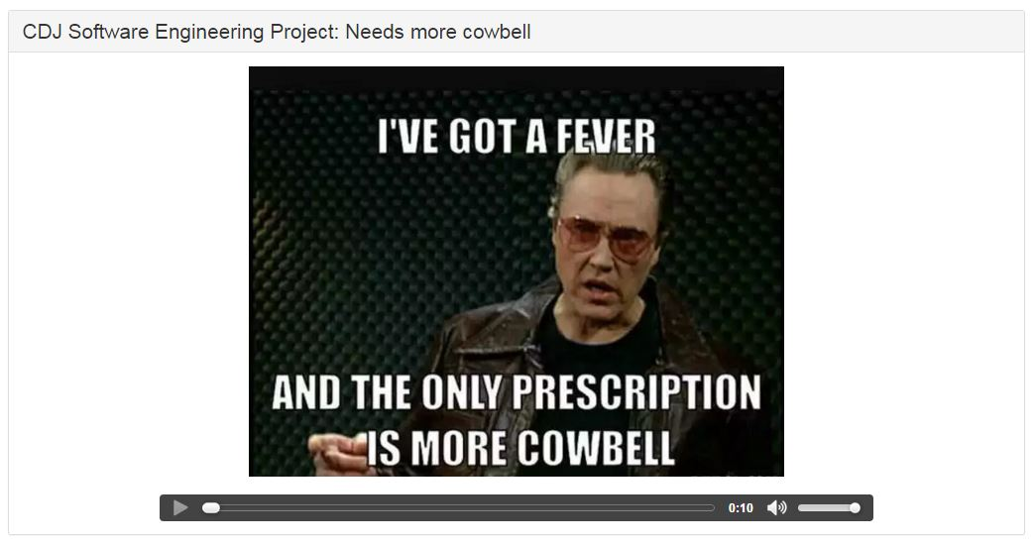
Sometimes the think-pair-share discussions get so feverish the only prescription is more cowbell. In other words, when the class gets too noisy you can ring this virtual bell to get everyone’s attention. The credit for inspiring this app goes to Kim Kenyon at the Cornell University Center for Teaching Excellence.

Student Profiles

Instructor-customizable profiles let students share information about themselves with the class. Use it to learn what students expect to learn, their previous coursework, or just to help people get to know each other (see flashcards).

Self/Peer Evals

(beta) Self/Peer evaluations are a fantastic way to help students master material and deliver high quality feedback - fast. Works great in both large and small classes for either regular assignments or exams.

Rubrics

(coming Summer 2016) Rubrics are a great tool - both for providing guidence and feedback This tool lets you create your own rubrics to use for assignments (self/peer evals for example). Also, you can search a database of existing rubrics to use as a starting point.

Rubrics

(coming Summer 2016) Rubrics are a great tool - both for providing guidence and feedback This tool lets you create your own rubrics to use for assignments (self/peer evals for example). Also, you can search a database of existing rubrics to use as a starting point.

