Our Advantage
  - Every Plan has a General Fund Reconciliation showing all Departments and which are included and which are not included in the plan.
  - A client can easily trace what is in the financials to the cost plan
  - Departments come in as a whole and items that are not allocable are either excluded or allocated to General Government
  - All lines of a financial report are brought in for clear audit trail back to financials.
  - Narratives are robust and clearly explain how the schedule was developed, decisions that were made and how data was handled.
  - All activities are clear and decisions noted on why the allocation basis was chosen.
  - We offer follow up training with EVERY plan we deliver!
  - Your plan will be delivered in hard copy, PDF and EXCEL.
  - We are price competitive.
  De Novo Consulting Solutions was founded in July, 2014.
  - Since that time we have grown to over 60 clients, completing cost allocation plans and rate studies for Counties, State Agencies and Transportation Boards.
  - Our plans have been negotiated with State and Federal agencies.
  - We believe in producing the best plan for our clients.
  Contact us
  Diane blaschko
  De Novo COnsulting Solutions, LLC
  612 600 8270 (cell)
  844 267 8752 (office)
  dianeblaschko@denovoconsultingsolutions.com
  sales@denovoconsultingsolutions.com
  De Novo Consulting Solutions, LLC
    - We deliver the best cost plan for the best price to our clients. We typically save clients 20-30%, look for new sources of revenue and provide a better documented plan in an EXCEL and PDF format.
  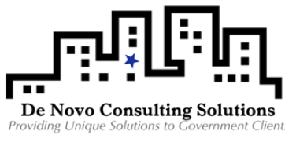

 |  |  | Our Team  - Diane Blaschko is a PMP and has over 25 years of consulting experience with County, City and State Agencies. I began my career in Ohio, where I did cost plans for 10 years. My project management background means that every project is scheduled, timed, and quality checked.  - Kate Hemleben is a CPA with years of State, County and City experience. She has completed over 40 State Cost Plans and over 50 County Cost Plans. Her experience is primarily in Ohio.  - Dawn Rhone is a CPA with 10 years of experience working with County and State Agencies in North Dakota, Minnesota and Nebraska. She brings a wealth of knowledge to the table.  - Britney Ahlmann has five years of experience working with cost plans in MN, ND, NE, IA and WI. She brings her expertise and experience to help us as we continue to grow.  - John Boyer is located in Columbus, OH and has over 25 years of cost accounting, cost plans, and systems design work on cost accounting and timekeeping systems. John wrote the original PET, QuIC and RMS systems for Ohio Human Service Agencies. He provides the technical resources for this project.  - Ronan Blaschko is located in Stillwater, MN. He has a JD from St. Thomas University and a BA from Vassar. He brings his background in cost accounting and legal experience to our group.
  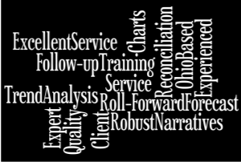
  The De Novo Difference
  - We will save you as much as 30% over our competitor pricing.
  - You get the most qualified individuals working directly for you.
  - Produced with our proprietary, state of the art, .NET system
  - Built in analysis tools
  - Automatically produces the plan in PDF and EXCEL formats
  Analysis
  Each plan undergoes a rigorous review with our automated tools that automatically compares the proposed plan to historical numbers and looks for changes, trends and points of discussion.
  “De Novo gave our plan a fresh look and found additional recoveries that weren’t in our old plan. We love the EXCEL format of the plan.”
  De Novo Client
  Receiving departments go through a three step review. First we review the receiving departments in total, second we review by central service and finally we look at changes by activity.
  Our Tools
  We have our own, proprietary cost allocation system. It is a .NET system and it can produce an excel version of the cost plan. In addition, we have built in analysis with every plan that will provide some detail. Our tools provide the consultant with feedback as the plan is being constructed so that they know immediately where to ask questions or for more information

